**Department of Electrical and Electronics Engineering**

**Third Year B. Tech. (ECE-AI-ML) Semester V**

**Embedded System Design and RTOS Course Code: ECE3015B**

**Project Proposal**

1. **Details of Group:**

|  |  |  |  |  |  |
| --- | --- | --- | --- | --- | --- |
| **Sr.**  **No.** | **Name of Student** | **Div** | **Roll No.** | **Email Address** | **Mobile No.** |
| **1** | **Shraddha Ketkar** | **A** | **61** | **-** | **-** |
| **2** | **Shriya Samridhi** | **A** | **56** |  |  |

1. **Title :**

Digital Thermometer Using STM32

1. **Problem Definition and Details :**

This project aims to design and implement a digital thermometer using the STM32 microcontroller, LM35 temperature sensor, and LCD 1602 for display. The system will measure temperature in real-time and display it on the LCD screen in Celsius. The LM35 provides an analog output proportional to the temperature, which is processed by the STM32’s ADC to convert the signal into a digital value. This value is then used to calculate and display the temperature. The system's primary focus is on accurate, real-time temperature readings, simple interfacing, and efficient use of the STM32’s peripherals.

1. **Resources Required :**

STM32G030K6Tx Microcontroller

* + LM35 Temperature Sensor
  + LCD 1602 Display
  + Connecting Wires
  + Power Supply (3.3V)
  + STM32CubeIDE for programming and debugging
  + STM32CubeMX for peripheral configuration
  + Breadboard/PCB for circuit construction

**Signature of Student/s with Date**

**Signature of Subject teacher**

**Department of Electrical and Electronics Engineering**

**Third Year B. Tech. (ECE AI-ML) Trimester V**

**Embedded System Design and RTOS Course Code: ECE3015B**

**DIGITAL THERMOMETER**

**By Shraddha Ketkar Shriya Samridhi**

NAME OF THE GUIDE

Shruti Danve

**ACKNOWLEDGMENT**

We would like to express our heartfelt gratitude to our project guide, **Shruti Danve**, for her invaluable guidance, encouragement, and expertise. Her support throughout the development of this project has been instrumental in helping us understand the principles and applications of embedded systems, as well as in overcoming challenges encountered during implementation.

We extend our thanks to all faculty members of the **Electrical and Electronics Engineering Department** for providing us with the resources and learning environment necessary for this project. We are also grateful for the practical training and insights imparted to us, which enabled us to apply theoretical concepts in a real-world setting.

Furthermore, we would like to acknowledge our peers and family members for their unwavering support and encouragement throughout the course of this project. Their motivation and understanding made it possible for us to dedicate time and effort to achieve our goals.

Lastly, we would like to thank **STM32CubeIDE** and **STM32CubeMX** development teams for creating excellent tools, documentation, and resources, which were essential for the successful completion of this project.

**Abstract:**

This project focuses on designing a digital thermometer using the STM32G030K6Tx microcontroller. The goal is to create an embedded system capable of measuring temperature in real-time using the LM35 sensor and displaying the results on an LCD 1602 display. The project makes use of STM32’s inbuilt ADC to convert the analog voltage from the LM35 into a digital value that corresponds to the measured temperature. The system’s efficiency, low power consumption, and ease of implementation make it ideal for applications where real-time temperature monitoring is essential. The LCD display interface ensures clear visibility, and the system has been designed to be modular and easily expandable for future improvements. This project will demonstrate the potential of microcontrollers in embedded system applications, particularly in sensor data acquisition and real-time display system

**INDEX**

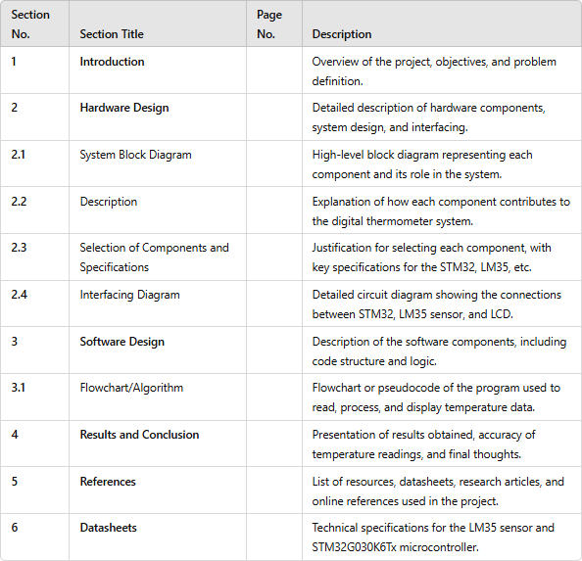

Introduction

A digital thermometer is an essential tool for measuring and monitoring temperature across various applications, from medical devices to environmental sensors and home automation systems. Traditional thermometers have their limitations, including slow response time, limited range, and the need for manual reading. In contrast, digital thermometers provide quick, accurate, and real-time temperature readings, which are highly beneficial for applications that require constant monitoring.

In this project, we aim to design a digital thermometer using the STM32 microcontroller and an LM35 temperature sensor.

The STM32 microcontroller, a powerful and energy-efficient device, is widely used in embedded systems due to its flexible interfacing, built-in analog-to-digital converter (ADC), and extensive support for programming and debugging through the STM32CubeIDE and STM32CubeMX tools.

The LM35 sensor, known for its simplicity and accuracy, is an analog temperature sensor that outputs a voltage linearly proportional to the ambient temperature, with a sensitivity of 10 mV/°C. This makes it an ideal choice for applications where precise, real-time temperature measurements are essential.

The core functionality of this digital thermometer involves interfacing the LM35 sensor with the STM32 microcontroller’s ADC, converting the analog voltage output from the sensor to a digital value, and then processing this data to display the temperature in Celsius. An LCD 1602 display is used to provide a clear, user-friendly interface that shows the temperature reading in real time

**Hardware Design for Digital Thermometer Using STM32 and LM35 Sensor**

The hardware design of this digital thermometer consists of key components that interact to measure, process, and display temperature data. Below is a breakdown of the hardware design sections:

## System Block Diagram

The system block diagram outlines the main components and their connections:

* + **Power Supply:** Provides the necessary 3.3V DC power for the STM32 microcontroller, LM35 sensor, and LCD.
  + STM32G030K6Tx Microcontroller: Acts as the central processor, responsible for reading the temperature from the sensor, converting it from analog to digital, and controlling the display.
  + **LM35 Temperature Sensor**: Outputs an analog voltage proportional to the temperature in Celsius (10 mV per degree Celsius), which is fed into the STM32’s ADC.
  + **LCD 1602 Display:** Displays the temperature in Celsius in real-time for easy readability.

-Interconnections: Shows the ADC input (PA0), LCD data pins (PB3, PB4, PB5, PB8), LCD control pins (RS and EN connected to PB9 and PC14), and power connections.

1. **Description of Components**

Each component in the system plays a specific role in enabling accurate temperature measurement and display.

* + Power Supply: Provides stable 3.3V power, which is essential for the STM32 microcontroller, LM35 sensor, and LCD display to operate reliably.

## STM32G030K6Tx Microcontroller:

* + - Functionality: The microcontroller performs data acquisition, processing, and output functions.
    - ADC Conversion: Reads the analog voltage output from the LM35 through its ADC pin (PA0), converts it to a digital value, calculates the temperature, and drives the LCD display.
    - Display Control: Uses GPIO pins to communicate with the LCD and display temperature readings.

## LM35 Temperature Sensor:

* + - Functionality: Provides an analog output voltage directly proportional to temperature (10 mV per °C).
    - Accuracy: Capable of measuring temperature with good accuracy, making it suitable for real-time applications.

## LCD 1602 Display:

* + - Functionality: The LCD provides a clear, two-line output for displaying temperature in Celsius.
    - Ease of Use: Designed for easy interfacing with the STM32, displaying temperature readings directly on the screen.

1. **Selection of Components and Specifications**

Each component was selected based on specific features relevant to the project’s needs.

**STM32G030K6Tx Microcontroller**: Chosen for its built-in ADC, low power consumption, and ease of use with STM32CubeIDE and STM32CubeMX software. This microcontroller is also known for its robust performance in embedded applications.

**LM35 Sensor**: Offers a linear response with a range from -55°C to 150°C and a sensitivity of 10 mV/°C, which simplifies the temperature-to-voltage conversion process.

* + **LCD 1602 Display:** A 16x2 character display that provides clear and easy-to-read output, with two lines available for displaying "Temperature: XX°C" in real-time.

1. **Interfacing Diagram**

The interfacing diagram shows the connections between the STM32 microcontroller, LM35 sensor, and LCD display:

* + **STM32 ADC Pin (PA0):**Connected to the output pin of the LM35 sensor for temperature data input.
  + **LCD Data Pins (D4 to D7):** Connected to PB3, PB4, PB5, and PB8 on the STM32.
  + **LCD Control Pins (RS, EN):** Connected to PB9 (RS) and PC14 (EN) for command and enable functions.
  + Power and Ground Connections: Connected to the 3.3V power source and ground to provide a stable operating voltage for all components

This hardware design provides the foundation for the digital thermometer system, enabling it to efficiently measure temperature and display readings in real time on an LCD display.

## System Block Diagram

This sub-section will contain a high-level block diagram representing the main components and their interactions in the system. Key blocks include:

* + - **Power Supply:** Provides 3.3V power for the STM32, LM35, and LCD.
    - STM32G030K6Tx Microcontroller: Processes the analog temperature signal and controls the LCD.
    - **LM35 Temperature Sensor**: Measures ambient temperature and outputs an analog voltage corresponding to the temperature in Celsius.
    - **LCD 1602 Display**: Displays the temperature reading in Celsius.
    - Interconnections: Shows connections between STM32’s ADC input (PA0), LCD data pins (PB3, PB4, PB5, PB8), control pins (RS and EN on PB9 and PC14), and power connections.

## Description

In this section, each component in the block diagram will be described in terms of its function in the thermometer system:

* + - Power Supply: Supplies the necessary voltage for the microcontroller and peripherals.
    - STM32 Microcontroller: Handles the ADC conversion of the LM35’s analog output to a digital value, calculates the temperature, and drives the LCD display.
    - **LM35 Sensor:** Outputs a linear voltage proportional to the temperature, which simplifies temperature-to-voltage conversion.
    - **LCD Display:** Provides a user-friendly interface for displaying real-time temperature data.

## Selection of Components and Specifications

This part justifies the choice of each component, listing their specifications:

* + - **STM32G030K6Tx:** Chosen for its built-in ADC, low power consumption, and compatibility with STM32CubeIDE and STM32CubeMX, which simplifies development.
    - **LM35 Sensor**: Offers precise and linear analog output, with a range from

-55°C to 150°C and a sensitivity of 10mV/°C.

* + - **LCD 1602 Display**: Provides clear, two-line display output for temperature readings, easy to interface with STM32.

## Interfacing Diagram

A circuit diagram showing the detailed connections between the STM32, LM35, and LCD. It includes:

* + - ADC Pin (PA0) connected to the LM35 output.
    - LCD Data Pins (D4 to D7) connected to PB3, PB4, PB5, and PB8.
    - LCD Control Pins (RS, EN) connected to PB9 and PC14.
    - Power and Ground Connections to each component as required.

## Software Design

* 1. **Flowchart/Algorithm**

The flowchart will illustrate the software flow from initializing peripherals to reading, converting, and displaying temperature.

1. Initialization Step: Set up ADC, GPIO pins, and LCD.
2. Reading Temperature: ADC reads the analog output from the LM35.
3. Processing: Convert the digital ADC value to temperature using a pre- defined formula.
4. Display: Send the temperature to the LCD to be displayed.
5. Repeat: Continuously update the temperature display in a loop.

## Results and Conclusion

This section will present the results obtained from testing the thermometer, including sample readings under various temperatures to verify accuracy.

Describe any challenges encountered and solutions implemented. Conclude with an assessment of the project, discussing its potential applications, limitations, and possibilities for future expansion (e.g., adding a humidity sensor or Bluetooth connectivity).

## References

* "The Definitive Guide to ARM Cortex-M0 and Cortex-M0+ Processors" by Joseph Yiu
* "Embedded Systems: Real-Time Interfacing to Arm Cortex-M Microcontrollers" by Jonathan W. Valvano
* "STM32 Arm Programming for Embedded Systems" by Muhammad Ali Mazidi, Shujen Chen, and Eshragh Ghaemi
* "Programming with STM32: Getting Started with the Nucleo Board and C/C++" by Donald Norris



**Datasheets**

**STM32G030x6/x8**

Arm® Cortex®-M0+ 32-bit MCU, up to 64 KB Flash, 8 KB RAM, 2x USART, timers, ADC, comm. I/Fs, 2.0-3.6V

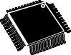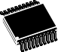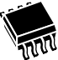**Datasheet** - **production data**

### Features

* Core: Arm® 32-bit Cortex®-M0+ CPU, frequency up to 64 MHz
* -40°C to 85°C operating temperature
* Memories
  + Up to 64 Kbytes of Flash memory with protection
  + 8 Kbytes of SRAM with HW parity check
* CRC calculation unit
* Reset and power management
  + Voltage range: 2.0 V to 3.6 V
  + Power-on/Power-down reset (POR/PDR)
  + Low-power modes: Sleep, Stop, Standby

SO8N

4.9 × 6 mm

TSSOP20

6.4 × 4.4 mm

LQFP32

7 × 7 mm LQFP48

7 × 7 mm

* Communication interfaces
  + Two I2C-bus interfaces supporting Fast- mode Plus (1 Mbit/s) with extra current sink, one supporting SMBus/PMBus and wakeup from Stop mode
  + Two USARTs with master/slave synchronous SPI; one supporting ISO7816
  + VBAT

supply for RTC and backup registers

interface, LIN, IrDA capability, auto baud

rate detection and wakeup feature

* Clock management
  + 4 to 48 MHz crystal oscillator
  + 32 kHz crystal oscillator with calibration
  + Internal 16 MHz RC with PLL option
  + Internal 32 kHz RC oscillator (±5 %)
* Up to 44 fast I/Os
  + All mappable on external interrupt vectors
  + Multiple 5 V-tolerant I/Os
* 5-channel DMA controller with flexible mapping
* 12-bit, 0.4 µs ADC (up to 16 ext. channels)
  + Up to 16-bit with hardware oversampling
  + Conversion range: 0 to 3.6V
* 8 timers: 16-bit for advanced motor control, four 16-bit general-purpose, two watchdogs, SysTick timer
* Calendar RTC with alarm and periodic wakeup from Stop/Standby
  + Two SPIs (32 Mbit/s) with 4- to 16-bit programmable bitframe, one multiplexed with I2S interface
* Development support: serial wire debug (SWD)
* All packages ECOPACK 2 compliant

**Table 1. Device summary**

|  |  |
| --- | --- |
| **Reference** | **Part number** |
| STM32G030x6 | STM32G030C6, STM32G030F6, STM32G030J6, STM32G030K6 |
| STM32G030x8 | STM32G030C8, STM32G030K8 |

# Contents

1. Introduction 8
2. Description 9
3. Functional overview 12
   1. Arm® Cortex®-M0+ core with MPU 12
   2. Memory protection unit 12
   3. Embedded Flash memory 12
   4. Embedded SRAM 13
   5. Boot modes 14
   6. Cyclic redundancy check calculation unit (CRC) 14
   7. Power supply management 14
      1. Power supply schemes 14
      2. Power supply supervisor 15
      3. Voltage regulator 15
      4. Low-power modes 16
      5. Reset mode 16
      6. VBAT operation 17
   8. Interconnect of peripherals 17
   9. Clocks and startup 18
   10. General-purpose inputs/outputs (GPIOs) 19
   11. Direct memory access controller (DMA) 19
   12. DMA request multiplexer (DMAMUX) 20
   13. Interrupts and events 20
       1. Nested vectored interrupt controller (NVIC) 20
       2. Extended interrupt/event controller (EXTI) 21
   14. Analog-to-digital converter (ADC) 21
       1. Temperature sensor 22
       2. Internal voltage reference (VREFINT) 22
       3. VBAT battery voltage monitoring 22
   15. Timers and watchdogs 22
       1. Advanced-control timer (TIM1) 23
       2. General-purpose timers (TIM3, 14, 16, 17) 23



* + 1. Independent watchdog (IWDG) 24
    2. System window watchdog (WWDG) 24
    3. SysTick timer 24
  1. Real-time clock (RTC), tamper (TAMP) and backup registers 24
  2. Inter-integrated circuit interface (I2C) 25
  3. Universal synchronous/asynchronous receiver transmitter (USART) 26
  4. Serial peripheral interface (SPI) 27
  5. Development support 28
     1. Serial wire debug port (SW-DP) 28

1. Pinouts, pin description and alternate functions 29
2. Electrical characteristics 38
   1. Parameter conditions 38
      1. Minimum and maximum values 38
      2. Typical values 38
      3. Typical curves 38
      4. Loading capacitor 38
      5. Pin input voltage 38
      6. Power supply scheme 39
      7. Current consumption measurement 39
   2. Absolute maximum ratings 40
   3. Operating conditions 41
      1. General operating conditions 41
      2. Operating conditions at power-up / power-down 41
      3. Embedded reset and power control block characteristics 41
      4. Embedded voltage reference 42
      5. Supply current characteristics 43
      6. Wakeup time from low-power modes and voltage scaling

transition times 49

* + 1. External clock source characteristics 50
    2. Internal clock source characteristics 54
    3. PLL characteristics 55
    4. Flash memory characteristics 56
    5. EMC characteristics 57
    6. Electrical sensitivity characteristics 58
    7. I/O current injection characteristics 59



* + 1. I/O port characteristics 60



* + 1. NRST input characteristics 65
    2. Analog switch booster 66
    3. Analog-to-digital converter characteristics 66
    4. Temperature sensor characteristics 71
    5. VBAT monitoring characteristics 71
    6. Timer characteristics 71
    7. Characteristics of communication interfaces 72

1. Package information 80
   1. SO8N package information 80
   2. TSSOP20 package information 83
   3. LQFP32 package information 85
   4. LQFP48 package information 88
   5. Thermal characteristics 91
      1. Reference document 91
2. Ordering information 92
3. Revision history 93

**List of tables**

Table 1. Device summary 1

Table 2. STM32G030x6/x8 family device features and peripheral counts 10

Table 3. Access status versus readout protection level and execution modes 13

Table 4. Interconnect of peripherals 17

Table 5. Temperature sensor calibration values 22

Table 6. Internal voltage reference calibration values 22

Table 7. Timer feature comparison 23

Table 8. I2C implementation 26

Table 9. USART implementation 27

Table 10. SPI/I2S implementation 28

Table 11. Terms and symbols used in *Table 12* 30

Table 12. Pin assignment and description 31

Table 13. Port A alternate function mapping 35

Table 14. Port B alternate function mapping 36

Table 15. Port C alternate function mapping 37

Table 16. Port D alternate function mapping 37

Table 17. Port F alternate function mapping 37

Table 18. Voltage characteristics 40

Table 19. Current characteristics 40

Table 20. Thermal characteristics 40

Table 21. General operating conditions 41

Table 22. Operating conditions at power-up / power-down 41

Table 23. Embedded reset and power control block characteristics 41

Table 24. Embedded internal voltage reference 42

Table 25. Current consumption in Run and Low-power run modes

at different die temperatures 44

Table 26. Current consumption in Sleep and Low-power sleep modes 45

Table 27. Current consumption in Stop 0 mode 45

Table 28. Current consumption in Stop 1 mode 46

Table 29. Current consumption in Standby mode 46

Table 30. Current consumption in VBAT mode 46

Table 31. Current consumption of peripherals 48

Table 32. Low-power mode wakeup times 49

Table 33. Regulator mode transition times 50

Table 34. High-speed external user clock characteristics 50

Table 35. Low-speed external user clock characteristics 51

Table 36. HSE oscillator characteristics 51

Table 37. LSE oscillator characteristics (fLSE = 32.768 kHz) 53

Table 38. HSI16 oscillator characteristics 54

Table 39. LSI oscillator characteristics 55

Table 40. PLL characteristics 55

Table 41. Flash memory characteristics 56

Table 42. Flash memory endurance and data retention 56

Table 43. EMS characteristics 57

Table 44. EMI characteristics 58

Table 45. ESD absolute maximum ratings 58

Table 46. Electrical sensitivity 59

Table 47. I/O current injection susceptibility 59



Table 48. I/O static characteristics 60



Table 49. Input characteristics of FT_e I/Os 61

Table 50. Output voltage characteristics 63

Table 51. I/O AC characteristics 63

Table 52. NRST pin characteristics 65

Table 53. Analog switch booster characteristics 66

Table 54. ADC characteristics 66

Table 55. Maximum ADC RAIN 68

Table 56. ADC accuracy 69

Table 57. TS characteristics 71

Table 58. VBAT monitoring characteristics 71

Table 59. VBAT charging characteristics 71

Table 60. TIMx characteristics 72

Table 61. IWDG min/max timeout period at 32 kHz LSI clock 72

Table 62. Minimum I2CCLK frequency 73

Table 63. I2C analog filter characteristics 73

Table 64. SPI characteristics 74

Table 65. I2S characteristics 76

Table 66. USART characteristics 78

Table 67. SO8N package mechanical data 80

Table 68. TSSOP20 package mechanical data 83

Table 69. LQFP32 mechanical data 86

Table 70. LQFP48 mechanical data 88

Table 71. Package thermal characteristics 91

Table 72. Document revision history 93

# List of figures



Figure 1. Block diagram 11

Figure 2. Power supply overview 15

Figure 3. STM32G030CxT LQFP48 pinout 29

Figure 4. STM32G030KxT LQFP32 pinout 29

Figure 5. STM32G030Fx TSSOP20 pinout 30

Figure 6. STM32G030Jx SO8N pinout 30

Figure 7. Pin loading conditions 38

Figure 8. Pin input voltage 38

Figure 9. Power supply scheme 39

Figure 10. Current consumption measurement scheme 39

Figure 11. VREFINT vs. temperature 43

Figure 12. High-speed external clock source AC timing diagram 50

Figure 13. Low-speed external clock source AC timing diagram 51

Figure 14. Typical application with an 8 MHz crystal 53

Figure 15. Typical application with a 32.768 kHz crystal 54

Figure 16. I/O input characteristics 61

Figure 17. Current injection into FT_e input with diode active 62

Figure 18. I/O AC characteristics definition(1) 65

Figure 19. Recommended NRST pin protection 66

Figure 20. ADC accuracy characteristics 70

Figure 21. Typical connection diagram using the ADC 70

Figure 22. SPI timing diagram - slave mode and CPHA = 0 75

Figure 23. SPI timing diagram - slave mode and CPHA = 1 75

Figure 24. SPI timing diagram - master mode 76

Figure 25. I2S slave timing diagram (Philips protocol) 77

Figure 26. I2S master timing diagram (Philips protocol). 78

Figure 27. SO8N package outline 80

Figure 28. SO8N package recommended footprint 81

Figure 29. SO8N package marking example 82

Figure 30. TSSOP20 package outline 83

Figure 31. TSSOP20 package footprint 84

Figure 32. TSSOP20 package marking example 84

Figure 33. LQFP32 package outline 85

Figure 34. Recommended footprint for LQFP32 package 86

Figure 35. LQFP32 package marking example 87

Figure 36. LQFP48 package outline 88

Figure 37. Recommended footprint for LQFP48 package 89

Figure 38. LQFP48 package marking example 90



This document provides information on STM32G030x6/x8 microcontrollers, such as description, functional overview, pin assignment and definition, electrical characteristics, packaging, and ordering codes.

Information on memory mapping and control registers is object of reference manual. Information on Arm®(a) Cortex®-M0+ core is available from the [www.arm.com](http://www.arm.com/) website.

a. Arm is a registered trademark of Arm Limited (or its subsidiaries) in the US and/or elsewhere.



The STM32G030x6/x8 mainstream microcontrollers are based on high-performance Arm® Cortex®-M0+ 32-bit RISC core operating at up to 64 MHz frequency. Offering a high

level of integration, they are suitable for a wide range of applications in consumer, industrial and appliance domains and ready for the Internet of Things (IoT) solutions.

The devices incorporate a memory protection unit (MPU), high-speed embedded memories (8 Kbytes of SRAM and up to 64 Kbytes of Flash program memory with read protection, write protection), DMA, an extensive range of system functions, enhanced I/Os, and peripherals. The devices offer standard communication interfaces (two I2Cs, two SPIs / one I2S, and two USARTs), one 12-bit ADC (2.5 MSps) with up to 19 channels, a low-power RTC, an advanced control PWM timer, four general-purpose 16-bit timers, two watchdog timers, and a SysTick timer.

The devices operate within ambient temperatures from -40 to 85°C and with supply voltages from 2.0 V to 3.6 V. Optimized dynamic consumption combined with a comprehensive set of power-saving modes allows the design of low-power applications.

VBAT direct battery input allows keeping RTC and backup registers powered. The devices come in packages with 8 to 48 pins.



Table 2. STM32G030x6/x8 family device features and peripheral counts

|  |  |  |  |  |  |  |  |
| --- | --- | --- | --- | --- | --- | --- | --- |
| **Peripheral** | | **STM32G030_** | | | | | |
| **_J6** | **_F6** | **_K6** | **_K8** | **_C6** | **_C8** |
| Flash memory (Kbyte) | | 32 | 32 | 32 | 64 | 32 | 64 |
| SRAM (Kbyte) | | 8 with parity | | | | | |
| Timers | Advanced control | 1 (16-bit) | | | | | |
| General-purpose | 4 (16-bit) | | | | | |
| SysTick | 1 | | | | | |
| Watchdog | 2 | | | | | |
| Comm. interfaces | SPI [I2S](1) | 2 [1] | | | | | |
| I2C | 2 | | | | | |
| USART | 2 | | | | | |
| RTC | | Yes | | | | | |
| Tamper pins | | 2 | | | | | |
| Random number generator | | No | | | | | |
| AES | | No | | | | | |
| GPIOs | | 5 | 17 | 29 | | 43 | |
| Wakeup pins | | 3 | 4 | | | | |
| 12-bit ADC channels (external + internal) | | 5 + 2 | 14 + 2 | 16 + 2 | | 16 + 3 | |
| Internal voltage reference buffer | | No | | | | | |
| Max. CPU frequency | | 64 MHz | | | | | |
| Operating voltage | | 2.0 to 3.6 V | | | | | |
| Operating temperature(2) | | Ambient: -40 to 85 °C  Junction: -40 to 105 °C | | | | | |
| Number of pins | | 8 | 20 | 32 | | 48 | |

1. The numbers in brackets denote the count of SPI interfaces configurable as I2S interface.
2. Depends on order code. Refer to *Section 7: Ordering information* for details.

TIMER 16/17



APB

decoder

AHB

APB

**Figure 1. Block diagram**



SUPPLY SUPERVISION

RC 16 MHz

PLL

RC 32 kHz

XTAL32 kHz

RTC, TAMP

Backup regs

SWCLK SWDIO

POWER

VCORE

VDDIO1 VDDA VDD

VDD/VDDA VSS/VSSA

POR

Reset Int

NRST

PAx PBx PCx

PDx

HSI16 PLLPCLK PLLRCLK

LSI

OSC_IN OSC_OUT

HSE

RCC

Reset & clock control

LSE

VBAT

Low-voltage detector

PFx

LSE

System and peripheral

EXTI clocks

from peripherals

OSC32_IN OSC32_OUT

RTC_OUT RTC_REFIN RTC_TS TAMP_IN

VREF+

16x IN

4 channels BK, BK2, ETR

4 channels ETR

1 channel

1 channel BK

MOSI/SD

MISO/MCK RX, TX

SCK/CK CTS, RTS, CK

NSS/WS RX, TX

CTS, RTS, CK

MOSI, MISO

SCK, NSS SCL, SDA, SMBA

SCL, SDA

Power domain of analog blocks :

VBAT

VDD

VDDA

VDDIO1

MSv47958V1

I/F

ADC

I/F

XTAL OSC 4-48 MHz

GPIOs

Port A Port B Port C Port D

Port F

DMA

DMAMUX

DBGMCU

SPI2

WWDG

SPI1/I2S

PWRCTRL

SYSCFG

AHB-to-APB

I2C2

I2C1

USART2

USART1

TIM16 & 17

TIM14

TIM3

TIM1

CRC

T sensor

POR

I/F

Flash memory up to 64 KB

Voltage regulator

Bus matrix

|  |  |  |
| --- | --- | --- |
| SWD |  | |
| CPU  CORTEX-M0+  fmax = 56 MHz | | |
| NVIC |  | IOPORT |

|  |  |
| --- | --- |
| SRAM | |
| 8 KB | Parity |

|  |  |
| --- | --- |
| IWDG | |
| I/F | VDD |

## Functional overview

### Arm® Cortex®-M0+ core with MPU

The Cortex-M0+ is an entry-level 32-bit Arm Cortex processor designed for a broad range of embedded applications. It offers significant benefits to developers, including:

* a simple architecture, easy to learn and program
* ultra-low power, energy-efficient operation
* excellent code density
* deterministic, high-performance interrupt handling
* upward compatibility with Cortex-M processor family
* platform security robustness, with integrated Memory Protection Unit (MPU).

The Cortex-M0+ processor is built on a highly area- and power-optimized 32-bit core, with a 2-stage pipeline Von Neumann architecture. The processor delivers exceptional energy efficiency through a small but powerful instruction set and extensively optimized design, providing high-end processing hardware including a single-cycle multiplier.

The Cortex-M0+ processor provides the exceptional performance expected of a modern 32-bit architecture, with a higher code density than other 8-bit and 16-bit microcontrollers.

Owing to embedded Arm core, the STM32G030x6/x8 devices are compatible with Arm tools and software.

The Cortex-M0+ is tightly coupled with a nested vectored interrupt controller (NVIC) described in *Section 3.13.1*.

### Memory protection unit

The memory protection unit (MPU) is used to manage the CPU accesses to memory to prevent one task to accidentally corrupt the memory or resources used by any other active task.

The MPU is especially helpful for applications where some critical or certified code has to be protected against the misbehavior of other tasks. It is usually managed by an RTOS (real- time operating system). If a program accesses a memory location that is prohibited by the MPU, the RTOS can detect it and take action. In an RTOS environment, the kernel can dynamically update the MPU area setting, based on the process to be executed.

The MPU is optional and can be bypassed for applications that do not need it.

### Embedded Flash memory

STM32G030x6/x8 devices feature up to 64 Kbytes of embedded Flash memory available for storing code and data.



Flexible protections can be configured thanks to option bytes:

* Readout protection (RDP) to protect the whole memory. Three levels are available:
  + Level 0: no readout protection
  + Level 1: memory readout protection: the Flash memory cannot be read from or written to if either debug features are connected, boot in RAM or bootloader is selected
  + Level 2: chip readout protection: debug features (Cortex-M0+ serial wire), boot in RAM and bootloader selection are disabled. This selection is irreversible.

Table 3. Access status versus readout protection level and execution modes

|  |  |  |  |  |  |  |  |
| --- | --- | --- | --- | --- | --- | --- | --- |
| **Area** | **Protection level** | **User execution** | | | **Debug, boot from RAM or boot from system memory (loader)** | | |
| **Read** | **Write** | **Erase** | **Read** | **Write** | **Erase** |
| User memory | 1 | Yes | Yes | Yes | No | No | No |
| 2 | Yes | Yes | Yes | N/A | N/A | N/A |
| System memory | 1 | Yes | No | No | Yes | No | No |
| 2 | Yes | No | No | N/A | N/A | N/A |
| Option bytes | 1 | Yes | Yes | Yes | Yes | Yes | Yes |
| 2 | Yes | No | No | N/A | N/A | N/A |
| Backup registers | 1 | Yes | Yes | N/A(1) | No | No | N/A(1) |
| 2 | Yes | Yes | N/A | N/A | N/A | N/A |

1. Erased upon RDP change from Level 1 to Level 0.
   * Write protection (WRP): the protected area is protected against erasing and programming. Two areas per bank can be selected, with 2-Kbyte granularity.

The whole non-volatile memory embeds the error correction code (ECC) feature supporting:

* + single error detection and correction
  + double error detection
  + readout of the ECC fail address from the ECC register

### Embedded SRAM

STM32G030x6/x8 devices have 8 Kbytes of embedded SRAM with parity. Hardware parity check allows memory data errors to be detected, which contributes to increasing functional safety of applications.

The memory can be read/write-accessed at CPU clock speed, with 0 wait states.

### Boot modes

At startup, the boot pin and boot selector option bit are used to select one of the three boot options:

* boot from User Flash memory
* boot from System memory
* boot from embedded SRAM

The boot pin is shared with a standard GPIO and can be enabled through the boot selector option bit. The boot loader is located in System memory. It manages the Flash memory reprogramming through one of the following interfaces:

* USART on pins PA9/PA10 or PA2/PA3
* I2C-bus on pins PB6/PB7 or PB10/PB11

### Cyclic redundancy check calculation unit (CRC)

The CRC (cyclic redundancy check) calculation unit is used to get a CRC code using a configurable generator polynomial value and size.

Among other applications, CRC-based techniques are used to verify data transmission or storage integrity. In the scope of the EN/IEC 60335-1 standard, they offer a means of verifying the Flash memory integrity. The CRC calculation unit helps compute a signature of the software during runtime, to be compared with a reference signature generated at link time and stored at a given memory location.

### Power supply management

#### Power supply schemes

The STM32G030x6/x8 devices require a 2.0 V to 3.6 V operating supply voltage (VDD). Several different power supplies are provided to specific peripherals:

* + - * VDD = 2.0 to 3.6 V

VDD is the external power supply for the internal regulator and the system analog such as reset, power management and internal clocks. It is provided externally through VDD/VDDA pin.

* + - * VDDA = 2.0 V to 3.6 V

VDDA is the analog power supply for the A/D converter. VDDA voltage level is identical to VDD voltage as it is provided externally through VDD/VDDA pin.

* + - * VDDIO1 = VDD

VDDIO1 is the power supply for the I/Os. VDDIO1 voltage level is identical to VDD voltage as it is provided externally through VDD/VDDA pin.

* + - * VBAT = 1.55 V to 3.6 V. VBAT is the power supply (through a power switch) for RTC, TAMP, low-speed external 32.768 kHz oscillator and backup registers when VDD is not present. VBAT is provided externally through VBAT pin. When this pin is not available on the package, VBAT bonding pad is internally bonded to the VDD/VDDA pin.
      * VREF+ is the analog peripheral input reference voltage. When VDDA < 2 V, VREF+ must be equal to VDDA. When VDDA ≥ 2 V, VREF+ must be between 2 V and VDDA. It can be grounded when the analog peripherals using VREF+ are not active.



VREF+ is delivered through VREF+ pin. On packages without VREF+ pin, VREF+ is internally connected with VDD.

* + - * VCORE

An embedded linear voltage regulator is used to supply the VCORE internal digital power. VCORE is the power supply for digital peripherals, SRAM and Flash memory. The Flash memory is also supplied with VDD.

**Figure 2. Power supply overview**

VREF+

VREF+

VDDA VSSA

VDDA domain

A/D converter

VDDIO1

VDDIO1 domain

VSS/VSSA

VDD/VDDA

VSS

VDD

VDD domain

Reset block Temp. sensor PLL, HSI

Standby circuitry (Wakeup, IWDG)

VCORE domain

VCORE

Low-voltage

detector

Flash memory

VBAT

RTC domain

BKP registers

LSE crystal 32.768 kHz osc RCC BDCR register

RTC and TAMP

MSv47920V1



Core SRAM

Digital peripherals

Voltage regulator

I/O ring

#### Power supply supervisor

The device has an integrated power-on/power-down (POR/PDR) reset active in all power modes and ensuring proper operation upon power-on and power-down. It maintains the device in reset when the supply voltage is below VPOR/PDR threshold, without the need for an external reset circuit.

#### Voltage regulator

Two embedded linear voltage regulators, main regulator (MR) and low-power regulator (LPR), supply most of digital circuitry in the device.

The MR is used in Run and Sleep modes. The LPR is used in Low-power run, Low-power sleep and Stop modes.

In Standby mode, both regulators are powered down and their outputs set in high- impedance state, such as to bring their current consumption close to zero.



#### Low-power modes

By default, the microcontroller is in Run mode after system or power reset. It is up to the user to select one of the low-power modes described below:

* + - * **Sleep** mode

In Sleep mode, only the CPU is stopped. All peripherals continue to operate and can wake up the CPU when an interrupt/event occurs.

* + - * **Low-power run** mode

This mode is achieved with VCORE supplied by the low-power regulator to minimize the regulator's operating current. The code can be executed from SRAM or from Flash, and the CPU frequency is limited to 2 MHz. The peripherals with independent clock can be clocked by HSI16.

* + - * Low-power sleep mode

This mode is entered from the low-power run mode. Only the CPU clock is stopped. When wakeup is triggered by an event or an interrupt, the system reverts to the Low- power run mode.

* + - * **Stop 0 and Stop 1** modes

In Stop 0 and Stop 1 modes, the device achieves the lowest power consumption while retaining the SRAM and register contents. All clocks in the VCORE domain are stopped. The PLL, as well as the HSI16 RC oscillator and the HSE crystal oscillator are disabled. The LSE or LSI keep running. The RTC can remain active (Stop mode with RTC, Stop mode without RTC).

Some peripherals with wakeup capability can enable the HSI16 RC during Stop mode, so as to get clock for processing the wakeup event. The main regulator remains active in Stop 0 mode while it is turned off in Stop 1 mode.

* + - * **Standby** mode

The Standby mode is used to achieve the lowest power consumption, with POR/PDR always active in this mode. The main regulator is switched off to power down VCORE domain. The low-power regulator is switched off. The PLL, as well as the HSI16 RC oscillator and the HSE crystal oscillator are also powered down. The RTC can remain active (Standby mode with RTC, Standby mode without RTC).

For each I/O, the software can determine whether a pull-up, a pull-down or no resistor shall be applied to that I/O during Standby mode.

Upon entering Standby mode, register contents are lost except for registers in the RTC domain and standby circuitry.

The device exits Standby mode upon external reset event (NRST pin), IWDG reset event, wakeup event (WKUP pin, configurable rising or falling edge) or RTC event (alarm, periodic wakeup, timestamp, tamper), or when a failure is detected on LSE (CSS on LSE).

#### Reset mode

During and upon exiting reset, the schmitt triggers of I/Os are disabled so as to reduce power consumption. In addition, when the reset source is internal, the built-in pull-up resistor on NRST pin is deactivated.



#### VBAT operation

The VBAT power domain, consuming very little energy, includes RTC, and LSE oscillator and backup registers.

In VBAT mode, the RTC domain is supplied from VBAT pin. The power source can be, for example, an external battery or an external supercapacitor. Two anti-tamper detection pins are available.

The RTC domain can also be supplied from VDD/VDDA pin.

By means of a built-in switch, an internal voltage supervisor allows automatic switching of RTC domain powering between VDD and voltage from VBAT pin to ensure that the supply voltage of the RTC domain (VBAT) remains within valid operating conditions. If both voltages are valid, the RTC domain is supplied from VDD/VDDA pin.

An internal circuit for charging the battery on VBAT pin can be activated if the VDD voltage is within a valid range.

*Note: External interrupts and RTC alarm/events cannot cause the microcontroller to exit the VBAT mode, as in that mode the VDD is not within a valid range.*

### Interconnect of peripherals

Several peripherals have direct connections between them. This allows autonomous communication between peripherals, saving CPU resources thus power supply consumption. In addition, these hardware connections allow fast and predictable latency.

Depending on peripherals, these interconnections can operate in Run, Sleep and Stop modes.

**Table 4. Interconnect of peripherals**

|  |  |  |  |  |  |
| --- | --- | --- | --- | --- | --- |
| **Interconnect source** | **Interconnect destination** | **Interconnect action** | **Run**  **Low-power run** | **Sleep**  **Low-power sleep** | **Stop** |
| TIMx | TIMx | Timer synchronization or chaining | Y | Y | - |
| ADCx | Conversion triggers | Y | Y | - |
| DMA | Memory-to-memory transfer trigger | Y | Y | - |
| ADCx | TIM1 | Timer triggered by analog watchdog | Y | Y | - |
| RTC | TIM16 | Timer input channel from RTC events | Y | Y | - |
| All clock sources (internal and external) | TIM14,16,17 | Clock source used as input channel for RC measurement and trimming | Y | Y | - |
| CSS  RAM (parity error) Flash memory (ECC error) | TIM1,16,17 | Timer break | Y | Y | - |

**Table 4. Interconnect of peripherals (continued)**

|  |  |  |  |  |  |
| --- | --- | --- | --- | --- | --- |
| **Interconnect source** | **Interconnect destination** | **Interconnect action** | **Run**  **Low-power run** | **Sleep**  **Low-power sleep** | **Stop** |
| CPU (hard fault) | TIM1,16,17 | Timer break | Y | - | - |
| GPIO | TIMx | External trigger | Y | Y | - |
| ADC | Conversion external trigger | Y | Y | - |

### Clocks and startup

The clock controller distributes the clocks coming from different oscillators to the core and the peripherals. It also manages clock gating for low-power modes and ensures clock robustness. It features:

* **Clock prescaler:** to get the best trade-off between speed and current consumption, the clock frequency to the CPU and peripherals can be adjusted by a programmable prescaler
* **Safe clock switching:** clock sources can be changed safely on the fly in run mode through a configuration register.
* **Clock management:** to reduce power consumption, the clock controller can stop the clock to the core, individual peripherals or memory.
* **System clock source:** three different sources can deliver SYSCLK system clock:
  + 4-48 MHz high-speed oscillator with external crystal or ceramic resonator (HSE). It can supply clock to system PLL. The HSE can also be configured in bypass mode for an external clock.
  + 16 MHz high-speed internal RC oscillator (HSI16), trimmable by software. It can supply clock to system PLL.
  + System PLL with maximum output frequency of 64 MHz. It can be fed with HSE or HSI16 clocks.
* **Auxiliary clock source:** two ultra-low-power clock sources for the real-time clock (RTC):
  + 32.768 kHz low-speed oscillator with external crystal (LSE), supporting four drive capability modes. The LSE can also be configured in bypass mode for using an external clock.
  + 32 kHz low-speed internal RC oscillator (LSI) with ±5% accuracy, also used to clock an independent watchdog.
* **Peripheral clock sources:** several peripherals ( I2S, USARTs, I2Cs, ADC) have their own clock independent of the system clock.
* **Clock security system (CSS):** in the event of HSE clock failure, the system clock is automatically switched to HSI16 and, if enabled, a software interrupt is generated. LSE



clock failure can also be detected and generate an interrupt. The CCS feature can be enabled by software.

* Clock output:
  + **MCO (microcontroller clock output)** provides one of the internal clocks for external use by the application
  + **LSCO (low speed clock output)** provides LSI or LSE in all low-power modes (except in VBAT operation).

Several prescalers allow the application to configure AHB and APB domain clock frequencies, 64 MHz at maximum.

### General-purpose inputs/outputs (GPIOs)

Each of the GPIO pins can be configured by software as output (push-pull or open-drain), as input (with or without pull-up or pull-down) or as peripheral alternate function (AF). Most of the GPIO pins are shared with special digital or analog functions.

Through a specific sequence, this special function configuration of I/Os can be locked, such as to avoid spurious writing to I/O control registers.

### Direct memory access controller (DMA)

The direct memory access (DMA) controller is a bus master and system peripheral with single-AHB architecture.

With 5 channels, it performs data transfers between memory-mapped peripherals and/or memories, to offload the CPU.

Each channel is dedicated to managing memory access requests from one or more peripherals. The unit includes an arbiter for handling the priority between DMA requests.

Main features of the DMA controller:

* Single-AHB master
* Peripheral-to-memory, memory-to-peripheral, memory-to-memory and peripheral-to- peripheral data transfers
* Access, as source and destination, to on-chip memory-mapped devices such as Flash memory, SRAM, and AHB and APB peripherals
* All DMA channels independently configurable:
  + Each channel is associated either with a DMA request signal coming from a peripheral, or with a software trigger in memory-to-memory transfers. This configuration is done by software.
  + Priority between the requests is programmable by software (four levels per channel: very high, high, medium, low) and by hardware in case of equality (such as request to channel 1 has priority over request to channel 2).
  + Transfer size of source and destination are independent (byte, half-word, word), emulating packing and unpacking. Source and destination addresses must be aligned on the data size.
  + Support of transfers from/to peripherals to/from memory with circular buffer management



* + Programmable number of data to be transferred: 0 to 216 - 1
* Generation of an interrupt request per channel. Each interrupt request originates from any of the three DMA events: transfer complete, half transfer, or transfer error.

### DMA request multiplexer (DMAMUX)

The DMAMUX request multiplexer enables routing a DMA request line between the peripherals and the DMA controller. Each channel selects a unique DMA request line, unconditionally or synchronously with events from its DMAMUX synchronization inputs. DMAMUX may also be used as a DMA request generator from programmable events on its input trigger signals.

### Interrupts and events

The device flexibly manages events causing interrupts of linear program execution, called exceptions. The Cortex-M0+ processor core, a nested vectored interrupt controller (NVIC) and an extended interrupt/event controller (EXTI) are the assets contributing to handling the exceptions. Exceptions include core-internal events such as, for example, a division by zero and, core-external events such as logical level changes on physical lines. Exceptions result in interrupting the program flow, executing an interrupt service routine (ISR) then resuming the original program flow.

The processor context (contents of program pointer and status registers) is stacked upon program interrupt and unstacked upon program resume, by hardware. This avoids context stacking and unstacking in the interrupt service routines (ISRs) by software, thus saving time, code and power. The ability to abandon and restart load-multiple and store-multiple operations significantly increases the device’s responsiveness in processing exceptions.

#### Nested vectored interrupt controller (NVIC)

The configurable nested vectored interrupt controller is tightly coupled with the core. It handles physical line events associated with a non-maskable interrupt (NMI) and maskable interrupts, and Cortex-M0+ exceptions. It provides flexible priority management.

The tight coupling of the processor core with NVIC significantly reduces the latency between interrupt events and start of corresponding interrupt service routines (ISRs). The ISR vectors are listed in a vector table, stored in the NVIC at a base address. The vector address of an ISR to execute is hardware-built from the vector table base address and the ISR order number used as offset.

If a higher-priority interrupt event happens while a lower-priority interrupt event occurring just before is waiting for being served, the later-arriving higher-priority interrupt event is served first. Another optimization is called tail-chaining. Upon a return from a higher-priority ISR then start of a pending lower-priority ISR, the unnecessary processor context unstacking and stacking is skipped. This reduces latency and contributes to power efficiency.



Features of the NVIC:

* + - * Low-latency interrupt processing
      * 4 priority levels
      * Handling of a non-maskable interrupt (NMI)
      * Handling of 32 maskable interrupt lines
      * Handling of 10 Cortex-M0+ exceptions
      * Later-arriving higher-priority interrupt processed first
      * Tail-chaining
      * Interrupt vector retrieval by hardware

#### Extended interrupt/event controller (EXTI)

The extended interrupt/event controller adds flexibility in handling physical line events and allows identifying wake-up events at processor wakeup from Stop mode.

The EXTI controller has a number of channels, of which some with rising, falling or rising, and falling edge detector capability. Any GPIO and a few peripheral signals can be connected to these channels.

The channels can be independently masked.

The EXTI controller can capture pulses shorter than the internal clock period.

A register in the EXTI controller latches every event even in Stop mode, which allows the software to identify the origin of the processor's wake-up from Stop mode or, to identify the GPIO and the edge event having caused an interrupt.

### Analog-to-digital converter (ADC)

A native 12-bit analog-to-digital converter is embedded into STM32G030x6/x8 devices. It can be extended to 16-bit resolution through hardware oversampling. The ADC has up to 16 external channels and 3 internal channels (temperature sensor, voltage reference, VBAT monitoring). It performs conversions in single-shot or scan mode. In scan mode, automatic conversion is performed on a selected group of analog inputs.

The ADC frequency is independent from the CPU frequency, allowing maximum sampling rate of ~2 MSps even with a low CPU speed. An auto-shutdown function guarantees that the ADC is powered off except during the active conversion phase.

The ADC can be served by the DMA controller. It can operate in the whole VDD supply range.

The ADC features a hardware oversampler up to 256 samples, improving the resolution to 16 bits (refer to AN2668).

An analog watchdog feature allows very precise monitoring of the converted voltage of one, some or all scanned channels. An interrupt is generated when the converted voltage is outside the programmed thresholds.

The events generated by the general-purpose timers (TIMx) can be internally connected to the ADC start triggers, to allow the application to synchronize A/D conversions with timers.



#### Temperature sensor

The temperature sensor (TS) generates a voltage VTS that varies linearly with temperature.

The temperature sensor is internally connected to an ADC input to convert the sensor output voltage into a digital value.

The sensor provides good linearity but it has to be calibrated to obtain good overall accuracy of the temperature measurement. As the offset of the temperature sensor may vary from part to part due to process variation, the uncalibrated internal temperature sensor is suitable only for relative temperature measurements.

To improve the accuracy of the temperature sensor, each part is individually factory- calibrated by ST. The resulting calibration data are stored in the part’s engineering bytes, accessible in read-only mode.

**Table 5. Temperature sensor calibration values**

|  |  |  |
| --- | --- | --- |
| **Calibration value name** | **Description** | **Memory address** |
| TS_CAL1 | TS ADC raw data acquired at a temperature of 30 °C (± 5 °C), VDDA = VREF+ = 3.0 V (± 10 mV) | 0x1FFF 75A8 - 0x1FFF 75A9 |

#### Internal voltage reference (VREFINT)

The internal voltage reference (VREFINT) provides a stable (bandgap) voltage output for the ADC. VREFINT is internally connected to an ADC input. The VREFINT voltage is individually precisely measured for each part by ST during production test and stored in the part’s engineering bytes. It is accessible in read-only mode.

**Table 6. Internal voltage reference calibration values**

|  |  |  |
| --- | --- | --- |
| **Calibration value name** | **Description** | **Memory address** |
| VREFINT | Raw data acquired at a temperature of 30 °C (± 5 °C), VDDA = VREF+ = 3.0 V (± 10 mV) | 0x1FFF 75AA - 0x1FFF 75AB |

#### VBAT battery voltage monitoring

This embedded hardware feature allows the application to measure the VBAT battery voltage using an internal ADC input. As the VBAT voltage may be higher than VDDA and thus outside the ADC input range, the VBAT pin is internally connected to a bridge divider by three. As a consequence, the converted digital value is one third the VBAT voltage.

### Timers and watchdogs

The device includes an advanced-control timer, four general-purpose timers, two watchdog timers and a SysTick timer. *Table 7*compares features of the advanced-control, general- purpose and basic timers.



**Table 7. Timer feature comparison**

|  |  |  |  |  |  |  |  |  |
| --- | --- | --- | --- | --- | --- | --- | --- | --- |
| **Timer type** | **Timer** | **Counter resolution** | **Counter type** | **Maximum operating frequency** | **Prescaler factor** | **DMA**  **request generation** | **Capture/ compare channels** | **Comple- mentary outputs** |
| Advanced- control | TIM1 | 16-bit | Up, down, up/down | 64 MHz | Integer from 1 to 216 | Yes | 4 | 3 |
| General- purpose | TIM3 | 16-bit | Up, down, up/down | 64 MHz | Integer from 1 to 216 | Yes | 4 | - |
| TIM14 | 16-bit | Up | 64 MHz | Integer from 1 to 216 | No | 1 | - |
| TIM16 TIM17 | 16-bit | Up | 64 MHz | Integer from 1 to 216 | Yes | 1 | 1 |

#### Advanced-control timer (TIM1)

The advanced-control timer can be seen as a three-phase PWM unit multiplexed on 6 channels. It has complementary PWM outputs with programmable inserted dead-times. It can also be seen as a complete general-purpose timer. The four independent channels can be used for:

* + - * input capture
      * output compare
      * PWM output (edge or center-aligned modes) with full modulation capability (0-100%)
      * one-pulse mode output

In debug mode, the advanced-control timer counter can be frozen and the PWM outputs disabled, so as to turn off any power switches driven by these outputs.

Many features are shared with those of the general-purpose TIMx timers (described in *Section 3.15.2*) using the same architecture, so the advanced-control timers can work together with the TIMx timers via the Timer Link feature for synchronization or event chaining.

#### General-purpose timers (TIM3, 14, 16, 17)

There are four synchronizable general-purpose timers embedded in the device (refer to *Table 7*for comparison). Each general-purpose timer can be used to generate PWM outputs or act as a simple timebase.

* + - * TIM3

This is a full-featured general-purpose timer with 16-bit auto-reload up/downcounter and 16-bit prescaler.

It has four independent channels for input capture/output compare, PWM or one-pulse mode output. It can operate in combination with other general-purpose timers via the Timer Link feature for synchronization or event chaining. It can generate independent



DMA request and support quadrature encoders. Its counter can be frozen in debug mode.

* + - * TIM14

This timer is based on a 16-bit auto-reload upcounter and a 16-bit prescaler. It has one channel for input capture/output compare, PWM output or one-pulse mode output. Its counter can be frozen in debug mode.

* + - * TIM16, TIM17

These are general-purpose timers featuring:

* + - * + 16-bit auto-reload upcounter and 16-bit prescaler
        + 1 channel and 1 complementary channel

All channels can be used for input capture/output compare, PWM or one-pulse mode output. The timers can operate together via the Timer Link feature for synchronization or event chaining. They can generate independent DMA request. Their counters can be frozen in debug mode.

#### Independent watchdog (IWDG)

The independent watchdog is based on an 8-bit prescaler and 12-bit downcounter with user-defined refresh window. It is clocked from an independent 32 kHz internal RC (LSI). Independent of the main clock, it can operate in Stop and Standby modes. It can be used either as a watchdog to reset the device when a problem occurs, or as a free-running timer for application timeout management. It is hardware- or software-configurable through the option bytes. Its counter can be frozen in debug mode.

#### System window watchdog (WWDG)

The window watchdog is based on a 7-bit downcounter that can be set as free-running. It can be used as a watchdog to reset the device when a problem occurs. It is clocked by the system clock. It has an early-warning interrupt capability. Its counter can be frozen in debug mode.

#### SysTick timer

This timer is dedicated to real-time operating systems, but it can also be used as a standard down counter.

Features of SysTick timer:

* + - * 24-bit down counter
      * Autoreload capability
      * Maskable system interrupt generation when the counter reaches 0
      * Programmable clock source

### Real-time clock (RTC), tamper (TAMP) and backup registers

The device embeds an RTC and five 32-bit backup registers, located in the RTC domain of the silicon die.

The ways of powering the RTC domain are described in *Section 3.7.6*. The RTC is an independent BCD timer/counter.



Features of the RTC:

* Calendar with subsecond, seconds, minutes, hours (12 or 24 format), week day, date, month, year, in BCD (binary-coded decimal) format
* Automatic correction for 28, 29 (leap year), 30, and 31 days of the month
* Programmable alarm
* On-the-fly correction from 1 to 32767 RTC clock pulses, usable for synchronization with a master clock
* Reference clock detection - a more precise second-source clock (50 or 60 Hz) can be used to improve the calendar precision
* Digital calibration circuit with 0.95 ppm resolution, to compensate for quartz crystal inaccuracy
* Two anti-tamper detection pins with programmable filter
* Timestamp feature to save a calendar snapshot, triggered by an event on the timestamp pin or a tamper event, or by switching to VBAT mode
* 17-bit auto-reload wakeup timer (WUT) for periodic events, with programmable resolution and period
* Multiple clock sources and references:
  + A 32.768 kHz external crystal (LSE)
  + An external resonator or oscillator (LSE)
  + The internal low-power RC oscillator (LSI, with typical frequency of 32 kHz)
  + The high-speed external clock (HSE) divided by 32

When clocked by LSE, the RTC operates in VBAT mode and in all low-power modes. When clocked by LSI, the RTC does not operate in VBAT mode, but it does in low-power modes.

All RTC events (Alarm, WakeUp Timer, Timestamp or Tamper) can generate an interrupt and wake the device up from the low-power modes.

The backup registers allow keeping 20 bytes of user application data in the event of VDD failure, if a valid backup supply voltage is provided on VBAT pin. They are not affected by the system reset, power reset, and upon the device’s wakeup from Standby mode.

### Inter-integrated circuit interface (I2C)

The device embeds two I2C peripherals. Refer to *Table 8*for the features.

The I2C-bus interface handles communication between the microcontroller and the serial I2C-bus. It controls all I2C-bus-specific sequencing, protocol, arbitration and timing.

Features of the I2C peripheral:

* I2C-bus specification and user manual rev. 5 compatibility:
  + Slave and master modes, multimaster capability
  + Standard-mode (Sm), with a bitrate up to 100 kbit/s
  + Fast-mode (Fm), with a bitrate up to 400 kbit/s
  + Fast-mode Plus (Fm+), with a bitrate up to 1 Mbit/s and extra output drive I/Os
  + 7-bit and 10-bit addressing mode, multiple 7-bit slave addresses
  + Programmable setup and hold times
  + Clock stretching
* SMBus specification rev 3.0 compatibility:
  + Hardware PEC (packet error checking) generation and verification with ACK control
  + Command and data acknowledge control
  + Address resolution protocol (ARP) support
  + Host and Device support
  + SMBus alert
  + Timeouts and idle condition detection
* PMBus rev 1.3 standard compatibility
* Independent clock: a choice of independent clock sources allowing the I2C communication speed to be independent of the PCLK reprogramming
* Wakeup from Stop mode on address match
* Programmable analog and digital noise filters
* 1-byte buffer with DMA capability

Table 8. I2C implementation

|  |  |  |
| --- | --- | --- |
| **I2C features(1)** | **I2C1** | **I2C2** |
| Standard mode (up to 100 kbit/s) | X | X |
| Fast mode (up to 400 kbit/s) | X | X |
| Fast Mode Plus (up to 1 Mbit/s) with extra output drive I/Os | X | X |
| Programmable analog and digital noise filters | X | X |
| SMBus/PMBus hardware support | X | - |
| Independent clock | X | - |
| Wakeup from Stop mode on address match | X | - |

1. X: supported

### Universal synchronous/asynchronous receiver transmitter (USART)

The device embeds universal synchronous/asynchronous receivers/transmitters that communicate at speeds of up to 8 Mbit/s.

They provide hardware management of the CTS, RTS and RS485 DE signals, multiprocessor communication mode, master synchronous communication and single-wire



half-duplex communication mode. Some can also support SmartCard communication (ISO 7816), IrDA SIR ENDEC, LIN Master/Slave capability and auto baud rate feature, and have a clock domain independent of the CPU clock, which allows them to wake up the MCU from Stop mode. The wakeup events from Stop mode are programmable and can be:

* start bit detection
* any received data frame
* a specific programmed data frame

All USART interfaces can be served by the DMA controller.

Table 9. USART implementation

|  |  |  |
| --- | --- | --- |
| **USART modes/features(1)** | **USART1** | **USART2** |
| Hardware flow control for modem | X | X |
| Continuous communication using DMA | X | X |
| Multiprocessor communication | X | X |
| Synchronous mode | X | X |
| Smartcard mode | X | - |
| Single-wire half-duplex communication | X | X |
| IrDA SIR ENDEC block | X | - |
| LIN mode | X | - |
| Dual clock domain and wakeup from Stop mode | X | - |
| Receiver timeout interrupt | X | - |
| Modbus communication | X | - |
| Auto baud rate detection | X | - |
| Driver Enable | X | X |

1. X: supported

### Serial peripheral interface (SPI)

The device contains two SPIs running at up to 32 Mbits/s in master and slave modes. It supports half-duplex, full-duplex and simplex communications. A 3-bit prescaler gives eight master mode frequencies. The frame size is configurable from 4 bits to 16 bits. The SPI peripherals support NSS pulse mode, TI mode and hardware CRC calculation.

The SPI peripherals can be served by the DMA controller.

The I2S interface mode of the SPI peripheral (if supported, see the following table) supports four different audio standards can operate as master or slave, in half-duplex communication mode. It can be configured to transfer 16 and 24 or 32 bits with 16-bit or 32-bit data resolution and synchronized by a specific signal. Audio sampling frequency from 8 kHz up to 192 kHz can be set by an 8-bit programmable linear prescaler. When operating in master mode, it can output a clock for an external audio component at 256 times the sampling frequency.



Table 10. SPI/I2S implementation

|  |  |  |
| --- | --- | --- |
| **SPI features(1)** | **SPI1** | **SPI2** |
| Hardware CRC calculation | X | X |
| Rx/Tx FIFO | X | X |
| NSS pulse mode | X | X |
| I2S mode | X | - |
| TI mode | X | X |

1. X = supported.

### Development support

#### Serial wire debug port (SW-DP)

An Arm SW-DP interface is provided to allow a serial wire debugging tool to be connected to the MCU.

## Pinouts, pin description and alternate functions



PA2

PA3

PA4

PA5

PA6

PA7 PB0 PB1

9

10

11

12

13

14

15

16

**Figure 3. STM32G030CxT LQFP48 pinout**

Top view

PC13 PC14-OSC32_IN PC15-OSC32_OUT

VBAT VREF+ VDD/VDDA VSS/VSSA PF0-OSC_IN PF1-OSC_OUT

NRST PA0

PA1

1

2

3

4

5

6

7

8

9

10

11

12

LQFP48

36 PA14-BOOT0

35 PA13

34 PA12 [PA10]

33 PA11 [PA9]

32 PA10

31 PC7

30 PC6

29 PA9

28 PA8

27 PB15

26 PB14

25 PB13

48

47

46

45

44

43

42

41

40

39

38

37

PB9 PB8 PB7 PB6 PB5 PB4 PB3 PD3 PD2 PD1 PD0 PA15

**Figure 4. STM32G030KxT LQFP32 pinout**

Top view

PB9 PC14-OSC32_IN PC15-OSC32_OUT

VDD/VDDA VSS/VSSA

NRST PA0

PA1

1

2

3

4

5

6

7

8

LQFP32

24

23

22

21

20

19

18

17

PA13

PA12 [PA10] PA11 [PA9] PA10

PC6 PA9

PA8

PB2

PA2

PA3

PA4

PA5

PA6

PA7 PB0 PB1 PB2 PB10 PB11 PB12

13

14

15

16

17

18

19

20

21

22

23

24

32

31

30

29

28

27

26

25

PB8 PB7 PB6 PB5 PB4 PB3 PA15

PA14-BOOT0



**Figure 5. STM32G030Fx TSSOP20 pinout**

Top view

PB7/PB8 1

PB9/PC14-OSC32_IN 2

PC15-OSC32_OUT 3

VDD/VDDA 4

VSS/VSSA 5

NRST 6

PA0 7

PA1 8

PA2 9

PA3 10

20 PB3/PB4/PB5/PB6

19 PA15/PA14-BOOT0

18 PA13

17 PA12[PA10]

16 PA11[PA9]

15 PB0/PB1/PB2/PA8

14 PA7

13 PA6

12 PA5

11 PA4

MSv47963V1

**Figure 6. STM32G030Jx SO8N pinout**



Top view

PB7/PB8/PB9/PC14-OSC32_IN

VDD/VDDA VSS/VSSA PA0/PA1/PA2/NRST

1

2

3

4

8

7

6

5

PB5/PB6/PA14-BOOT0/PA15 PA13

PA12[PA10]

PA8/PA11[PA9]/PB0/PB1

MSv47964V1

**Table 11. Terms and symbols used in** ***Table 12***

|  |  |  |
| --- | --- | --- |
| **Column** | **Symbol** | **Definition** |
| Pin name | Terminal name corresponds to its by-default function at reset, unless otherwise specified in parenthesis under the pin name. | |
| Pin type | S | Supply pin |
| I | Input only pin |
| I/O | Input / output pin |
| I/O structure | FT | 5 V tolerant I/O |
| RST | Bidirectional reset pin with embedded weak pull-up resistor |
| **Options for FT I/Os** | |
| _f | I/O, Fm+ capable |
| _a | I/O, with analog switch function |
| _e | I/O, with switchable diode to VDDIOx |
| Note | Upon reset, all I/Os are set as analog inputs, unless otherwise specified. | |



**Table 11. Terms and symbols used in *Table 12* (continued)**

|  |  |  |  |
| --- | --- | --- | --- |
| **Column** | | **Symbol** | **Definition** |
| Pin functions | Alternate functions | Functions selected through GPIOx_AFR registers | |
| Additional functions | Functions directly selected/enabled through peripheral registers | |

**Table 12. Pin assignment and description**

|  |  |  |  |  |  |  |  |  |  |
| --- | --- | --- | --- | --- | --- | --- | --- | --- | --- |
| **Pin** | | | | **Pin name**  **(function upon reset)** | **Pin type** | **I/O structure** | **Note** | **Alternate functions** | **Additional functions** |
| **SO8N** | **TSSOP20** | **LQFP32** | **LQFP48** |
| - | - | - | 1 | PC13 | I/O | FT | (1)(2) | TIM1_BK | TAMP_IN1, RTC_TS, RTC_OUT1, WKUP2 |
| - | - | - | 2 | PC14- OSC32_IN (PC14) | I/O | FT | (1)(2) | TIM1_BK2 | OSC32_IN |
| 1 | 2 | 2 | - | PC14- OSC32_IN (PC14) | I/O | FT | (1)(2) | TIM1_BK2 | OSC32_IN, OSC_IN |
| - | 3 | 3 | 3 | PC15- OSC32_OUT (PC15) | I/O | FT | (1)(2) | OSC32_EN, OSC_EN | OSC32_OUT |
| - | - | - | 4 | VBAT | S | - | - | - | VBAT |
| - | - | - | 5 | VREF+ | S | - | - | - | - |
| 2 | 4 | 4 | 6 | VDD/VDDA | S | - | - | - | - |
| 3 | 5 | 5 | 7 | VSS/VSSA | S | - | - | - | - |
| - | - | - | 8 | PF0-OSC_IN (PF0) | I/O | FT | - | TIM14_CH1 | OSC_IN |
| - | - | - | 9 | PF1- OSC_OUT (PF1) | I/O | FT | - | OSC_EN | OSC_OUT |
| 4 | 6 | 6 | 10 | NRST | I/O | FT | - | - | NRST |
| 4 | 7 | 7 | 11 | PA0 | I/O | FT_a | (3) | SPI2_SCK, USART2_CTS, | ADC_IN0, TAMP_IN2,WKUP1 |
| 4 | 8 | 8 | 12 | PA1 | I/O | FT_ea | (3) | SPI1_SCK/I2S1_CK, USART2_RTS_DE_CK, I2C1_SMBA, EVENTOUT | ADC_IN1 |



**Table 12. Pin assignment and description (continued)**

|  |  |  |  |  |  |  |  |  |  |
| --- | --- | --- | --- | --- | --- | --- | --- | --- | --- |
| **Pin** | | | | **Pin name**  **(function upon reset)** | **Pin type** | **I/O structure** | **Note** | **Alternate functions** | **Additional functions** |
| **SO8N** | **TSSOP20** | **LQFP32** | **LQFP48** |
| 4 | 9 | 9 | 13 | PA2 | I/O | FT_a | (3) | SPI1_MOSI/I2S1_SD, USART2_TX, | ADC_IN2, WKUP4,LSCO |
| - | 10 | 10 | 14 | PA3 | I/O | FT_ea | - | SPI2_MISO, USART2_RX, EVENTOUT | ADC_IN3 |
| - | - | - | 15 | PA4 | I/O | FT_a | - | SPI1_NSS/I2S1_WS, SPI2_MOSI, TIM14_CH1, EVENTOUT | ADC_IN4, RTC_OUT2 |
| - | 11 | 11 | - | PA4 | I/O | FT_a | - | SPI1_NSS/I2S1_WS, SPI2_MOSI, TIM14_CH1, EVENTOUT | ADC_IN4, TAMP_IN1, RTC_TS, RTC_OUT1, WKUP2 |
| - | 12 | 12 | 16 | PA5 | I/O | FT_ea | - | SPI1_SCK/I2S1_CK, EVENTOUT | ADC_IN5 |
| - | 13 | 13 | 17 | PA6 | I/O | FT_ea | - | SPI1_MISO/I2S1_MCK, TIM3_CH1, TIM1_BK, TIM16_CH1 | ADC_IN6 |
| - | 14 | 14 | 18 | PA7 | I/O | FT_a | - | SPI1_MOSI/I2S1_SD, TIM3_CH2, TIM1_CH1N, TIM14_CH1, TIM17_CH1 | ADC_IN7 |
| 5 | 15 | 15 | 19 | PB0 | I/O | FT_ea | - | SPI1_NSS/I2S1_WS, TIM3_CH3, TIM1_CH2N | ADC_IN8 |
| 5 | 15 | 16 | 20 | PB1 | I/O | FT_ea | - | TIM14_CH1, TIM3_CH4, TIM1_CH3N, EVENTOUT | ADC_IN9 |
| - | 15 | 17 | 21 | PB2 | I/O | FT_ea | - | SPI2_MISO, EVENTOUT | ADC_IN10 |
| - | - | - | 22 | PB10 | I/O | FT_fa | - | SPI2_SCK, I2C2_SCL | ADC_IN11 |
| - | - | - | 23 | PB11 | I/O | FT_fa | - | SPI2_MOSI, I2C2_SDA | ADC_IN15 |
| - | - | - | 24 | PB12 | I/O | FT_a | - | SPI2_NSS, TIM1_BK, EVENTOUT | ADC_IN16 |
| - | - | - | 25 | PB13 | I/O | FT_f | - | SPI2_SCK, TIM1_CH1N, I2C2_SCL, EVENTOUT | - |
| - | - | - | 26 | PB14 | I/O | FT_f | - | SPI2_MISO, TIM1_CH2N, I2C2_SDA, EVENTOUT | - |
| - | - | - | 27 | PB15 | I/O | FT | - | SPI2_MOSI, TIM1_CH3N, EVENTOUT | RTC_REFIN |
| 5 | 15 | 18 | 28 | PA8 | I/O | FT | - | MCO, SPI2_NSS, TIM1_CH1, EVENTOUT | - |



**Table 12. Pin assignment and description (continued)**

|  |  |  |  |  |  |  |  |  |  |
| --- | --- | --- | --- | --- | --- | --- | --- | --- | --- |
| **Pin** | | | | **Pin name**  **(function upon reset)** | **Pin type** | **I/O structure** | **Note** | **Alternate functions** | **Additional functions** |
| **SO8N** | **TSSOP20** | **LQFP32** | **LQFP48** |
| - | - | 19 | 29 | PA9 | I/O | FT_f | - | MCO, USART1_TX, TIM1_CH2, SPI2_MISO, I2C1_SCL, EVENTOUT | - |
| - | - | 20 | 30 | PC6 | I/O | FT | - | TIM3_CH1 | - |
| - | - | - | 31 | PC7 | I/O | FT | - | TIM3_CH2 | - |
| - | - | 21 | 32 | PA10 | I/O | FT_f | - | SPI2_MOSI, USART1_RX, TIM1_CH3, TIM17_BK, I2C1_SDA, EVENTOUT | - |
| - | - | - | 33 | PA11 [PA9] | I/O | FT_f | (4) | SPI1_MISO/I2S1_MCK, USART1_CTS, TIM1_CH4, TIM1_BK2, I2C2_SCL | - |
| 5 | 16 | 22 | - | PA11 [PA9] | I/O | FT_fa | (4) | SPI1_MISO/I2S1_MCK, USART1_CTS, TIM1_CH4, TIM1_BK2, I2C2_SCL | ADC_IN15 |
| - | - | - | 34 | PA12 [PA10] | I/O | FT_f | (4) | SPI1_MOSI/I2S1_SD, USART1_RTS_DE_CK, TIM1_ETR, I2S_CKIN, I2C2_SDA | - |
| 6 | 17 | 23 | - | PA12 [PA10] | I/O | FT_fa | (4) | SPI1_MOSI/I2S1_SD, USART1_RTS_DE_CK, TIM1_ETR, I2S_CKIN, I2C2_SDA | ADC_IN16 |
| 7 | 18 | 24 | 35 | PA13 | I/O | FT_ea | (5) | SWDIO, IR_OUT, EVENTOUT | ADC_IN17 |
| 8 | 19 | 25 | 36 | PA14-BOOT0 | I/O | FT_a | (5) | SWCLK, USART2_TX, EVENTOUT | ADC_IN18, BOOT0 |
| 8 | 19 | 26 | 37 | PA15 | I/O | FT | - | SPI1_NSS/I2S1_WS, USART2_RX, EVENTOUT | - |
| - | - | - | 38 | PD0 | I/O | FT | - | EVENTOUT, SPI2_NSS, TIM16_CH1 | - |
| - | - | - | 39 | PD1 | I/O | FT | - | EVENTOUT, SPI2_SCK, TIM17_CH1 | - |
| - | - | - | 40 | PD2 | I/O | FT | - | TIM3_ETR, TIM1_CH1N | - |
| - | - | - | 41 | PD3 | I/O | FT | - | USART2_CTS, SPI2_MISO, TIM1_CH2N | - |

**Table 12. Pin assignment and description (continued)**

|  |  |  |  |  |  |  |  |  |  |
| --- | --- | --- | --- | --- | --- | --- | --- | --- | --- |
| **Pin** | | | | **Pin name**  **(function upon reset)** | **Pin type** | **I/O structure** | **Note** | **Alternate functions** | **Additional functions** |
| **SO8N** | **TSSOP20** | **LQFP32** | **LQFP48** |
| - | 20 | 27 | 42 | PB3 | I/O | FT | - | SPI1_SCK/I2S1_CK, TIM1_CH2, USART1_RTS_DE_CK, EVENTOUT | - |
| - | 20 | 28 | 43 | PB4 | I/O | FT | - | SPI1_MISO/I2S1_MCK, TIM3_CH1, USART1_CTS, TIM17_BK, EVENTOUT | - |
| 8 | 20 | 29 | 44 | PB5 | I/O | FT | - | SPI1_MOSI/I2S1_SD, TIM3_CH2, TIM16_BK, I2C1_SMBA | WKUP6 |
| 8 | 20 | 30 | 45 | PB6 | I/O | FT_f | - | USART1_TX, TIM1_CH3, TIM16_CH1N, SPI2_MISO, I2C1_SCL, EVENTOUT | - |
| - | - | - | 46 | PB7 | I/O | FT_f | - | USART1_RX, SPI2_MOSI, TIM17_CH1N, I2C1_SDA, EVENTOUT | - |
| 1 | 1 | 31 | - | PB7 | I/O | FT_fa | - | USART1_RX, SPI2_MOSI, TIM17_CH1N, I2C1_SDA, EVENTOUT | ADC_IN11 |
| 1 | 1 | 32 | 47 | PB8 | I/O | FT_f | - | SPI2_SCK, TIM16_CH1, I2C1_SCL, EVENTOUT | - |
| 1 | 2 | 1 | 48 | PB9 | I/O | FT_f | - | IR_OUT, TIM17_CH1, SPI2_NSS, I2C1_SDA, EVENTOUT | - |

1. PC13, PC14 and PC15 are supplied through the power switch. Since the switch only sinks a limited amount of current (3 mA), the use of GPIOs PC13 to PC15 in output mode is limited:

* The speed should not exceed 2 MHz with a maximum load of 30 pF
* These GPIOs must not be used as current sources (for example to drive a LED).

1. After an RTC domain power-up, PC13, PC14 and PC15 operate as GPIOs. Their function then depends on the content of the RTC registers. The RTC registers are not reset upon system reset. For details on how to manage these GPIOs, refer to the RTC domain and RTC register descriptions in the RM0444 reference manual.
2. As in SO8N device, the PA0, PA1, and PA2 GPIOs are bonded with NRST on the pin 4, low level applied to any of these GPIOs provokes the device reset. To prevent the risk of spurious resets, keep these GPIOs configured at all times as analog or digital inputs (as opposed to output or alternate function).
3. Pins PA9 and PA10 can be remapped in place of pins PA11 and PA12 (default mapping), using SYSCFG_CFGR1 register.
4. Upon reset, these pins are configured as SW debug alternate functions, and the internal pull-up on PA13 pin and the internal pull-down on PA14 pin are activated.



**Table 13. Port A alternate function mapping**



**STM32G030x6/x8**

DS12991 Rev 4

35/94

|  |  |  |  |  |  |  |  |  |
| --- | --- | --- | --- | --- | --- | --- | --- | --- |
| **Port** | **AF0** | **AF1** | **AF2** | **AF3** | **AF4** | **AF5** | **AF6** | **AF7** |
| PA0 | SPI2_SCK | USART2_CTS | - | - | - | - | - | - |
| PA1 | SPI1_SCK/ I2S1_CK | USART2_RTS  _DE_CK | - | - | - | - | I2C1_SMBA | EVENTOUT |
| PA2 | SPI1_MOSI/ I2S1_SD | USART2_TX | - | - | - | - | - | - |
| PA3 | SPI2_MISO | USART2_RX | - | - | - | - | - | EVENTOUT |
| PA4 | SPI1_NSS/ I2S1_WS | SPI2_MOSI | - | - | TIM14_CH1 | - | - | EVENTOUT |
| PA5 | SPI1_SCK/ I2S1_CK | - | - | - | - | - | - | EVENTOUT |
| PA6 | SPI1_MISO/ I2S1_MCK | TIM3_CH1 | TIM1_BKIN | - | - | TIM16_CH1 | - | - |
| PA7 | SPI1_MOSI/ I2S1_SD | TIM3_CH2 | TIM1_CH1N | - | TIM14_CH1 | TIM17_CH1 | - | - |
| PA8 | MCO | SPI2_NSS | TIM1_CH1 | - | - | - | - | EVENTOUT |
| PA9 | MCO | USART1_TX | TIM1_CH2 | - | SPI2_MISO | - | I2C1_SCL | EVENTOUT |
| PA10 | SPI2_MOSI | USART1_RX | TIM1_CH3 | - | - | TIM17_BKIN | I2C1_SDA | EVENTOUT |
| PA11 | SPI1_MISO/ I2S1_MCK | USART1_CTS | TIM1_CH4 | - | - | TIM1_BKIN2 | I2C2_SCL | - |
| PA12 | SPI1_MOSI/ I2S1_SD | USART1_RTS  _DE_CK | TIM1_ETR | - | - | I2S_CKIN | I2C2_SDA | - |
| PA13 | SWDIO | IR_OUT | - | - | - | - | - | EVENTOUT |
| PA14 | SWCLK | USART2_TX | - | - | - | - | - | EVENTOUT |
| PA15 | SPI1_NSS/ I2S1_WS | USART2_RX | - | - | - | - | - | EVENTOUT |



**STM32G030x6/x8**

36/94

DS12991 Rev 4

|  |  |  |  |  |  |  |  |  |
| --- | --- | --- | --- | --- | --- | --- | --- | --- |
| **Port** | **AF0** | **AF1** | **AF2** | **AF3** | **AF4** | **AF5** | **AF6** | **AF7** |
| PB0 | SPI1_NSS/ I2S1_WS | TIM3_CH3 | TIM1_CH2N | - | - | - | - | - |
| PB1 | TIM14_CH1 | TIM3_CH4 | TIM1_CH3N | - | - | - | - | EVENTOUT |
| PB2 | - | SPI2_MISO | - | - | - | - | - | EVENTOUT |
| PB3 | SPI1_SCK/ I2S1_CK | TIM1_CH2 | - | - | USART1_RTS  _DE_CK | - | - | EVENTOUT |
| PB4 | SPI1_MISO/ I2S1_MCK | TIM3_CH1 | - | - | USART1_CTS | TIM17_BKIN | - | EVENTOUT |
| PB5 | SPI1_MOSI/ I2S1_SD | TIM3_CH2 | TIM16_BKIN | - | - | - | I2C1_SMBA | - |
| PB6 | USART1_TX | TIM1_CH3 | TIM16_CH1N | - | SPI2_MISO | - | I2C1_SCL | EVENTOUT |
| PB7 | USART1_RX | SPI2_MOSI | TIM17_CH1N | - | - | - | I2C1_SDA | EVENTOUT |
| PB8 | - | SPI2_SCK | TIM16_CH1 | - | - | - | I2C1_SCL | EVENTOUT |
| PB9 | IR_OUT | - | TIM17_CH1 | - | - | SPI2_NSS | I2C1_SDA | EVENTOUT |
| PB10 | - | - | - | - | - | SPI2_SCK | I2C2_SCL | - |
| PB11 | SPI2_MOSI | - | - | - | - | - | I2C2_SDA | - |
| PB12 | SPI2_NSS | - | TIM1_BKIN | - | - | - | - | EVENTOUT |
| PB13 | SPI2_SCK | - | TIM1_CH1N | - | - | - | I2C2_SCL | EVENTOUT |
| PB14 | SPI2_MISO | - | TIM1_CH2N | - | - | - | I2C2_SDA | EVENTOUT |
| PB15 | SPI2_MOSI | - | TIM1_CH3N | - | - | - | - | EVENTOUT |



**STM32G030x6/x8**

DS12991 Rev 4

37/94

|  |  |  |  |  |  |  |  |  |
| --- | --- | --- | --- | --- | --- | --- | --- | --- |
| **Port** | **AF0** | **AF1** | **AF2** | **AF3** | **AF4** | **AF5** | **AF6** | **AF7** |
| PC6 | - | TIM3_CH1 | - | - | - | - | - | - |
| PC7 | - | TIM3_CH2 | - | - | - | - | - | - |
| PC13 | - | - | TIM1_BKIN | - | - | - | - | - |
| PC14 | - | - | TIM1_BKIN2 | - | - | - | - | - |
| PC15 | OSC32_EN | OSC_EN | - | - | - | - | - | - |

**Table 16. Port D alternate function mapping**

*

|  |  |  |  |  |  |  |  |  |
| --- | --- | --- | --- | --- | --- | --- | --- | --- |
| **Port** | **AF0** | **AF1** | **AF2** | **AF3** | **AF4** | **AF5** | **AF6** | **AF7** |
| PD0 | EVENTOUT | SPI2_NSS | TIM16_CH1 | - | - | - | - | - |
| PD1 | EVENTOUT | SPI2_SCK | TIM17_CH1 | - | - | - | - | - |
| PD2 | - | TIM3_ETR | TIM1_CH1N | - | - | - | - | - |
| PD3 | USART2_CTS | SPI2_MISO | TIM1_CH2N | - | - | - | - | - |

**Table 17. Port F alternate function mapping**

|  |  |  |  |  |  |  |  |  |
| --- | --- | --- | --- | --- | --- | --- | --- | --- |
| **Port** | **AF0** | **AF1** | **AF2** | **AF3** | **AF4** | **AF5** | **AF6** | **AF7** |
| PF0 | - | - | TIM14_CH1 | - | - | - | - | - |
| PF1 | OSC_EN | - | - | - | - | - | - | - |

### Parameter conditions

Unless otherwise specified, all voltages are referenced to VSS.

Parameter values defined at temperatures or in temperature ranges out of the ordering information scope are to be ignored.

Packages used for characterizing certain electrical parameters may differ from the commercial packages as per the ordering information.

#### Minimum and maximum values

Unless otherwise specified, the minimum and maximum values are guaranteed in the worst conditions of ambient temperature, supply voltage and frequencies by tests in production on 100% of the devices with an ambient temperature at TA = 25 °C and TA = TA(max) (given by the selected temperature range).

Data based on characterization results, design simulation and/or technology characteristics are indicated in the table footnotes and are not tested in production. Based on characterization, the minimum and maximum values refer to sample tests and represent the mean value plus or minus three times the standard deviation (mean ±3σ).

#### Typical values

Unless otherwise specified, typical data are based on TA = 25 °C, VDD = VDDA = 3 V. They are given only as design guidelines and are not tested.

Typical ADC accuracy values are determined by characterization of a batch of samples from a standard diffusion lot over the full temperature range, where 95% of the devices have an error less than or equal to the value indicated (mean ±2σ).

#### Typical curves

Unless otherwise specified, all typical curves are given only as design guidelines and are not tested.

#### Loading capacitor

The loading conditions used for pin parameter measurement are shown in *Figure 7*.

#### Pin input voltage

The input voltage measurement on a pin of the device is described in *Figure 8*.



**Figure 7. Pin loading conditions**

**Figure 8. Pin input voltage**

MCU pin

MCU pin

C = 50 pF

VIN

38/94 DS12991 Rev 4



Figure 9. Power supply scheme



VBAT

1.55 V to 3.6 V

Power switch

Backup circuitry (LSE, RTC and

backup registers)

VDD

VCORE

VDD/VDDA

VDD Regulator

VDDIO1

OUT

1 x 100 nF

+ 1 x 4.7 μF

GPIOs

IN

Kernel logic IO (CPU, digital and logic memories)

VSS

VDDA

VREF

VREF+

100 nF

Vref+ Vref-

VSSA

ADC

VSS/VSSA

MSv47984V1

Level shifter

**Caution:** Power supply pin pair (VDD/VDDA and VSS/VSSA) must be decoupled with filtering ceramic capacitors as shown above. These capacitors must be placed as close as possible to, or below, the appropriate pins on the underside of the PCB to ensure the good functionality of the device.

#### 5.1.7 Current consumption measurement

Figure 10. Current consumption measurement scheme



IDDVBAT

VBAT

VBAT

V

IDD

DD

VDD/VDDA

(VDDA)

MSv47901V1

DS12991 Rev 4 39/94



### Absolute maximum ratings

Stresses above the absolute maximum ratings listed in *Table 18*, *Table 19*and *Table 20*may cause permanent damage to the device. These are stress ratings only and functional operation of the device at these conditions is not implied. Exposure to maximum rating conditions for extended periods may affect device reliability.

All voltages are defined with respect to VSS.

Table 18. Voltage characteristics

|  |  |  |  |  |
| --- | --- | --- | --- | --- |
| **Symbol** | **Ratings** | **Min** | **Max** | **Unit** |
| VDD | External supply voltage | - 0.3 | 4.0 | V |
| VBAT | External supply voltage on VBAT pin | - 0.3 | 4.0 |
| VREF+ | External voltage on VREF+ pin | - 0.3 | Min(VDD + 0.4, 4.0) |
| (1)  VIN | Input voltage on FT_xx | - 0.3 | VDD + 4.0(2) |
| Input voltage on any other pin | - 0.3 | 4.0 |

1. Refer to *Table 19*for the maximum allowed injected current values.
2. To sustain a voltage higher than 4 V the internal pull-up/pull-down resistors must be disabled.

Table 19. Current characteristics

|  |  |  |  |
| --- | --- | --- | --- |
| **Symbol** | **Ratings** | **Max** | **Unit** |
| IVDD/VDDA | Current into VDD/VDDA power pin (source)(1) | 100 | mA |
| IVSS/VSSA | Current out of VSS/VSSA ground pin (sink)(1) | 100 |
| IIO(PIN) | Output current sunk by any I/O and control pin except FT_f | 15 |
| Output current sunk by any FT_f pin | 20 |
| Output current sourced by any I/O and control pin | 15 |
| ∑IIO(PIN) | Total output current sunk by sum of all I/Os and control pins | 80 |
| Total output current sourced by sum of all I/Os and control pins | 80 |
| IINJ(PIN)(2) | Injected current on a FT_xx pin | -5 / NA(3) |
| ∑|IINJ(PIN)| | Total injected current (sum of all I/Os and control pins)(4) | 25 |

1. All main power (VDD/VDDA, VBAT) and ground (VSS/VSSA) pins must always be connected to the external power supplies, in the permitted range.
2. A positive injection is induced by VIN > VDDIOx while a negative injection is induced by VIN < VSS. IINJ(PIN) must never be exceeded. Refer also to *Table 18: Voltage characteristics*for the maximum allowed input voltage values.
3. Positive injection is not possible on these I/Os and does not occur for input voltages lower than the specified maximum value.
4. When several inputs are submitted to a current injection, the maximum ∑|IINJ(PIN)| is the absolute sum of the negative injected currents (instantaneous values).

Table 20. Thermal characteristics

|  |  |  |  |
| --- | --- | --- | --- |
| **Symbol** | **Ratings** | **Value** | **Unit** |
| TSTG | Storage temperature range | –65 to +150 | °C |
| TJ | Maximum junction temperature | 150 | °C |

40/94 DS12991 Rev 4



### Operating conditions

#### General operating conditions

Table 21. General operating conditions

|  |  |  |  |  |  |
| --- | --- | --- | --- | --- | --- |
| **Symbol** | **Parameter** | **Conditions** | **Min** | **Max** | **Unit** |
| fHCLK | Internal AHB clock frequency | - | 0 | 64 | MHz |
| fPCLK | Internal APB clock frequency | - | 0 | 64 |
| VDD/DDA | Supply voltage | - | 2.0(1) | 3.6 | V |
| VBAT | Backup operating voltage | - | 1.55 | 3.6 | V |
| VIN | I/O input voltage | - | -0.3 | Min(VDD + 3.6, 5.5)(2) | V |
| TA | Ambient temperature(3) | - | -40 | 85 | °C |
| TJ | Junction temperature | - | -40 | 105 | °C |

1. When RESET is released functionality is guaranteed down to VPDR min.
2. For operation with voltage higher than VDD +0.3 V, the internal pull-up and pull-down resistors must be disabled.
3. The TA(max) applies to PD(max). At PD < PD(max) the ambient temperature is allowed to go higher than TA(max) provided that the junction temperature TJ does not exceed TJ(max). Refer to *Section 6.5: Thermal characteristics*.

#### Operating conditions at power-up / power-down

The parameters given in *Table 22*are derived from tests performed under the ambient temperature condition summarized in *Table 21*.

**Table 22. Operating conditions at power-up / power-down**

|  |  |  |  |  |  |
| --- | --- | --- | --- | --- | --- |
| **Symbol** | **Parameter** | **Conditions** | **Min** | **Max** | **Unit** |
| tVDD | VDD slew rate | VDD rising | - | ∞ | µs/V |
| VDD falling | 10 | ∞ |

#### Embedded reset and power control block characteristics

The parameters given in *Table 23*are derived from tests performed under the ambient temperature conditions summarized in *Table 21*.

Table 23. Embedded reset and power control block characteristics

|  |  |  |  |  |  |  |
| --- | --- | --- | --- | --- | --- | --- |
| **Symbol** | **Parameter** | **Conditions(1)** | **Min** | **Typ** | **Max** | **Unit** |
| tRSTTEMPO(2) | POR temporization when VDD crosses VPOR | VDD rising | - | 250 | 400 | μs |
| VPOR(2) | Power-on reset threshold | - | 2.06 | 2.10 | 2.14 | V |
| (2)  VPDR | Power-down reset threshold | - | 1.960 | 2.00 | 2.04 | V |
| Vhyst_POR_PDR | Hysteresis of VPOR and VPDR | Hysteresis in continuous mode | - | 20 | - | mV |
| Hysteresis in other mode | - | 30 | - |

DS12991 Rev 4 41/94



1. Continuous mode means Run/Sleep modes, or temperature sensor enable in Low-power run/Low-power sleep modes.
2. Guaranteed by design.

#### Embedded voltage reference

The parameters given in *Table 24*are derived from tests performed under the ambient temperature and supply voltage conditions summarized in *Table 21: General operating**conditions*.

Table 24. Embedded internal voltage reference

|  |  |  |  |  |  |  |
| --- | --- | --- | --- | --- | --- | --- |
| **Symbol** | **Parameter** | **Conditions** | **Min** | **Typ** | **Max** | **Unit** |
| VREFINT | Internal reference voltage | -40°C < TJ < 105°C | 1.182 | 1.212 | 1.232 | V |
| tS_vrefint (1) | ADC sampling time when reading the internal reference voltage | - | 4(2) | - | - | µs |
| tstart_vrefint | Start time of reference voltage buffer when ADC is enable | - | - | 8 | 12(2) | µs |
| IDD(VREFINTBUF) | VREFINT buffer consumption from VDD when converted by ADC | - | - | 12.5 | 20(2) | µA |
| ∆VREFINT | Internal reference voltage spread over the temperature range | VDD = 3 V | - | 5 | 7.5(2) | mV |
| TCoeff_vrefint | Temperature coefficient | - | - | 30 | 50(2) | ppm/°C |
| ACoeff | Long term stability | 1000 hours, T = 25 °C | - | 300 | 1000(2) | ppm |
| VDDCoeff | Voltage coefficient | 3.0 V < VDD < 3.6 V | - | 250 | 1200(2) | ppm/V |
| VREFINT_DIV1 | 1/4 reference voltage | - | 24 | 25 | 26 | % VREFINT |
| VREFINT_DIV2 | 1/2 reference voltage | 49 | 50 | 51 |
| VREFINT_DIV3 | 3/4 reference voltage | 74 | 75 | 76 |

1. The shortest sampling time can be determined in the application by multiple iterations.
2. Guaranteed by design.

42/94 DS12991 Rev 4



**Figure 11. VREFINT vs. temperature**



120 °C

100

80

60

-20

-40

40

20

Mean

0

Min

V

1.235

1.23

1.225

1.22

1.215

1.21

1.205

1.2

1.195

1.19

1.185

MSv40169V1

Max

#### Supply current characteristics

The current consumption is a function of several parameters and factors such as the operating voltage, ambient temperature, I/O pin loading, device software configuration, operating frequencies, I/O pin switching rate, program location in memory and executed binary code.

The current consumption is measured as described in *Figure 10: Current consumption**measurement scheme*.

##### Typical and maximum current consumption

The MCU is placed under the following conditions:

* + - * All I/O pins are in analog input mode
      * All peripherals are disabled except when explicitly mentioned
      * The Flash memory access time is adjusted with the minimum wait states number, depending on the fHCLK frequency (refer to the table “Number of wait states according to CPU clock (HCLK) frequency” available in the RM0454 reference manual).
      * When the peripherals are enabled fPCLK = fHCLK
      * For Flash memory and shared peripherals fPCLK = fHCLK = fHCLKS

Unless otherwise stated, values given in *Table 25*through *Table 31*are derived from tests performed under ambient temperature and supply voltage conditions summarized in *Table 21: General operating conditions*.

DS12991 Rev 4 43/94



Table 25. Current consumption in Run and Low-power run modes at different die temperatures

|  |  |  |  |  |  |  |  |  |  |
| --- | --- | --- | --- | --- | --- | --- | --- | --- | --- |
| **Symbol** | **Parameter** | **Conditions** | | | **Typ** | | **Max(1)** | | **Unit** |
| **General** | **fHCLK** | **Fetch from(2)** | **25°C** | **85°C** | **25°C** | **85°C** |
| IDD(Run) | Supply current in Run mode | Range 1; PLL enabled;  fHCLK = fHSI bypass (≤16 MHz),  fHCLK = fPLLRCLK (>16 MHz);  (3) | 64 MHz | Flash memory | 5.7 | 5.9 | 8.0 | 8.3 | mA |
| 56 MHz | 5.1 | 5.2 | 7.1 | 7.1 |
| 48 MHz | 4.6 | 4.7 | 5.7 | 6.0 |
| 32 MHz | 3.2 | 3.3 | 4.6 | 4.9 |
| 24 MHz | 2.5 | 2.6 | 3.5 | 3.8 |
| 16 MHz | 1.6 | 1.7 | 2.5 | 2.9 |
| 64 MHz | SRAM | 4.7 | 4.8 | 7.2 | 7.5 |
| 56 MHz | 4.2 | 4.3 | 6.5 | 6.7 |
| 48 MHz | 3.7 | 3.9 | 5.7 | 6.0 |
| 32 MHz | 2.6 | 2.7 | 4.1 | 4.3 |
| 24 MHz | 2.0 | 2.1 | 3.2 | 3.5 |
| 16 MHz | 1.3 | 1.3 | 2.3 | 2.4 |
| Range 2; PLL enabled;  fHCLK = fHSI bypass (≤16 MHz),  fHCLK = fPLLRCLK (>16 MHz);  (3) | 16 MHz | Flash memory | 1.3 | 1.3 | 2.0 | 2.3 |
| 8 MHz | 0.7 | 0.8 | 1.4 | 1.5 |
| 2 MHz | 0.3 | 0.3 | 0.6 | 0.9 |
| 16 MHz | SRAM | 1.1 | 1.1 | 1.9 | 2.1 |
| 8 MHz | 0.6 | 0.6 | 1.2 | 1.4 |
| 2 MHz | 0.2 | 0.3 | 0.6 | 0.9 |
| IDD(LPRun) | Supply current in Low-power run mode | PLL disabled; fHCLK = fHSE bypass  (> 32 kHz),  fHCLK = fLSE bypass (= 32 kHz);  (3) | 2 MHz | Flash memory | 182 | 226 | 570 | 790 | µA |
| 1 MHz | 99 | 132 | 480 | 700 |
| 500 kHz | 58 | 89 | 430 | 630 |
| 125 kHz | 25 | 56 | 370 | 600 |
| 32 kHz | 17 | 47 | 330 | 480 |
| 2 MHz | SRAM | 161 | 191 | 550 | 800 |
| 1 MHz | 91 | 114 | 470 | 750 |
| 500 kHz | 48 | 81 | 410 | 710 |
| 125 kHz | 21 | 51 | 360 | 500 |
| 32 kHz | 15 | 37 | 310 | 400 |

1. Based on characterization results, not tested in production.
2. Prefetch and cache enabled when fetching from Flash. Code compiled with high optimization for space in SRAM.
3. VDD = 3.0 V for values in Typ columns and 3.6 V for values in Max columns, all peripherals disabled, cache enabled, prefetch disabled for code and data fetch from Flash and enabled from SRAM

44/94 DS12991 Rev 4



Table 26. Current consumption in Sleep and Low-power sleep modes

|  |  |  |  |  |  |  |  |  |  |
| --- | --- | --- | --- | --- | --- | --- | --- | --- | --- |
| **Symbol** | **Parameter** | **Conditions** | | | **Typ** | | **Max(1)** | | **Unit** |
| **General** | **Voltage scaling** | **fHCLK** | **25°C** | **85°C** | **25°C** | **85°C** |
| IDD(Sleep) | Supply current in Sleep mode | Flash memory enabled; fHCLK = fHSE bypass  (≤16 MHz; PLL disabled),  fHCLK = fPLLRCLK  (>16 MHz; PLL enabled);  All peripherals disabled | Range 1 | 64 MHz | 1.4 | 1.5 | 2.2 | 2.4 | mA |
| 56 MHz | 1.3 | 1.4 | 1.9 | 2.1 |
| 48 MHz | 1.2 | 1.2 | 1.9 | 1.9 |
| 32 MHz | 0.9 | 0.9 | 1.4 | 1.5 |
| 24 MHz | 0.7 | 0.8 | 1.1 | 1.3 |
| 16 MHz | 0.4 | 0.4 | 0.7 | 0.8 |
| Range 2 | 16 MHz | 0.3 | 0.4 | 0.6 | 0.7 |
| 8 MHz | 0.2 | 0.3 | 0.3 | 0.6 |
| 2 MHz | 0.1 | 0.2 | 0.2 | 0.5 |
| IDD(LPSleep) | Supply current in Low-power sleep mode | Flash memory disabled; PLL disabled;  fHCLK = fHSE bypass (> 32 kHz), fHCLK = fLSE bypass (= 32 kHz); All peripherals disabled | | 2 MHz | 43 | 77 | 175 | 410 | µA |
| 1 MHz | 29 | 60 | 150 | 375 |
| 500 kHz | 23 | 52 | 145 | 285 |
| 125 kHz | 16 | 46 | 130 | 270 |
| 32 kHz | 13 | 44 | 125 | 260 |

1. Based on characterization results, not tested in production.

Table 27. Current consumption in Stop 0 mode

|  |  |  |  |  |  |  |  |  |
| --- | --- | --- | --- | --- | --- | --- | --- | --- |
| **Symbol** | **Parameter** | **Conditions** | | **Typ** | | **Max(1)** | | **Unit** |
| **VDD** | | **25°C** | **85°C** | **25°C** | **85°C** |
| IDD(Stop 0) | Supply current in Stop 0 mode | HSI kernel ON | 2.4 V | 290 | 320 | 395 | 540 | µA |
| 3 V | 295 | 325 | 415 | 580 |
| 3.6 V | 295 | 325 | 445 | 595 |
| HSI kernel OFF | 2.4 V | 105 | 145 | 145 | 265 |
| 3 V | 105 | 150 | 150 | 285 |
| 3.6 V | 110 | 150 | 150 | 295 |

1. Based on characterization results, not tested in production.

DS12991 Rev 4 45/94



Table 28. Current consumption in Stop 1 mode

|  |  |  |  |  |  |  |  |  |  |
| --- | --- | --- | --- | --- | --- | --- | --- | --- | --- |
| **Symbol** | **Parameter** | **Conditions** | | | **Typ** | | **Max(1)** | | **Unit** |
|  | **RTC** | **VDD** | **25°C** | **85°C** | **25°C** | **85°C** |
|  |  |  |  | 2.4 V | 3.4 | 28 | 17 | 130 |  |
|  |  |  | Disabled | 3 V | 3.6 | 28 | 22 | 140 |  |
|  | Supply | Flash |  | 3.6 V | 3.9 | 29 | 28 | 155 |  |
| IDD(Stop 1) | current in Stop 1 mode | memory not powered |  | µA |
| Enabled (clocked by | 2.4 V | 3.9 | 28 | 22 | 140 |
| 3 V | 4.1 | 29 | 23 | 155 |
|  |  |  | LSE |  |
| 3.6 V | 4.6 | 29 | 28 | 160 |
|  |  |  | bypass) |  |

1. Based on characterization results, not tested in production.

Table 29. Current consumption in Standby mode

|  |  |  |  |  |  |  |  |  |
| --- | --- | --- | --- | --- | --- | --- | --- | --- |
| **Symbol** | **Parameter** | **Conditions** | | **Typ** | | **Max(1)** | | **Unit** |
| **General** | **VDD** | **25°C** | **85°C** | **25°C** | **85°C** |
| IDD(Standby) | Supply current in Standby mode | RTC disabled | 2.4 V | 1.0 | 1.8 | 2.1 | 14 | µA |
| 3.0 V | 1.2 | 2.1 | 2.7 | 16 |
| 3.6 V | 1.4 | 2.5 | 3.0 | 19 |
| RTC enabled, clocked by LSI | 2.4 V | 1.3 | 2.1 | 2.2 | 17 |
| 3.0 V | 1.7 | 2.5 | 2.9 | 19 |
| 3.6 V | 2.1 | 3.0 | 3.8 | 19 |

1. Based on characterization results, not tested in production.

**Table 30. Current consumption in VBAT mode**

|  |  |  |  |  |  |  |
| --- | --- | --- | --- | --- | --- | --- |
| **Symbol** | **Parameter** | **Conditions** | | **Typ** | | **Unit** |
| **RTC** | **VBAT** | **25°C** | **85°C** |
| IDD_VBAT | Supply current in VBAT mode | Enabled, clocked by LSE bypass at 32.768 kHz | 2.4 V | 270 | 360 | nA |
| 3.0 V | 360 | 460 |
| 3.6 V | 470 | 600 |
| Enabled, clocked by LSE crystal at 32.768 kHz | 2.4 V | 410 | 440 |
| 3.0 V | 510 | 530 |
| 3.6 V | 630 | 770 |

##### I/O system current consumption

The current consumption of the I/O system has two components: static and dynamic.

I/O static current consumption

All the I/Os used as inputs with pull-up generate current consumption when the pin is externally held low. The value of this current consumption can be simply computed by using the pull-up/pull-down resistors values given in *Table 48: I/O static characteristics*.

For the output pins, any external pull-down or external load must also be considered to estimate the current consumption.

46/94 DS12991 Rev 4



Additional I/O current consumption is due to I/Os configured as inputs if an intermediate voltage level is externally applied. This current consumption is caused by the input Schmitt trigger circuits used to discriminate the input value. Unless this specific configuration is required by the application, this supply current consumption can be avoided by configuring these I/Os in analog mode. This is notably the case of ADC input pins which should be configured as analog inputs.

**Caution:** Any floating input pin can also settle to an intermediate voltage level or switch inadvertently, as a result of external electromagnetic noise. To avoid current consumption related to floating pins, they must either be configured in analog mode, or forced internally to a definite digital value. This can be done either by using pull-up/down resistors or by configuring the pins in output mode.

I/O dynamic current consumption

In addition to the internal peripheral current consumption measured previously (see *Table 31: Current consumption of peripherals*), the I/Os used by an application also contribute to the current consumption. When an I/O pin switches, it uses the current from

the I/O supply voltage to supply the I/O pin circuitry and to charge/discharge the capacitive load (internal or external) connected to the pin:

ISW =

VDDIO1  fSW  C

where

ISW is the current sunk by a switching I/O to charge/discharge the capacitive load VDDIO1 is the I/O supply voltage

fSW is the I/O switching frequency

C is the total capacitance seen by the I/O pin: C = CINT+ CEXT + CS CS is the PCB board capacitance including the pad pin.

The test pin is configured in push-pull output mode and is toggled by software at a fixed frequency.

##### On-chip peripheral current consumption

The current consumption of the on-chip peripherals is given in the following table. The MCU is placed under the following conditions:

* All I/O pins are in Analog mode
* The given value is calculated by measuring the difference of the current consumptions:
  + when the peripheral is clocked on
  + when the peripheral is clocked off
* Ambient operating temperature and supply voltage conditions summarized in *Table 18:**Voltage characteristics*
* The power consumption of the digital part of the on-chip peripherals is given in the following table. The power consumption of the analog part of the peripherals (where applicable) is indicated in each related section of the datasheet.

DS12991 Rev 4 47/94



Table 31. Current consumption of peripherals

|  |  |  |  |  |
| --- | --- | --- | --- | --- |
| **Peripheral** | **Bus** | **Consumption in µA/MHz** | | |
| **Range 1** | **Range 2** | **Low-power run and sleep** |
| IOPORT Bus | IOPORT | 0.5 | 0.4 | 0.3 |
| GPIOA | IOPORT | 3.1 | 2.4 | 3.0 |
| GPIOB | IOPORT | 2.9 | 2.3 | 3.0 |
| GPIOC | IOPORT | 0.9 | 0.8 | 1.0 |
| GPIOD | IOPORT | 0.7 | 0.6 | 1.0 |
| GPIOF | IOPORT | 0.5 | 0.5 | 1.0 |
| Bus matrix | AHB | 3.2 | 2.2 | 2.8 |
| All AHB Peripherals | AHB | 9.8 | 8.2 | 8.5 |
| DMA1/DMAMUX | AHB | 3.4 | 2.9 | 3.0 |
| CRC | AHB | 0.5 | 0.4 | 0.5 |
| FLASH | AHB | 4.3 | 3.6 | 3.5 |
| All APB peripherals | APB | 23.5 | 20.0 | 20.5 |
| AHB to APB bridge(1) | APB | 0.2 | 0.2 | 0.1 |
| PWR | APB | 0.4 | 0.3 | 0.5 |
| SYSCFG | APB | 0.4 | 0.4 | 0.5 |
| WWDG | APB | 0.2 | 0.3 | 0.5 |
| TIM1 | APB | 7.0 | 5.9 | 6.5 |
| TIM3 | APB | 3.6 | 3.1 | 3.5 |
| TIM14 | APB | 1.5 | 1.3 | 1.5 |
| TIM16 | APB | 2.3 | 2.0 | 2.5 |
| TIM17 | APB | 1.0 | 0.8 | 0.3 |
| I2C1 | APB | 3.2 | 2.7 | 3.0 |
| I2C2 | APB | 0.7 | 0.6 | 1.0 |
| SPI1 | APB | 2.2 | 1.8 | 2.0 |
| SPI2 | APB | 1.3 | 1.1 | 1.5 |
| USART1 | APB | 6.6 | 5.6 | 6.0 |
| USART2 | APB | 1.8 | 1.5 | 2.0 |
| ADC | APB | 1.6 | 1.5 | 1.5 |

1. The AHB to APB Bridge is automatically active when at least one peripheral is ON on the APB.

48/94 DS12991 Rev 4



#### Wakeup time from low-power modes and voltage scaling transition times

The wakeup times given in *Table 32*are the latency between the event and the execution of the first user instruction.

Table 32. Low-power mode wakeup times(1)

|  |  |  |  |  |  |
| --- | --- | --- | --- | --- | --- |
| **Symbol** | **Parameter** | **Conditions** | **Typ** | **Max** | **Unit** |
| tWUSLEEP | Wakeup time from Sleep to Run mode | - | 11 | 11 | CPU  cycles |
| tWULPSLEEP | Wakeup time from Low-power sleep mode | Transiting to Low-power-run-mode execution in Flash memory not powered in Low-power sleep mode; HCLK = HSI16 / 8 = 2 MHz | 11 | 14 |
| tWUSTOP0 | Wakeup time from Stop 0 | Transiting to Run-mode execution in Flash memory not powered in Stop 0 mode;  HCLK = HSI16 = 16 MHz;  Regulator in Range 1 or Range 2 | 5.6 | 6 | µs |
| Transiting to Run-mode execution in SRAM or in Flash memory powered in Stop 0 mode;  HCLK = HSI16 = 16 MHz;  Regulator in Range 1 or Range 2 | 2 | 2.4 |
| tWUSTOP1 | Wakeup time from Stop 1 | Transiting to Run-mode execution in Flash memory not powered in Stop 1 mode;  HCLK = HSI16 = 16 MHz;  Regulator in Range 1 or Range 2 | 9.0 | 11.2 | µs |
| Transiting to Run-mode execution in SRAM or in Flash memory powered in Stop 1 mode;  HCLK = HSI16 = 16 MHz;  Regulator in Range 1 or Range 2 | 5 | 7.5 |
| Transiting to Low-power-run-mode execution in Flash memory not powered in Stop 1 mode;  HCLK = HSI16/8 = 2 MHz;  Regulator in low-power mode (LPR = 1 in PWR_CR1) | 22 | 25.3 |
| Transiting to Low-power-run-mode execution in SRAM or in Flash memory powered in Stop 1 mode;  HCLK = HSI16 / 8 = 2 MHz;  Regulator in low-power mode (LPR = 1 in PWR_CR1) | 18 | 23.5 |
| tWUSTBY | Wakeup time from Standby mode | Transiting to Run mode; HCLK = HSI16 = 16 MHz;  Regulator in Range 1 | 14.5 | 30 | µs |
| tWULPRUN | Wakeup time from Low-power run mode(2) | Transiting to Run mode; HSISYS = HSI16/8 = 2 MHz | 5 | 7 | µs |

1. Based on characterization results, not tested in production.
2. Time until REGLPF flag is cleared in PWR_SR2.

DS12991 Rev 4 49/94



Table 33. Regulator mode transition times(1)

|  |  |  |  |  |  |
| --- | --- | --- | --- | --- | --- |
| **Symbol** | **Parameter** | **Conditions** | **Typ** | **Max** | **Unit** |
| tVOST | Transition times between regulator Range 1 and Range 2(2) | HSISYS = HSI16 | 20 | 40 | µs |

1. Based on characterization results, not tested in production.
2. Time until VOSF flag is cleared in PWR_SR2.

#### External clock source characteristics

##### High-speed external user clock generated from an external source

In bypass mode the HSE oscillator is switched off and the input pin is a standard GPIO. The external clock signal has to respect the I/O characteristics in *Section 5.3.14*. See

*Figure 12*for recommended clock input waveform.

Table 34. High-speed external user clock characteristics(1)

|  |  |  |  |  |  |  |
| --- | --- | --- | --- | --- | --- | --- |
| **Symbol** | **Parameter** | **Conditions** | **Min** | **Typ** | **Max** | **Unit** |
| fHSE_ext | User external clock source frequency | Voltage scaling Range 1 | - | 8 | 48 | MHz |
| Voltage scaling Range 2 | - | 8 | 26 |
| VHSEH | OSC_IN input pin high level voltage | - | 0.7 VDDIO1 | - | VDDIO1 | V |
| VHSEL | OSC_IN input pin low level voltage | - | VSS | - | 0.3 VDDIO1 |
| tw(HSEH) tw(HSEL) | OSC_IN high or low time | Voltage scaling Range 1 | 7 | - | - | ns |
| Voltage scaling Range 2 | 18 | - | - |

1. Guaranteed by design.

Figure 12. High-speed external clock source AC timing diagram

tw(HSEH)

tr(HSE)

MS19214V2

THSE

t

tw(HSEL)

tf(HSE)

VHSEH

90%

10%

VHSEL

50/94 DS12991 Rev 4



##### Low-speed external user clock generated from an external source

In bypass mode the LSE oscillator is switched off and the input pin is a standard GPIO. The external clock signal has to respect the I/O characteristics in *Section 5.3.14*. See

*Figure 13*for recommended clock input waveform.

Table 35. Low-speed external user clock characteristics(1)

|  |  |  |  |  |  |  |
| --- | --- | --- | --- | --- | --- | --- |
| **Symbol** | **Parameter** | **Conditions** | **Min** | **Typ** | **Max** | **Unit** |
| fLSE_ext | User external clock source frequency | - | - | 32.768 | 1000 | kHz |
| VLSEH | OSC32_IN input pin high level voltage | - | 0.7 VDDIO1 | - | VDDIO1 | V |
| VLSEL | OSC32_IN input pin low level voltage | - | VSS | - | 0.3 VDDIO1 |
| tw(LSEH) tw(LSEL) | OSC32_IN high or low time | - | 250 | - | - | ns |

1. Guaranteed by design.

**Figure 13. Low-speed external clock source AC timing diagram**

tw(LSEH)

tr(LSE)

MS19215V2

TLSE

t

tw(LSEL)

tf(LSE)

VLSEH

90%

10%

VLSEL

##### High-speed external clock generated from a crystal/ceramic resonator

The high-speed external (HSE) clock can be supplied with a 4 to 48 MHz crystal/ceramic resonator oscillator. All the information given in this paragraph are based on design simulation results obtained with typical external components specified in *Table 36*. In the application, the resonator and the load capacitors have to be placed as close as possible to the oscillator pins in order to minimize output distortion and startup stabilization time. Refer to the crystal resonator manufacturer for more details on the resonator characteristics (frequency, package, accuracy).

Table 36. HSE oscillator characteristics(1)

|  |  |  |  |  |  |  |
| --- | --- | --- | --- | --- | --- | --- |
| **Symbol** | **Parameter** | **Conditions(2)** | **Min** | **Typ** | **Max** | **Unit** |
| fOSC_IN | Oscillator frequency | - | 4 | 8 | 48 | MHz |
| RF | Feedback resistor | - | - | 200 | - | kΩ |

DS12991 Rev 4 51/94



Table 36. HSE oscillator characteristics(1) (continued)

|  |  |  |  |  |  |  |
| --- | --- | --- | --- | --- | --- | --- |
| **Symbol** | **Parameter** | **Conditions(2)** | **Min** | **Typ** | **Max** | **Unit** |
| IDD(HSE) | HSE current consumption | During startup(3) | - | - | 5.5 | mA |
| VDD = 3 V, Rm = 30 Ω,  CL = 10 pF@8 MHz | - | 0.58 | - |
| VDD = 3 V, Rm = 45 Ω,  CL = 10 pF@8 MHz | - | 0.59 | - |
| VDD = 3 V, Rm = 30 Ω,  CL = 5 pF@48 MHz | - | 0.89 | - |
| VDD = 3 V, Rm = 30 Ω,  CL = 10 pF@48 MHz | - | 1.14 | - |
| VDD = 3 V, Rm = 30 Ω,  CL = 20 pF@48 MHz | - | 1.94 | - |
| Gm | Maximum critical crystal transconductance | Startup | - | - | 1.5 | mA/V |
| (4)  tSU(HSE) | Startup time | VDD is stabilized | - | 2 | - | ms |

1. Guaranteed by design.
2. Resonator characteristics given by the crystal/ceramic resonator manufacturer.
3. This consumption level occurs during the first 2/3 of the tSU(HSE) startup time
4. tSU(HSE) is the startup time measured from the moment it is enabled (by software) to a stabilized 8 MHz oscillation is reached. This value is measured for a standard crystal resonator and it can vary significantly with the crystal manufacturer

For CL1 and CL2, it is recommended to use high-quality external ceramic capacitors in the 5 pF to 20 pF range (typ.), designed for high-frequency applications, and selected to match the requirements of the crystal or resonator (see *Figure 14*). CL1 and CL2 are usually the same size. The crystal manufacturer typically specifies a load capacitance which is the series combination of CL1 and CL2. PCB and MCU pin capacitance must be included (10 pF can be used as a rough estimate of the combined pin and board capacitance) when sizing CL1 and CL2.

*Note: For information on selecting the crystal, refer to the application note AN2867 “Oscillator design guide for ST microcontrollers” available from the ST website* [*www.st.com.*](http://www.st.com/)

52/94 DS12991 Rev 4



Figure 14. Typical application with an 8 MHz crystal



Bias

RF controlled gain

MS19876V1

CL2

OSC_OUT

REXT (1)

8 MHz

resonator

fHSE

OSC_IN

Resonator with integrated capacitors

CL1

* 1. REXT value depends on the crystal characteristics.

##### Low-speed external clock generated from a crystal resonator

The low-speed external (LSE) clock can be supplied with a 32.768 kHz crystal resonator oscillator. All the information given in this paragraph are based on design simulation results obtained with typical external components specified in *Table 37*. In the application, the resonator and the load capacitors have to be placed as close as possible to the oscillator pins in order to minimize output distortion and startup stabilization time. Refer to the crystal resonator manufacturer for more details on the resonator characteristics (frequency, package, accuracy).

Table 37. LSE oscillator characteristics (fLSE = 32.768 kHz)(1)

|  |  |  |  |  |  |  |
| --- | --- | --- | --- | --- | --- | --- |
| **Symbol** | **Parameter** | **Conditions(2)** | **Min** | **Typ** | **Max** | **Unit** |
| IDD(LSE) | LSE current consumption | LSEDRV[1:0] = 00  Low drive capability | - | 250 | - | nA |
| LSEDRV[1:0] = 01  Medium low drive capability | - | 315 | - |
| LSEDRV[1:0] = 10  Medium high drive capability | - | 500 | - |
| LSEDRV[1:0] = 11  High drive capability | - | 630 | - |
| Gmcritmax | Maximum critical crystal gm | LSEDRV[1:0] = 00  Low drive capability | - | - | 0.5 | µA/V |
| LSEDRV[1:0] = 01  Medium low drive capability | - | - | 0.75 |
| LSEDRV[1:0] = 10  Medium high drive capability | - | - | 1.7 |
| LSEDRV[1:0] = 11  High drive capability | - | - | 2.7 |
| tSU(LSE)(3) | Startup time | VDD is stabilized | - | 2 | - | s |

1. Guaranteed by design.
2. Refer to the note and caution paragraphs below the table, and to the application note AN2867 “Oscillator design guide for ST microcontrollers”.

DS12991 Rev 4 53/94



1. tSU(LSE) is the startup time measured from the moment it is enabled (by software) to a stabilized 32.768 kHz oscillation is reached. This value is measured for a standard crystal and it can vary significantly with the crystal manufacturer

*Note: For information on selecting the crystal, refer to the application note AN2867 “Oscillator design guide for ST microcontrollers” available from the ST website* [*www.st.com.*](http://www.st.com/)

Figure 15. Typical application with a 32.768 kHz crystal



32.768 kHz

resonator

MS30253V2

CL2

OSC32_OUT

Drive programmable amplifier

fLSE

OSC32_IN

Resonator with integrated capacitors

CL1

*Note: An external resistor is not required between OSC32_IN and OSC32_OUT and it is forbidden to add one.*

#### Internal clock source characteristics

The parameters given in *Table 38*are derived from tests performed under ambient temperature and supply voltage conditions summarized in *Table 21: General operating**conditions*. The provided curves are characterization results, not tested in production.

##### High-speed internal (HSI16) RC oscillator

Table 38. HSI16 oscillator characteristics(1)

|  |  |  |  |  |  |  |
| --- | --- | --- | --- | --- | --- | --- |
| **Symbol** | **Parameter** | **Conditions** | **Min** | **Typ** | **Max** | **Unit** |
| fHSI16 | HSI16 Frequency | VDD=3.0 V, TA=30 °C | 15.88 | - | 16.08 | MHz |
| ∆Temp(HSI16) | HSI16 oscillator frequency drift over temperature | TA= 0 to 85 °C | -1 | - | 1 | % |
| TA= -40 to 85 °C | -2 | - | 1.5 | % |
| ∆VDD(HSI16) | HSI16 oscillator frequency drift over VDD | VDD=VDD(min) to 3.6 V | -0.1 | - | 0.05 | % |
| TRIM | HSI16 frequency user trimming step | From code 127 to 128 | -8 | -6 | -4 | % |
| From code 63 to 64  From code 191 to 192 | -5.8 | -3.8 | -1.8 |
| For all other code increments | 0.2 | 0.3 | 0.4 |
| DHSI16(2) | Duty Cycle | - | 45 | - | 55 | % |
| (2)  tsu(HSI16) | HSI16 oscillator start-up time | - | - | 0.8 | 1.2 | μs |

54/94 DS12991 Rev 4



Table 38. HSI16 oscillator characteristics(1) (continued)

|  |  |  |  |  |  |  |
| --- | --- | --- | --- | --- | --- | --- |
| **Symbol** | **Parameter** | **Conditions** | **Min** | **Typ** | **Max** | **Unit** |
| tstab(HSI16)(2) | HSI16 oscillator stabilization time | - | - | 3 | 5 | μs |
| (2)  IDD(HSI16) | HSI16 oscillator power consumption | - | - | 155 | 190 | μA |

1. Based on characterization results, not tested in production.
2. Guaranteed by design.

##### Low-speed internal (LSI) RC oscillator

Table 39. LSI oscillator characteristics(1)

|  |  |  |  |  |  |  |
| --- | --- | --- | --- | --- | --- | --- |
| **Symbol** | **Parameter** | **Conditions** | **Min** | **Typ** | **Max** | **Unit** |
| fLSI | LSI frequency | VDD = 3.0 V, TA = 30 °C | 31.04 | - | 32.96 | kHz |
| VDD = VDD(min) to 3.6 V, TA = -40 to 85 °C | 29.5 | - | 34 |
| (2)  tSU(LSI) | LSI oscillator start-up time | - | - | 80 | 130 | μs |
| (2)  tSTAB(LSI) | LSI oscillator stabilization time | 5% of final frequency | - | 125 | 180 | μs |
| IDD(LSI)(2) | LSI oscillator power consumption | - | - | 110 | 180 | nA |

1. Based on characterization results, not tested in production.
2. Guaranteed by design.

#### PLL characteristics

The parameters given in *Table 40*are derived from tests performed under temperature and VDD supply voltage conditions summarized in *Table 21: General operating conditions*.

Table 40. PLL characteristics(1)

|  |  |  |  |  |  |  |
| --- | --- | --- | --- | --- | --- | --- |
| **Symbol** | **Parameter** | **Conditions** | **Min** | **Typ** | **Max** | **Unit** |
| fPLL_IN | PLL input clock frequency(2) | - | 2.66 | - | 16 | MHz |
| DPLL_IN | PLL input clock duty cycle | - | 45 | - | 55 | % |
| fPLL_P_OUT | PLL multiplier output clock P | Voltage scaling Range 1 | 3.09 | - | 122 | MHz |
| Voltage scaling Range 2 | 3.09 | - | 40 |
| fPLL_R_OUT | PLL multiplier output clock R | Voltage scaling Range 1 | 12 | - | 64 | MHz |
| Voltage scaling Range 2 | 12 | - | 16 |
| fVCO_OUT | PLL VCO output | Voltage scaling Range 1 | 96 | - | 344 | MHz |
| Voltage scaling Range 2 | 96 | - | 128 |
| tLOCK | PLL lock time | - | - | 15 | 40 | μs |
| Jitter | RMS cycle-to-cycle jitter | System clock 56 MHz | - | 50 | - | ±ps |
| RMS period jitter | - | 40 | - |

DS12991 Rev 4 55/94



Table 40. PLL characteristics(1) (continued)

|  |  |  |  |  |  |  |
| --- | --- | --- | --- | --- | --- | --- |
| **Symbol** | **Parameter** | **Conditions** | **Min** | **Typ** | **Max** | **Unit** |
| IDD(PLL) | PLL power consumption on V (1)  DD | VCO freq = 96 MHz | - | 200 | 260 | μA |
| VCO freq = 192 MHz | - | 300 | 380 |
| VCO freq = 344 MHz | - | 520 | 650 |

1. Guaranteed by design.
2. Make sure to use the appropriate division factor M to obtain the specified PLL input clock values.

#### Flash memory characteristics

Table 41. Flash memory characteristics(1)

|  |  |  |  |  |  |
| --- | --- | --- | --- | --- | --- |
| **Symbol** | **Parameter** | **Conditions** | **Typ** | **Max** | **Unit** |
| tprog | 64-bit programming time | - | 85 | 125 | µs |
| tprog_row | Row (32 double word) programming time | Normal programming | 2.7 | 4.6 | ms |
| Fast programming | 1.7 | 2.8 |
| tprog_page | Page (2 Kbyte) programming time | Normal programming | 21.8 | 36.6 |
| Fast programming | 13.7 | 22.4 |
| tERASE | Page (2 Kbyte) erase time | - | 22.0 | 40.0 |
| tprog_bank | Bank (64 Kbyte(2)) programming time | Normal programming | 0.7 | 1.2 | s |
| Fast programming | 0.4 | 0.7 |
| tME | Mass erase time | - | 22.1 | 40.1 | ms |
| IDD(FlashA) | Average consumption from VDD | Programming | 3 | - | mA |
| Page erase | 3 | - |
| Mass erase | 5 | - |
| IDD(FlashP) | Maximum current (peak) | Programming, 2 µs peak duration | 7 | - | mA |
| Erase, 41 µs peak duration | 7 | - |

1. Guaranteed by design.
2. Values provided also apply to devices with less Flash memory than one 64 Kbyte bank

Table 42. Flash memory endurance and data retention

|  |  |  |  |  |
| --- | --- | --- | --- | --- |
| **Symbol** | **Parameter** | **Conditions** | **Min(1)** | **Unit** |
| NEND | Endurance | TA = -40 to +85 °C | 1 | kcycles |
| tRET | Data retention | 1 kcycle(2) at TA = 85 °C | 15 | Years |

1. Guaranteed by characterization results.
2. Cycling performed over the whole temperature range.

56/94 DS12991 Rev 4



#### EMC characteristics

Susceptibility tests are performed on a sample basis during device characterization.

##### Functional EMS (electromagnetic susceptibility)

While a simple application is executed on the device (toggling 2 LEDs through I/O ports). the device is stressed by two electromagnetic events until a failure occurs. The failure is indicated by the LEDs:

* + - * **Electrostatic discharge (ESD)** (positive and negative) is applied to all device pins until a functional disturbance occurs. This test is compliant with the IEC 61000-4-2 standard.
      * **FTB**: A Burst of Fast Transient voltage (positive and negative) is applied to VDD and VSS through a 100 pF capacitor, until a functional disturbance occurs. This test is compliant with the IEC 61000-4-4 standard.

A device reset allows normal operations to be resumed.

The test results are given in *Table 43*. They are based on the EMS levels and classes defined in application note AN1709.

**Table 43. EMS characteristics**

|  |  |  |  |
| --- | --- | --- | --- |
| **Symbol** | **Parameter** | **Conditions** | **Level/ Class** |
| VFESD | Voltage limits to be applied on any I/O pin to induce a functional disturbance | VDD = 3.3 V, TA = +25 °C, fHCLK = 64 MHz, LQFP48,  conforming to IEC 61000-4-2 | 2B |
| VEFTB | Fast transient voltage burst limits to be applied through 100 pF on VDD and VSS pins to induce a functional disturbance | VDD = 3.3 V, TA = +25 °C, fHCLK = 64 MHz, LQFP48,  conforming to IEC 61000-4-4 | 5A |

##### Designing hardened software to avoid noise problems

EMC characterization and optimization are performed at component level with a typical application environment and simplified MCU software. It should be noted that good EMC performance is highly dependent on the user application and the software in particular.

Therefore it is recommended that the user applies EMC software optimization and prequalification tests in relation with the EMC level requested for his application.

Software recommendations

The software flowchart must include the management of runaway conditions such as:

* + - * corrupted program counter
      * unexpected reset
      * critical data corruption (for example control registers)

DS12991 Rev 4 57/94



Prequalification trials

Most of the common failures (unexpected reset and program counter corruption) can be reproduced by manually forcing a low state on the NRST pin or the Oscillator pins for 1 second.

To complete these trials, ESD stress can be applied directly on the device, over the range of specification values. When unexpected behavior is detected, the software can be hardened to prevent unrecoverable errors occurring (see application note AN1015).

##### Electromagnetic Interference (EMI)

The electromagnetic field emitted by the device are monitored while a simple application is executed (toggling 2 LEDs through the I/O ports). This emission test is compliant with

IEC 61967-2 standard which specifies the test board and the pin loading.

**Table 44. EMI characteristics**

|  |  |  |  |  |  |
| --- | --- | --- | --- | --- | --- |
| **Symbol** | **Parameter** | **Conditions** | **Monitored frequency band** | **Max vs. [fHSE/fHCLK]** | **Unit** |
| **8 MHz / 64 MHz** |
| SEMI | Peak level | VDD = 3.6 V, TA = 25 °C,  LQFP64 package compliant with IEC 61967-2 | 0.1 MHz to 30 MHz | -4 | dBµV |
| 30 MHz to 130 MHz | 1 |
| 130 MHz to 1 GHz | 3 |
| 1 GHz to 2 GHz | 8 |
| EMI level | 2.5 | - |

#### Electrical sensitivity characteristics

Based on three different tests (ESD, LU) using specific measurement methods, the device is stressed in order to determine its performance in terms of electrical sensitivity.

##### Electrostatic discharge (ESD)

Electrostatic discharges (a positive then a negative pulse separated by 1 second) are applied to the pins of each sample according to each pin combination. The sample size depends on the number of supply pins in the device (3 parts × (n+1) supply pins). This test conforms to the ANSI/JEDEC standard.

Table 45. ESD absolute maximum ratings

|  |  |  |  |  |  |
| --- | --- | --- | --- | --- | --- |
| **Symbol** | **Ratings** | **Conditions** | **Class** | **Maximum value(1)** | **Unit** |
| VESD(HBM) | Electrostatic discharge voltage (human body model) | TA = +25 °C, conforming to ANSI/ESDA/JEDEC JS-001 | 2 | 2000 | V |
| VESD(CDM) | Electrostatic discharge voltage (charge device model) | TA = +25 °C, conforming to ANSI/ESDA/JEDEC JS-002 | C2a | 500 |

1. Based on characterization results, not tested in production.

58/94 DS12991 Rev 4



##### Static latch-up

Two complementary static tests are required on six parts to assess the latch-up performance:

* + A supply overvoltage is applied to each power supply pin.
  + A current is injected to each input, output and configurable I/O pin. These tests are compliant with EIA/JESD 78A IC latch-up standard.

**Table 46. Electrical sensitivity**

|  |  |  |  |
| --- | --- | --- | --- |
| **Symbol** | **Parameter** | **Conditions** | **Class** |
| LU | Static latch-up class | TA = +85 °C conforming to JESD78 | II Level A |

#### I/O current injection characteristics

As a general rule, current injection to the I/O pins, due to external voltage below VSS or above VDDIO1 (for standard, 3.3 V-capable I/O pins) should be avoided during normal product operation. However, in order to give an indication of the robustness of the microcontroller in cases when abnormal injection accidentally happens, susceptibility tests are performed on a sample basis during device characterization.

##### Functional susceptibility to I/O current injection

While a simple application is executed on the device, the device is stressed by injecting current into the I/O pins programmed in floating input mode. While current is injected into the I/O pin, one at a time, the device is checked for functional failures.

The failure is indicated by an out-of-range parameter: ADC error above a certain limit (higher than 5 LSB TUE), induced leakage current on adjacent pins out of conventional limits (-5 µA/+0 µA range) or other functional failure (for example reset occurrence or oscillator frequency deviation).

Negative induced leakage current is caused by negative injection and positive induced leakage current is caused by positive injection.

Table 47. I/O current injection susceptibility(1)

|  |  |  |  |  |  |
| --- | --- | --- | --- | --- | --- |
| **Symbol** | **Description** | | **Functional susceptibility** | | **Unit** |
| **Negative injection** | **Positive injection** |
| IINJ | Injected current on pin | All except PA1, PA3, PA5, PA6, PA13, PB0, PB1, PB2, and PB8 | -5 | N/A | mA |
| PA1, PA5, PA13, PB1, PB2 | 0 | +5 / N/A(2) |
| PA3, PA6, PB0 | -5 | +5 / N/A(2) |
| PB8 | 0 | N/A |

1. Based on characterization results, not tested in production.
2. The injection current value is applicable when the switchable diode is activated, N/A when not activated.

DS12991 Rev 4 59/94



#### I/O port characteristics

##### General input/output characteristics

Unless otherwise specified, the parameters given in *Table 48*are derived from tests performed under the conditions summarized in *Table 21: General operating conditions*. All I/Os are designed as CMOS- and TTL-compliant.

Table 48. I/O static characteristics

|  |  |  |  |  |  |  |  |
| --- | --- | --- | --- | --- | --- | --- | --- |
| **Symbol** | **Parameter** | **Conditions** | | **Min** | **Typ** | **Max** | **Unit** |
| V (1) IL | I/O input low level voltage | All | VDD(min) < VDDIO1 < 3.6 V | - | - | 0.3 x VDDIO1  (2) | V |
| 0.39 x VDDIO1  - 0.06 (3) |  |
| VIH(1) | I/O input high level voltage | All | VDD(min) < VDDIO1 < 3.6 V | 0.7 x VDDIO1(  2) | - | - | V |
| 0.49 x VDDIO1  + 0.26(3) | - | - |
| Vhys(3) | I/O input hysteresis | FT_xx, NRST | VDD(min) < VDDIO1 < 3.6 V | - | 200 | - | mV |
| Ilkg | Input leakage current(3) | All except FT_e | 0 < VIN ≤ VDDIO1 | - | - | ±70 | nA |
| VDDIO1 ≤ VIN ≤ VDDIO1+1 V | - | - | 600(4) |
| VDDIO1 +1 V < VIN ≤  5.5 V(3) | - | - | 150(4) |
| FT_e  (5) | 0 < Vin < Vddio1 | - | - | 5 | µA |
| RPU | Weak pull-up equivalent resistor (6) | VIN = VSS | | 25 | 40 | 55 | kΩ |
| RPD | Weak pull-down equivalent resistor(6) | Vin = Vddio1 | | 25 | 40 | 55 | kΩ |
| CIO | I/O pin capacitance | - | | - | 5 | - | pF |

1. Refer to *Figure 16: I/O input characteristics*.
2. Tested in production.
3. Guaranteed by design.
4. This value represents the pad leakage of the I/O itself. The total product pad leakage is provided by this formula: ITotal_Ileak_max = 10 µA + [number of I/Os where VIN is applied on the pad] ₓ Ilkg(Max).
5. FT_e with diode enabled. Input leakage current of FT_e I/Os with the diode disabled is the same as standard I/Os.
6. Pull-up and pull-down resistors are designed with a true resistance in series with a switchable PMOS/NMOS. This PMOS/NMOS contribution to the series resistance is minimal (~10% order).

60/94 DS12991 Rev 4



All I/Os are CMOS- and TTL-compliant (no software configuration required). Their characteristics cover more than the strict CMOS-technology or TTL parameters, as shown in *Figure 16*.

**Figure 16. I/O input characteristics**

3

2.5

Minimum required logic level 1 zone

2

TTL standard requirement

VIN (V)

1.5

Undefined input range

1

TTL standard requirement

0.5

Minimum required logic level 0 zone

0

2.0

2.2

2.4

2.6

2.8

VDDIO (V)

3.0

3.2

3.4

3.6

Device characteristics

Test thresholds

MSv47926V1

(CMOS standard requirement)

V

IHmin

= 0.7 V

DDIO

V

IHmin

= 0.49 V

DDIO

+ 0.26

##### Characteristics of FT_e I/Os

V

ILmax

= 0.39 V

DDIO

- 0.06

(CMOS standard requirement)

V

ILmax

= 0.3 V

DDIO

The following table and figure specify input characteristics of FT_e I/Os.

Table 49. Input characteristics of FT_e I/Os

|  |  |  |  |  |  |  |
| --- | --- | --- | --- | --- | --- | --- |
| **Symbol** | **Parameter** | **Conditions** | **Min** | **Typ** | **Max** | **Unit** |
| IINJ | Injected current on pin | - | - | - | 5 | mA |
| VDDIO1-VIN | Voltage over VDDIO1 | IINJ = 5 mA | - | - | 2 | V |
| Rd | Diode dynamic serial resistor | IINJ = 5 mA | - | - | 300 | Ω |

DS12991 Rev 4 61/94



**Figure 17. Current injection into FT_e input with diode active**

1.8

1.6

1.4

0

1.0

0.8

0.6

0.4

0.2

1

0

2

IINJ (mA)

3

4

125°C

-40°C 25°C

5

2

MSv63112V1

VIN – VDDIO1 (V)

1.2

##### Output driving current

The GPIOs (general purpose input/outputs) can sink or source up to ±6 mA, and up to

±15 mA with relaxed VOL/VOH.

In the user application, the number of I/O pins which can drive current must be limited to respect the absolute maximum rating specified in *Section 5.2*:

* The sum of the currents sourced by all the I/Os on VDDIO1, plus the maximum consumption of the MCU sourced on VDD, cannot exceed the absolute maximum rating IVDD (see *Table 18: Voltage characteristics*).
* The sum of the currents sunk by all the I/Os on VSS, plus the maximum consumption of the MCU sunk on VSS, cannot exceed the absolute maximum rating IVSS (see *Table 18:**Voltage characteristics*).

##### Output voltage levels

Unless otherwise specified, the parameters given in the table below are derived from tests performed under the ambient temperature and supply voltage conditions summarized in *Table 21: General operating conditions*. All I/Os are CMOS- and TTL-compliant (FT OR TT unless otherwise specified).

62/94 DS12991 Rev 4



Table 50. Output voltage characteristics(1)

|  |  |  |  |  |  |
| --- | --- | --- | --- | --- | --- |
| **Symbol** | **Parameter** | **Conditions** | **Min** | **Max** | **Unit** |
| VOL | Output low level voltage for an I/O pin | CMOS port(2) | - | 0.4 |  |
| |IIO| 6 mA |  |
| VOH | Output high level voltage for an I/O pin | VDDIO1 - 0.4 | - |
| VDDIO1 ≥ 2.7 V |  |
| V (3) | Output low level voltage for an I/O pin | TTL port(2)  |IIO| = 6 mA VDDIO1 ≥ 2.7 V | - | 0.4 |  |
| OL |  |
| V (3) | Output high level voltage for an I/O pin | 2.4 | - |  |
| OH |  |
| V (3) OL | Output low level voltage for an I/O pin | All I/Os  |IIO| = 15 mA VDDIO1 ≥ 2.7 V | - | 1.3 | V |
| V (3) OH | Output high level voltage for an I/O pin | VDDIO1 - 1.3 | - |
| V (3) | Output low level voltage for an I/O pin | |IIO| = 3 mAVDDIO1 | - | 0.4 |  |
| OL |  |
| V (3) | Output high level voltage for an I/O pin | VDDIO1 - 0.45 | - |  |
| OH |  |
| VOLFM+ (3) | Output low level voltage for an FT I/O pin in FM+ mode (FT I/O with _f option) | |IIO| = 20 mA VDDIO1 ≥ 2.7 V | - | 0.4 |  |
| |IIO| = 9 mAVDDIO1 | - | 0.4 |

1. The IIO current sourced or sunk by the device must always respect the absolute maximum rating specified in *Table 18:* *Voltage characteristics*, and the sum of the currents sourced or sunk by all the I/Os (I/O ports and control pins) must always respect the absolute maximum ratings ΣIIO.
2. TTL and CMOS outputs are compatible with JEDEC standards JESD36 and JESD52.
3. Guaranteed by design.

##### Input/output AC characteristics

The definition and values of input/output AC characteristics are given in *Figure 18*and

*Table 51*, respectively.

Unless otherwise specified, the parameters given are derived from tests performed under the ambient temperature and supply voltage conditions summarized in *Table 21: General**operating conditions*.

Table 51. I/O AC characteristics(1)(2)

|  |  |  |  |  |  |  |
| --- | --- | --- | --- | --- | --- | --- |
| **Speed** | **Symbol** | **Parameter** | **Conditions** | **Min** | **Max** | **Unit** |
| 00 | Fmax | Maximum frequency | C=50 pF, 2.7 V ≤ VDDIO1 ≤ 3.6 V | - | 2 | MHz |
| C=50 pF, 2.0 V ≤ VDDIO1 ≤ 2.7 V | - | 0.35 |
| C=10 pF, 2.7 V ≤ VDDIO1 ≤ 3.6 V | - | 3 |
| C=10 pF, 2.0 V ≤ VDDIO1 ≤ 2.7 V | - | 0.45 |
| Tr/Tf | Output rise and fall time | C=50 pF, 2.7 V ≤ VDDIO1 ≤ 3.6 V | - | 100 | ns |
| C=50 pF, 2.0 V ≤ VDDIO1 ≤ 2.7 V | - | 225 |
| C=10 pF, 2.7 V ≤ VDDIO1 ≤ 3.6 V | - | 75 |
| C=10 pF, 2.0 V ≤ VDDIO1 ≤ 2.7 V | - | 150 |

DS12991 Rev 4 63/94



Table 51. I/O AC characteristics(1)(2) (continued)

|  |  |  |  |  |  |  |
| --- | --- | --- | --- | --- | --- | --- |
| **Speed** | **Symbol** | **Parameter** | **Conditions** | **Min** | **Max** | **Unit** |
| 01 | Fmax | Maximum frequency | C=50 pF, 2.7 V ≤ VDDIO1 ≤ 3.6 V | - | 10 | MHz |
| C=50 pF, 1.6 V ≤ VDDIO1 ≤ 2.7 V | - | 2 |
| C=10 pF, 2.7 V ≤ VDDIO1 ≤ 3.6 V | - | 15 |
| C=10 pF, 1.6 V ≤ VDDIO1 ≤ 2.7 V | - | 2.5 |
| Tr/Tf | Output rise and fall time | C=50 pF, 2.7 V ≤ VDDIO1 ≤ 3.6 V | - | 30 | ns |
| C=50 pF, 1.6 V ≤ VDDIO1 ≤ 2.7 V | - | 60 |
| C=10 pF, 2.7 V ≤ VDDIO1 ≤ 3.6 V | - | 15 |
| C=10 pF, 1.6 V ≤ VDDIO1 ≤ 2.7 V | - | 30 |
| 10 | Fmax | Maximum frequency | C=50 pF, 2.7 V ≤ VDDIO1 ≤ 3.6 V | - | 30 | MHz |
| C=50 pF, 1.6 V ≤ VDDIO1 ≤ 2.7 V | - | 15 |
| C=10 pF, 2.7 V ≤ VDDIO1 ≤ 3.6 V | - | 60 |
| C=10 pF, 1.6 V ≤ VDDIO1 ≤ 2.7 V | - | 30 |
| Tr/Tf | Output rise and fall time | C=50 pF, 2.7 V ≤ VDDIO1 ≤ 3.6 V | - | 11 | ns |
| C=50 pF, 1.6 V ≤ VDDIO1 ≤ 2.7 V | - | 22 |
| C=10 pF, 2.7 V ≤ VDDIO1 ≤ 3.6 V | - | 4 |
| C=10 pF, 1.6 V ≤ VDDIO1 ≤ 2.7 V | - | 8 |
| 11 | Fmax | Maximum frequency | C=30 pF, 2.7 V ≤ VDDIO1 ≤ 3.6 V | - | 60 | MHz |
| C=30 pF, 1.6 V ≤ VDDIO1 ≤ 2.7 V | - | 30 |
| C=10 pF, 2.7 V ≤ VDDIO1 ≤ 3.6 V | - | 80(3) |
| C=10 pF, 1.6 V ≤ VDDIO1 ≤ 2.7 V | - | 40 |
| Tr/Tf | Output rise and fall time | C=30 pF, 2.7 V ≤ VDDIO1 ≤ 3.6 V | - | 5.5 | ns |
| C=30 pF, 1.6 V ≤ VDDIO1 ≤ 2.7 V | - | 11 |
| C=10 pF, 2.7 V ≤ VDDIO1 ≤ 3.6 V | - | 2.5 |
| C=10 pF, 1.6 V ≤ VDDIO1 ≤ 2.7 V | - | 5 |
| Fm+ | Fmax | Maximum frequency | C=50 pF, 1.6 V ≤ VDDIO1 ≤ 3.6 V | - | 1 | MHz |
| Tf | Output fall time(4) | - | 5 | ns |

1. The I/O speed is configured using the OSPEEDRy[1:0] bits. The Fm+ mode is configured in the SYSCFG_CFGR1 register. Refer to the RM0454 reference manual for a description of GPIO Port configuration register.
2. Guaranteed by design.
3. This value represents the I/O capability but the maximum system frequency is limited to 64 MHz.
4. The fall time is defined between 70% and 30% of the output waveform, according to I2C specification.

64/94 DS12991 Rev 4



Figure 18. I/O AC characteristics definition(1)

90%

MS32132V2

when loaded by the specified capacitance.

Maximum frequency is achieved if (t r+ t f (≤ 2/3)T and if the duty cycle is (45-55%)

T

tf(IO)out

tr(IO)out

10%

50% 50%

10% 90%

* 1. Refer to *Table 51: I/O AC characteristics*.

#### NRST input characteristics

The NRST input driver uses CMOS technology. It is connected to a permanent pull-up resistor, RPU.

Unless otherwise specified, the parameters given in the following table are derived from tests performed under the ambient temperature and supply voltage conditions summarized in *Table 21: General operating conditions*.

Table 52. NRST pin characteristics(1)

|  |  |  |  |  |  |  |
| --- | --- | --- | --- | --- | --- | --- |
| **Symbol** | **Parameter** | **Conditions** | **Min** | **Typ** | **Max** | **Unit** |
| VIL(NRST) | NRST input low level voltage | - | - | - | 0.3 x VDDIO1 | V |
| VIH(NRST) | NRST input high level voltage | - | 0.7 x VDDIO1 | - | - |
| Vhys(NRST) | NRST Schmitt trigger voltage hysteresis | - | - | 200 | - | mV |
| RPU | Weak pull-up equivalent resistor(2) | VIN = VSS | 25 | 40 | 55 | kΩ |
| VF(NRST) | NRST input filtered pulse | - | - | - | 70 | ns |
| VNF(NRST) | NRST input not filtered pulse | 2.0 V ≤ VDD ≤ 3.6 V | 350 | - | - | ns |

1. Guaranteed by design.
2. The pull-up is designed with a true resistance in series with a switchable PMOS. This PMOS contribution to the series resistance is minimal (~10% order).

DS12991 Rev 4 65/94



Figure 19. Recommended NRST pin protection



RPU

MS19878V3

0.1 μF

Filter

Internal reset

NRST(2)

VDD

External reset circuit(1)

* 1. The reset network protects the device against parasitic resets.
  2. The user must ensure that the level on the NRST pin can go below the VIL(NRST) max level specified in

*Table 52: NRST pin characteristics*. Otherwise the reset will not be taken into account by the device.

* 1. The external capacitor on NRST must be placed as close as possible to the device.

#### Analog switch booster

Table 53. Analog switch booster characteristics(1)

|  |  |  |  |  |  |
| --- | --- | --- | --- | --- | --- |
| **Symbol** | **Parameter** | **Min** | **Typ** | **Max** | **Unit** |
| VDD | Supply voltage | VDD(min) | - | 3.6 | V |
| tSU(BOOST) | Booster startup time | - | - | 240 | µs |
|  | Booster consumption for VDD ≤ 2.7 V | - | - | 500 |  |
| Booster consumption for  2.7 V ≤ VDD ≤ 3.6 V | - | - | 900 |

1. Guaranteed by design.

#### Analog-to-digital converter characteristics

Unless otherwise specified, the parameters given in *Table 54*are preliminary values derived from tests performed under ambient temperature, fPCLK frequency and VDDA supply voltage conditions summarized in *Table 21: General operating conditions*.

*Note: It is recommended to perform a calibration after each power-up.*

Table 54. ADC characteristics(1)

|  |  |  |  |  |  |  |
| --- | --- | --- | --- | --- | --- | --- |
| **Symbol** | **Parameter** | **Conditions(2)** | **Min** | **Typ** | **Max** | **Unit** |
| VDDA | Analog supply voltage | - | 2.0 | - | 3.6 | V |
| VREF+ | Positive reference voltage | - | 2 | - | VDDA | V |
| fADC | ADC clock frequency | Range 1 | 0.14 | - | 35 | MHz |
| Range 2 | 0.14 | - | 16 |

66/94 DS12991 Rev 4



Table 54. ADC characteristics(1) (continued)

|  |  |  |  |  |  |  |
| --- | --- | --- | --- | --- | --- | --- |
| **Symbol** | **Parameter** | **Conditions(2)** | **Min** | **Typ** | **Max** | **Unit** |
| fs | Sampling rate | 12 bits | - | - | 2.50 | MSps |
| 10 bits | - | - | 2.92 |
| 8 bits | - | - | 3.50 |
| 6 bits | - | - | 4.38 |
| fTRIG | External trigger frequency | fADC = 35 MHz; 12 bits | - | - | 2.33 | MHz |
| 12 bits | - | - | fADC/15 |
| VAIN (3) | Conversion voltage range | - | VSSA | - | VREF+ | V |
| RAIN | External input impedance | - | - | - | 50 | kΩ |
| CADC | Internal sample and hold capacitor | - | - | 5 | - | pF |
| tSTAB | ADC power-up time | - | 2 | | | Conversion cycle |
| tCAL | Calibration time | fADC = 35 MHz | 2.35 | | | µs |
| - | 82 | | | 1/fADC |
| tLATR | Trigger conversion latency | CKMODE = 00 | 2 | - | 3 | 1/fADC |
| CKMODE = 01 | 6.5 | | | 1/fPCLK |
| CKMODE = 10 | 12.5 | | |
| CKMODE = 11 | 3.5 | | |
| ts | Sampling time | fADC = 35 MHz | 0.043 | - | 4.59 | µs |
| 1.5 | - | 160.5 | 1/fADC |
| tADCVREG_STUP | ADC voltage regulator start-up time | - | - | - | 20 | µs |
| tCONV | Total conversion time (including sampling time) | fADC = 35 MHz  Resolution = 12 bits | 0.40 | - | 4.95 | µs |
| Resolution = 12 bits | ts + 12.5 cycles for successive approximation  = 14 to 173 | | | 1/fADC |
| tIDLE | Laps of time allowed between two conversions without rearm | - | - | - | 100 | µs |
| IDDA(ADC) | ADC consumption from VDDA | fs = 2.5 MSps | - | 410 | - | µA |
| fs = 1 MSps | - | 164 | - |
| fs = 10 kSps | - | 17 | - |
| IDDV(ADC) | ADC consumption from VREF+ | fs = 2.5 MSps | - | 65 | - | µA |
| fs = 1 MSps | - | 26 | - |
| fs = 10 kSps | - | 0.26 | - |

DS12991 Rev 4 67/94



1. Guaranteed by design
2. I/O analog switch voltage booster must be enabled (BOOSTEN = 1 in the SYSCFG_CFGR1) when VDDA < 2.4 V and disabled when VDDA ≥ 2.4 V.
3. VREF+ is internally connected to VDDA on some packages.Refer to *Section 4: Pinouts, pin description and alternate functions* for further details.

Table 55. Maximum ADC RAIN

|  |  |  |  |
| --- | --- | --- | --- |
| **Resolution** | **Sampling cycle at 35 MHz** | **Sampling time at 35 MHz [ns]** | **Max. RAIN(1)(2) (Ω)** |
| 12 bits | 1.5 | 43 | 50 |
| 3.5 | 100 | 680 |
| 7.5 | 214 | 2200 |
| 12.5 | 357 | 4700 |
| 19.5 | 557 | 8200 |
| 39.5 | 1129 | 15000 |
| 79.5 | 2271 | 33000 |
| 160.5 | 4586 | 50000 |
| 10 bits | 1.5 | 43 | 68 |
| 3.5 | 100 | 820 |
| 7.5 | 214 | 3300 |
| 12.5 | 357 | 5600 |
| 19.5 | 557 | 10000 |
| 39.5 | 1129 | 22000 |
| 79.5 | 2271 | 39000 |
| 160.5 | 4586 | 50000 |
| 8 bits | 1.5 | 43 | 82 |
| 3.5 | 100 | 1500 |
| 7.5 | 214 | 3900 |
| 12.5 | 357 | 6800 |
| 19.5 | 557 | 12000 |
| 39.5 | 1129 | 27000 |
| 79.5 | 2271 | 50000 |
| 160.5 | 4586 | 50000 |

68/94 DS12991 Rev 4



Table 55. Maximum ADC RAIN (continued)

|  |  |  |  |
| --- | --- | --- | --- |
| **Resolution** | **Sampling cycle at 35 MHz** | **Sampling time at 35 MHz [ns]** | **Max. RAIN(1)(2) (Ω)** |
| 6 bits | 1.5 | 43 | 390 |
| 3.5 | 100 | 2200 |
| 7.5 | 214 | 5600 |
| 12.5 | 357 | 10000 |
| 19.5 | 557 | 15000 |
| 39.5 | 1129 | 33000 |
| 79.5 | 2271 | 50000 |
| 160.5 | 4586 | 50000 |

1. Guaranteed by design.
2. I/O analog switch voltage booster must be enabled (BOOSTEN = 1 in the SYSCFG_CFGR1) when VDDA < 2.4 V and disabled when VDDA ≥ 2.4 V.

**Table 56. ADC accuracy(1)(2)(3)**

|  |  |  |  |  |  |  |
| --- | --- | --- | --- | --- | --- | --- |
| **Symbol** | **Parameter** | **Conditions(4)** | **Min** | **Typ** | **Max** | **Unit** |
| ET | Total unadjusted error | VDDA=VREF+ < 3.6 V;  fADC = 35 MHz; fs ≤ 2.5 MSps; TA = entire range | - | 3 | 6.5 | LSB |
| EO | Offset error | VDDA=VREF+ < 3.6 V;  fADC = 35 MHz; fs ≤ 2.5 MSps; TA = entire range | - | 1.5 | 4.5 | LSB |
| EG | Gain error | VDDA=VREF+ < 3.6 V;  fADC = 35 MHz; fs ≤ 2.5 MSps; TA = entire range | - | 3 | 5 | LSB |
| ED | Differential linearity error | VDDA=VREF+ < 3.6 V;  fADC = 35 MHz; fs ≤ 2.5 MSps; TA = entire range | - | 1.2 | 1.5 | LSB |
| EL | Integral linearity error | VDDA=VREF+ < 3.6 V;  fADC = 35 MHz; fs ≤ 2.5 MSps; TA = entire range | - | 2.5 | 3 | LSB |
| ENOB | Effective number of bits | VDDA=VREF+ < 3.6 V;  fADC = 35 MHz; fs ≤ 2.5 MSps; TA = entire range | 9.6 | 10.2 | - | bit |
| SINAD | Signal-to-noise and distortion ratio | VDDA=VREF+ < 3.6 V;  fADC = 35 MHz; fs ≤ 2.5 MSps; TA = entire range | 59.5 | 63 | - | dB |
| SNR | Signal-to-noise ratio | VDDA=VREF+ < 3.6 V;  fADC = 35 MHz; fs ≤ 2.5 MSps; TA = entire range | 60 | 64 | - | dB |
| THD | Total harmonic distortion | VDDA=VREF+ < 3.6 V;  fADC = 35 MHz; fs ≤ 2.5 MSps; TA = entire range | - | -74 | -70 | dB |

DS12991 Rev 4 69/94



* 1. Based on characterization results, not tested in production.
  2. ADC DC accuracy values are measured after internal calibration.
  3. Injecting negative current on any analog input pin significantly reduces the accuracy of A-to-D conversion of signal on another analog input. It is recommended to add a Schottky diode (pin to ground) to analog pins susceptible to receive negative current.
  4. I/O analog switch voltage booster enabled (BOOSTEN = 1 in the SYSCFG_CFGR1) when VDDA < 2.4 V and disabled when VDDA ≥ 2.4 V.

Figure 20. ADC accuracy characteristics



**ET total unadjusted error:** maximum deviation between the actual and ideal transfer curves.

(2)

1. Example of an actual transfer curve
2. Ideal transfer curve
3. End point correlation line

(3)

Code

4095

4094

4093

4093 4094 4095

EG

MSv19880V3

(VAIN / VREF+)*4095

1 2 3 4 5 6 7

0

1 LSB ideal

**EL integral linearity error:** maximum deviation between any actual transition and the end point correlation line.

ED

EL

**EG gain error:** deviation between the last ideal transition and the last actual one.

**ED differential linearity error:** maximum deviation between actual steps and the ideal ones.

EO

**EO offset error:** maximum deviation between the first actual transition and the first ideal one.

(1)

7

6

5

4

3

2

1

ET

**Figure 21. Typical connection diagram using the ADC**



AINx

RAIN

Sample and hold ADC converter

VT

VDDA

MS33900V5

CADC

Ilkg (3)

VT

Cparasitic(2)

VAIN

12-bit converter

RADC

(1)

1. Refer to *Table 54: ADC characteristics*for the values of RAIN and CADC.
2. Cparasitic represents the capacitance of the PCB (dependent on soldering and PCB layout quality) plus the pad capacitance (refer to *Table 48: I/O static characteristics*for the value of the pad capacitance). A high Cparasitic value will downgrade conversion accuracy. To remedy this, fADC should be reduced.
3. Refer to *Table 48: I/O static characteristics*for the values of Ilkg.

##### General PCB design guidelines

Power supply decoupling should be performed as shown in *Figure 9: Power supply scheme*. The 100 nF capacitor should be ceramic (good quality) and it should be placed as close as possible to the chip.

70/94 DS12991 Rev 4



#### Temperature sensor characteristics

Table 57. TS characteristics

|  |  |  |  |  |  |
| --- | --- | --- | --- | --- | --- |
| **Symbol** | **Parameter** | **Min** | **Typ** | **Max** | **Unit** |
| T (1) L | VTS linearity with temperature | - | ±1 | ±2 | °C |
| Avg_Slope(2) | Average slope | 2.3 | 2.5 | 2.7 | mV/°C |
| V30 | Voltage at 30°C (±5 °C)(3) | 0.742 | 0.76 | 0.785 | V |
| tSTART(TS_BUF)(1) | Sensor Buffer Start-up time in continuous mode(4) | - | 8 | 15 | µs |
| (1)  tSTART | Start-up time when entering in continuous mode(4) | - | 70 | 120 | µs |
| tS_temp(1) | ADC sampling time when reading the temperature | 5 | - | - | µs |
| IDD(T (1)  S) | Temperature sensor consumption from VDD, when selected by ADC | - | 4.7 | 7 | µA |

1. Guaranteed by design.
2. Based on characterization results, not tested in production.
3. Measured at VDDA = 3.0 V ±10 mV. The V30 ADC conversion result is stored in the TS_CAL1 byte.
4. Continuous mode means Run/Sleep modes, or temperature sensor enable in Low-power run/Low-power sleep modes.

#### VBAT monitoring characteristics

Table 58. VBAT monitoring characteristics

|  |  |  |  |  |  |
| --- | --- | --- | --- | --- | --- |
| **Symbol** | **Parameter** | **Min** | **Typ** | **Max** | **Unit** |
| R | Resistor bridge for VBAT | - | 39 | - | kΩ |
| Q | Ratio on VBAT measurement | - | 3 | - | - |
| Er(1) | Error on Q | -10 | - | 10 | % |
| (1)  tS_vbat | ADC sampling time when reading the VBAT | 12 | - | - | µs |

1. Guaranteed by design.

**Table 59. VBAT charging characteristics**

|  |  |  |  |  |  |  |
| --- | --- | --- | --- | --- | --- | --- |
| **Symbol** | **Parameter** | **Conditions** | **Min** | **Typ** | **Max** | **Unit** |
| RBC | Battery charging resistor | VBRS = 0 | - | 5 | - | kΩ |
| VBRS = 1 | - | 1.5 | - |

#### Timer characteristics

The parameters given in the following tables are guaranteed by design. Refer to *Section 5.3.14: I/O port characteristics*for details on the input/output alternate function characteristics (output compare, input capture, external clock, PWM output).

DS12991 Rev 4 71/94



Table 60. TIMx(1) characteristics

|  |  |  |  |  |  |
| --- | --- | --- | --- | --- | --- |
| **Symbol** | **Parameter** | **Conditions** | **Min** | **Max** | **Unit** |
| tres(TIM) | Timer resolution time | - | 1 | - | tTIMxCLK |
| fTIMxCLK = 64 MHz | 15.625 | - | ns |
| fEXT | Timer external clock frequency on CH1 to CH4 | - | 0 | fTIMxCLK/2 | MHz |
| fTIMxCLK = 64 MHz | 0 | 40 |
| ResTIM | Timer resolution | TIMx | - | 16 | bit |
| tCOUNTER | 16-bit counter clock period | - | 1 | 65536 | tTIMxCLK |
| fTIMxCLK = 64 MHz | 0.015625 | 1024 | µs |
| tMAX_COUNT | Maximum possible count with 32-bit counter | - | - | 65536 × 65536 | tTIMxCLK |
| fTIMxCLK = 64 MHz | - | 67.10 | s |

1. TIMx, is used as a general term in which x stands for 1,, 3, 4, 5, 6, 7, 8, 15, 16 or 17.

Table 61. IWDG min/max timeout period at 32 kHz LSI clock(1)

|  |  |  |  |  |
| --- | --- | --- | --- | --- |
| **Prescaler divider** | **PR[2:0] bits** | **Min timeout RL[11:0]= 0x000** | **Max timeout RL[11:0]= 0xFFF** | **Unit** |
| /4 | 0 | 0.125 | 512 | ms |
| /8 | 1 | 0.250 | 1024 |
| /16 | 2 | 0.500 | 2048 |
| /32 | 3 | 1.0 | 4096 |
| /64 | 4 | 2.0 | 8192 |
| /128 | 5 | 4.0 | 16384 |
| /256 | 6 or 7 | 8.0 | 32768 |

1. The exact timings further depend on the phase of the APB interface clock versus the LSI clock, which causes an uncertainty of one RC period.

#### Characteristics of communication interfaces

##### I2C-bus interface characteristics

The I2C-bus interface meets timing requirements of the I2C-bus specification and user manual rev. 03 for:

* + - * Standard-mode (Sm): with a bit rate up to 100 kbit/s
      * Fast-mode (Fm): with a bit rate up to 400 kbit/s
      * Fast-mode Plus (Fm+): with a bit rate up to 1 Mbit/s.

The timings are guaranteed by design as long as the I2C peripheral is properly configured (refer to the reference manual RM0454) and when the I2CCLK frequency is greater than the minimum shown in the following table.

72/94 DS12991 Rev 4



Table 62. Minimum I2CCLK frequency

|  |  |  |  |  |  |
| --- | --- | --- | --- | --- | --- |
| **Symbol** | **Parameter** | **Condition** | | **Typ** | **Unit** |
|  |  | Standard-mode | | 2 |  |
|  |  |  | Analog filter enabled | 9 |  |
| DNF = 0 |
| fI2CCLK(min) | Minimum I2CCLK  frequency for correct operation of I2C | Fast-mode |  | MHz |
| Analog filter disabled | 9 |
| DNF = 1 |
|  | Analog filter enabled |  |
|  | peripheral |  | 18 |  |
| DNF = 0 |
|  |  | Fast-mode Plus |  |  |
| Analog filter disabled |  |
|  |  |  | 16 |  |
| DNF = 1 |

The SDA and SCL I/O requirements are met with the following restrictions: the SDA and SCL I/O pins are not “true” open-drain. When configured as open-drain, the PMOS connected between the I/O pin and VDDIO1 is disabled, but is still present. Only FT_f I/O pins support Fm+ low-level output current maximum requirement. Refer to *Section 5.3.14: I/O**port characteristics*for the I2C I/Os characteristics.

All I2C SDA and SCL I/Os embed an analog filter. Refer to the following table for its characteristics:

Table 63. I2C analog filter characteristics(1)

|  |  |  |  |  |
| --- | --- | --- | --- | --- |
| **Symbol** | **Parameter** | **Min** | **Max** | **Unit** |
| tAF | Limiting duration of spikes suppressed by the filter(2) | 50 | 260 | ns |

1. Based on characterization results, not tested in production.
2. Spikes shorter than the limiting duration are suppressed.

##### SPI/I2S characteristics

Unless otherwise specified, the parameters given in *Table 64*for SPI are derived from tests performed under the ambient temperature, fPCLKx frequency and supply voltage conditions summarized in *Table 21: General operating conditions*. The additional general conditions are:

* + OSPEEDRy[1:0] set to 11 (output speed)
  + capacitive load C = 30 pF
  + measurement points at CMOS levels: 0.5 x VDD

Refer to *Section 5.3.14: I/O port characteristics*for more details on the input/output alternate function characteristics (NSS, SCK, MOSI, MISO for SPI).

DS12991 Rev 4 73/94



Table 64. SPI characteristics(1)

|  |  |  |  |  |  |  |
| --- | --- | --- | --- | --- | --- | --- |
| **Symbol** | **Parameter** | **Conditions** | **Min** | **Typ** | **Max** | **Unit** |
| fSCK  1/tc(SCK) | SPI clock frequency | Master mode  VDD(min) < VDD < 3.6 V  Range 1 | - | - | 32 | MHz |
| Master transmitter VDD(min) < VDD < 3.6 V  Range 1 | 32 |
| Slave receiver VDD(min) < VDD < 3.6 V  Range 1 | 32 |
| Slave transmitter/full duplex  2.7 < VDD < 3.6 V  Range 1 | 32 |
| Slave transmitter/full duplex VDD(min) < VDD < 3.6 V  Range 1 | 25 |
| VDD(min) < VDD < 3.6 V  Range 2 | 8 |
| tsu(NSS) | NSS setup time | Slave mode, SPI prescaler = 2 | 4 ₓ TPCLK | - | - | ns |
| th(NSS) | NSS hold time | Slave mode, SPI prescaler = 2 | 2 ₓ TPCLK | - | - | ns |
| tw(SCKH) | SCK high time | Master mode | TPCLK  - 1.5 | TPCLK | TPCLK  + 1 | ns |
| tw(SCKL) | SCK low time | Master mode | TPCLK  - 1.5 | TPCLK | TPCLK  + 1 | ns |
| tsu(MI) | Master data input setup time | - | 1 | - | - | ns |
| tsu(SI) | Slave data input setup time | - | 3 | - | - | ns |
| th(MI) | Master data input hold time | - | 5 | - | - | ns |
| th(SI) | Slave data input hold time | - | 2 | - | - | ns |
| ta(SO) | Data output access time | Slave mode | 9 | - | 34 | ns |
| tdis(SO) | Data output disable time | Slave mode | 9 | - | 16 | ns |
| tv(SO) | Slave data output valid time | 2.7 < VDD < 3.6 V  Range 1 | - | 9 | 12 | ns |
| VDD(min) < VDD < 3.6 V  Range 1 | - | 9 | 19.5 |
| VDD(min) < VDD < 3.6 V  Voltage Range 2 | - | 11 | 24 |
| tv(MO) | Master data output valid time | - | - | 3 | 5 | ns |

74/94 DS12991 Rev 4



Table 64. SPI characteristics(1) (continued)

|  |  |  |  |  |  |  |
| --- | --- | --- | --- | --- | --- | --- |
| **Symbol** | **Parameter** | **Conditions** | **Min** | **Typ** | **Max** | **Unit** |
| th(SO) | Slave data output hold time | - | 5 | - | - | ns |
| th(MO) | Master data output hold time | - | 1 | - | - | ns |

1. Based on characterization results, not tested in production.

Figure 22. SPI timing diagram - slave mode and CPHA = 0

NSS input

tc(SCK)

th(NSS)

tsu(NSS)

tw(SCKH)

tr(SCK)

CPHA=0 CPOL=0

CPHA=0 CPOL=1

ta(SO)

tw(SCKL)

tv(SO)

th(SO)

tf(SCK)

tdis(SO)

MISO output

First bit OUT

Next bits OUT

Last bit OUT

th(SI)

tsu(SI)

MOSI input

First bit IN

Next bits IN

Last bit IN

MSv41658V1

SCK input

**Figure 23. SPI timing diagram - slave mode and CPHA = 1**

NSS input

tc(SCK)

tsu(NSS)

tw(SCKH)

tf(SCK)

th(NSS)

CPHA=1 CPOL=0

CPHA=1 CPOL=1

ta(SO)

tw(SCKL)

tv(SO)

th(SO)

tr(SCK)

tdis(SO)

MISO output

First bit OUT

Next bits OUT

Last bit OUT

tsu(SI)

MOSI input

th(SI)

First bit IN

Next bits IN

Last bit IN

MSv41659V1

SCK input



1. Measurement points are done at CMOS levels: 0.3 VDD and 0.7 VDD.

DS12991 Rev 4 75/94



Figure 24. SPI timing diagram - master mode

High

NSS input

tc(SC~~K)~~

CPHA= 0 CPOL=0

CPHA= 0 CPOL=1

CPHA=1 CPOL=0

CPHA=1 CPOL=1

tsu(MI)

MISO

INP UT

tw(SCKH) tw(SCKL)

MSB IN

th(MI)

MSB OUT

tv(MO)

BIT6 IN

tr(SCK) tf(SCK)

LSB IN

MOSI

OUTPUT

B IT1 OUT

th(MO)

LSB OUT

ai14136c

SCK Output

SCK Output

1. Measurement points are set at CMOS levels: 0.3 VDD and 0.7 VDD.

Table 65. I2S characteristics(1)

|  |  |  |  |  |  |
| --- | --- | --- | --- | --- | --- |
| **Symbol** | **Parameter** | **Conditions** | **Min** | **Max** | **Unit** |
| fMCK | I2S main clock output | fMCK= 256 x Fs; (Fs = audio sampling frequency)  Fsmin = 8 kHz; Fsmax = 192 kHz; | 2.048 | 49.152 | MHz |
| fCK | I2S clock frequency | Master data | - | 64xFs | MHz |
| Slave data | - | 64xFs |
| DCK | I2S clock frequency duty cycle | Slave receiver | 30 | 70 | % |

76/94 DS12991 Rev 4



|  |  |  |  |  |  |
| --- | --- | --- | --- | --- | --- |
| **Symbol** | **Parameter** | **Conditions** | **Min** | **Max** | **Unit** |
| tv(WS) | WS valid time | Master mode | - | 6 | ns |
| th(WS) | WS hold time | Master mode | 3 | - |
| tsu(WS) | WS setup time | Slave mode | 3 | - |
| th(WS) | WS hold time | Slave mode | 2 | - |
| tsu(SD_MR) | Data input setup time | Master receiver | 4 | - |
| tsu(SD_SR) | Slave receiver | 5 | - |
| th(SD_MR) | Data input hold time | Master receiver | 4.5 | - |
| th(SD_SR) | Slave receiver | 2 | - |
| tv(SD_ST) | Data output valid time - slave transmitter | after enable edge; 2.7 < VDD < 3.6V | - | 10 |
| after enable edge; VDD(min) < VDD < 3.6V | 15 |
| tv(SD_MT) | Data output valid time - master transmitter | after enable edge | - | 5.5 |
| th(SD_ST) | Data output hold time - slave transmitter | after enable edge | 7 | - |
| th(SD_MT) | Data output hold time - master transmitter | after enable edge | 1 | - |

1. Based on characterization results, not tested in production.

Figure 25. I2S slave timing diagram (Philips protocol)

tc(CK)

CPOL = 0

CPOL = 1

tw(CKH)

tw(CKL)

th(WS)

WS input

tsu(WS)

tv(SD_ST)

th(SD_ST)

SDtransmit

SDreceive

LSB transmit(2) tsu(SD_SR)

LSB receive(2)

MSB transmit

MSB receive

Bitn transmit th(SD_SR)

Bitn receive LSB receive

MSv39721V1

CK Input

* 1. Measurement points are done at CMOS levels: 0.3 VDDIO1 and 0.7 VDDIO1.
  2. LSB transmit/receive of the previously transmitted byte. No LSB transmit/receive is sent before the first byte.

DS12991 Rev 4 77/94



CK output

1. Based on characterization results, not tested in production.

90%

10%

tf(CK)

tr(CK)

tc(CK)

CPOL = 0

tw(CKH)

CPOL = 1

tv(WS)

tw(CKL)

th(WS)

WS output

tv(SD_MT)

th(SD_MT)

SDtransmit

LSB transmit(2) tsu(SD_MR)

LSB receive(2)

MSB transmit

MSB receive

Bitn transmit th(SD_MR)

Bitn receive

LSB transmit

SDreceive

LSB receive

MSv39720V1

1. LSB transmit/receive of the previously transmitted byte. No LSB transmit/receive is sent before the first byte.

##### USART characteristics

Unless otherwise specified, the parameters given in *Table 66*for USART are derived from tests performed under the ambient temperature, fPCLKx frequency and supply voltage conditions summarized in *Table 21: General operating conditions*. The additional general conditions are:

* + OSPEEDRy[1:0] set to 10 (output speed)
  + capacitive load C = 30 pF
  + measurement points at CMOS levels: 0.5 x VDD

Refer to *Section 5.3.14: I/O port characteristics*for more details on the input/output alternate function characteristics (NSS, CK, TX, and RX for USART).

Table 66. USART characteristics

|  |  |  |  |  |  |  |
| --- | --- | --- | --- | --- | --- | --- |
| **Symbol** | **Parameter** | **Conditions** | **Min** | **Typ** | **Max** | **Unit** |
| fCK | USART clock frequency | Master mode | - | - | 8 | MHz |
| Slave mode | - | - | 21 |

78/94 DS12991 Rev 4



|  |  |  |  |  |  |  |
| --- | --- | --- | --- | --- | --- | --- |
| **Symbol** | **Parameter** | **Conditions** | **Min** | **Typ** | **Max** | **Unit** |
| tsu(NSS) | NSS setup time | Slave mode | tker + 2 | - | - | ns |
| th(NSS) | NSS hold time | Slave mode | 2 | - | - |
| tw(CKH) | CK high time | Master mode | 1 / fCK / 2  - 1 | 1 / fCK / 2 | 1 / fCK / 2  + 1 |
| tw(CKL) | CK low time |
| tsu(RX) | Data input setup time | Master mode | tker + 2 | - | - |
| Slave mode | 3 | - | - |
| th(RX) | Data input hold time | Master mode | 2 | - | - |
| Slave mode | 1 | - | - |
| tv(TX) | Data output valid time | Master mode | - | 1 | 2 |
| Slave mode | - | 10 | 19 |
| th(TX) | Data output hold time | Master mode | 0 | - | - |
| Slave mode | 7 | - | - |

DS12991 Rev 4 79/94



In order to meet environmental requirements, ST offers these devices in different grades of ECOPACK packages, depending on their level of environmental compliance. ECOPACK specifications, grade definitions and product status are available at: [*www.st.com*.](http://www.st.com/)

ECOPACK is an ST trademark.

### SO8N package information

SO8N is an 8-lead 4.9 x 6 mm plastic small-outline package with 150 mils body width.

Figure 27. SO8N package outline



ccc

L

L1

1

k

8

0.25 mm GAUGE PLANE

SO-A_V2

D

e

b

c

A

A1

A2

h x 45˚

E1 E

* + 1. Drawing is not to scale.

Table 67. SO8N package mechanical data

|  |  |  |  |  |  |  |
| --- | --- | --- | --- | --- | --- | --- |
| **Symbol** | **millimeters** | | | **inches(1)** | | |
| **Min.** | **Typ.** | **Max.** | **Min.** | **Typ.** | **Max.** |
| A | - | - | 1.750 | - | - | 0.0689 |
| A1 | 0.100 | - | 0.250 | 0.0039 | - | 0.0098 |
| A2 | 1.250 | - | - | 0.0492 | - | - |
| b | 0.280 | - | 0.480 | 0.0110 | - | 0.0189 |
| c | 0.170 | - | 0.230 | 0.0067 | - | 0.0091 |
| D | 4.800 | 4.900 | 5.000 | 0.1890 | 0.1929 | 0.1969 |
| E | 5.800 | 6.000 | 6.200 | 0.2283 | 0.2362 | 0.2441 |
| E1 | 3.800 | 3.900 | 4.000 | 0.1496 | 0.1535 | 0.1575 |
| e | - | 1.270 | - | - | 0.0500 | - |
| h | 0.250 | - | 0.500 | 0.0098 | - | 0.0197 |
| k | 0° | - | 8° | 0° | - | 8° |
| L | 0.400 | - | 1.270 | 0.0157 | - | 0.0500 |

80/94 DS12991 Rev 4



|  |  |  |  |  |  |  |
| --- | --- | --- | --- | --- | --- | --- |
| **Symbol** | **millimeters** | | | **inches(1)** | | |
| **Min.** | **Typ.** | **Max.** | **Min.** | **Typ.** | **Max.** |
| L1 | - | 1.040 | - | - | 0.0409 | - |
| ccc | - | - | 0.100 | - | - | 0.0039 |

1. Values in inches are converted from mm and rounded to four decimal digits.

Figure 28. SO8N package recommended footprint



0.6 (x8)

1.27

O7_FP_V1

3.9

6.7

1. Dimensions are expressed in millimeters.

DS12991 Rev 4 81/94



The following figure gives an example of topside marking orientation versus pin 1 identifier location.

The printed markings may differ depending on the supply chain.

Other optional marking or inset/upset marks that identify the parts throughout supply chain operations, are not indicated below.

Figure 29. SO8N package marking example



Date code Revision code

R

32G030J6

Product identification(1)

Pin 1 indentifier

MSv63117V1

|  |  |  |
| --- | --- | --- |
|  | Y | WW |

1. Parts marked as ES or E or accompanied by an Engineering Sample notification letter are not yet qualified and therefore not approved for use in production. ST is not responsible for any consequences resulting from such use. In no event will ST be liable for the customer using any of these engineering samples in production. ST's Quality department must be contacted prior to any decision to use these engineering samples to run a qualification activity.

82/94 DS12991 Rev 4



### TSSOP20 package information

TSSOP20 is a 20-lead, 6.5 x 4.4 mm thin small-outline package with 0.65 mm pitch.

Figure 30. TSSOP20 package outline



11

20

A1

YA_ME_V3

1

A2

SEATING PLANE

C

L

L1

k

E1 E

10

0.25 mm GAUGE PLANE

PIN 1 IDENTIFICATION

aaa C

A

D

c

b e

* + 1. Drawing is not to scale.

Table 68. TSSOP20 package mechanical data

|  |  |  |  |  |  |  |
| --- | --- | --- | --- | --- | --- | --- |
| **Symbol** | **millimeters** | | | **inches(1)** | | |
| **Min.** | **Typ.** | **Max.** | **Min.** | **Typ.** | **Max.** |
| A | - | - | 1.200 | - | - | 0.0472 |
| A1 | 0.050 | - | 0.150 | 0.0020 | - | 0.0059 |
| A2 | 0.800 | 1.000 | 1.050 | 0.0315 | 0.0394 | 0.0413 |
| b | 0.190 | - | 0.300 | 0.0075 | - | 0.0118 |
| c | 0.090 | - | 0.200 | 0.0035 | - | 0.0079 |
| D(2) | 6.400 | 6.500 | 6.600 | 0.2520 | 0.2559 | 0.2598 |
| E | 6.200 | 6.400 | 6.600 | 0.2441 | 0.2520 | 0.2598 |
| E1(3) | 4.300 | 4.400 | 4.500 | 0.1693 | 0.1732 | 0.1772 |
| e | - | 0.650 | - | - | 0.0256 | - |
| L | 0.450 | 0.600 | 0.750 | 0.0177 | 0.0236 | 0.0295 |
| L1 | - | 1.000 | - | - | 0.0394 | - |
| k | 0° | - | 8° | 0° | - | 8° |
| aaa | - | - | 0.100 | - | - | 0.0039 |

1. Values in inches are converted from mm and rounded to four decimal digits.
2. Dimension “D” does not include mold flash, protrusions or gate burrs. Mold flash, protrusions or gate burrs shall not exceed 0.15mm per side.
3. Dimension “E1” does not include interlead flash or protrusions. Interlead flash or protrusions shall not exceed 0.25mm per side.

DS12991 Rev 4 83/94



Figure 31. TSSOP20 package footprint



11

1

10

0.40

YA_FP_V1

7.10 4.40

0.25

0.25

1.35

20

1.35

6.25

0.65

1. Dimensions are expressed in millimeters.

##### Device marking

The following figure gives an example of topside marking orientation versus pin 1 identifier location.

The printed markings may differ depending on the supply chain.

Other optional marking or inset/upset marks that identify the parts throughout supply chain operations, are not indicated below.

Figure 32. TSSOP20 package marking example



er

Date code

32G030F6P6

Product identification(1)

Pin 1 indentifi

Revision code

MSv47962V2

|  |  |  |  |  |
| --- | --- | --- | --- | --- |
|  | Y | WW |  | R |

1. Parts marked as ES or E or accompanied by an Engineering Sample notification letter are not yet qualified and therefore not approved for use in production. ST is not responsible for any consequences resulting from such use. In no event will ST be liable for the customer using any of these engineering samples in production. ST's Quality department must be contacted prior to any decision to use these engineering

84/94 DS12991 Rev 4



samples to run a qualification activity.

### LQFP32 package information

LQFP32 is a 32-pin, 7 x 7 mm low-profile quad flat package.

Figure 33. LQFP32 package outline



C

D D1

D3

L1

24

17

25

16

32

9

PIN 1 IDENTIFICATION

1

8

e

5V_ME_V2

L

GAUGE PLANE

0.25 mm

K

SEATING PLANE

A

A2

A1

A1

c

|  |  |  |
| --- | --- | --- |
|  | ccc | C |

* + 1. Drawing is not to scale.

b

E3 E1

E

DS12991 Rev 4 85/94



Table 69. LQFP32 mechanical data

|  |  |  |  |  |  |  |
| --- | --- | --- | --- | --- | --- | --- |
| **Symbol** | **millimeters** | | | **inches(1)** | | |
| **Min** | **Typ** | **Max** | **Min** | **Typ** | **Max** |
| A | - | - | 1.600 | - | - | 0.0630 |
| A1 | 0.050 | - | 0.150 | 0.0020 | - | 0.0059 |
| A2 | 1.350 | 1.400 | 1.450 | 0.0531 | 0.0551 | 0.0571 |
| b | 0.300 | 0.370 | 0.450 | 0.0118 | 0.0146 | 0.0177 |
| c | 0.090 | - | 0.200 | 0.0035 | - | 0.0079 |
| D | 8.800 | 9.000 | 9.200 | 0.3465 | 0.3543 | 0.3622 |
| D1 | 6.800 | 7.000 | 7.200 | 0.2677 | 0.2756 | 0.2835 |
| D3 | - | 5.600 | - | - | 0.2205 | - |
| E | 8.800 | 9.000 | 9.200 | 0.3465 | 0.3543 | 0.3622 |
| E1 | 6.800 | 7.000 | 7.200 | 0.2677 | 0.2756 | 0.2835 |
| E3 | - | 5.600 | - | - | 0.2205 | - |
| e | - | 0.800 | - | - | 0.0315 | - |
| L | 0.450 | 0.600 | 0.750 | 0.0177 | 0.0236 | 0.0295 |
| L1 | - | 1.000 | - | - | 0.0394 | - |
| k | 0° | 3.5° | 7° | 0° | 3.5° | 7° |
| ccc | - | - | 0.100 | - | - | 0.0039 |

1. Values in inches are converted from mm and rounded to 4 decimal digits.

Figure 34. Recommended footprint for LQFP32 package

0.80

1.20

24

17

25 16 0.50

0.30

7.30

6.10

9.70

7.30

32

9

1 8

1.20

6.10

9.70

5V_FP_V2



1. Dimensions are expressed in millimeters.

86/94 DS12991 Rev 4



##### Device marking

The following figure gives an example of topside marking orientation versus pin 1 identifier location.

The printed markings may differ depending on the supply chain.

Other optional marking or inset/upset marks, which identify the parts throughout supply chain operations, are not indicated below.

Figure 35. LQFP32 package marking example



Product identification (1)

Date code

Pin 1 identifier

Revision code

R

MSv47961V2

030K6T6

STM32G

|  |  |  |  |
| --- | --- | --- | --- |
|  | Y | WW |  |

1. Parts marked as ES or E or accompanied by an Engineering Sample notification letter are not yet qualified and therefore not approved for use in production. ST is not responsible for any consequences resulting from such use. In no event will ST be liable for the customer using any of these engineering samples in production. ST's Quality department must be contacted prior to any decision to use these engineering samples to run a qualification activity.

DS12991 Rev 4 87/94



### LQFP48 package information

LQFP48 is a 48-pin, 7 x 7 mm low-profile quad flat package.

Figure 36. LQFP48 package outline

SEATING PLANE

5B_ME_V2

A

A2

A1

c

|  |  |  |
| --- | --- | --- |
|  | ccc | C |

* + 1. Drawing is not to scale.



C

D

D1 D3

L

L1

36 25

37

24

b

48

13

PIN 1

IDENTIFICATION 1

12

e

GAUGE PLANE

0.25 mm

E3 E1

E

Table 70. LQFP48 mechanical data

K

A1

|  |  |  |  |  |  |  |
| --- | --- | --- | --- | --- | --- | --- |
| **Symbol** | **millimeters** | | | **inches(1)** | | |
| **Min** | **Typ** | **Max** | **Min** | **Typ** | **Max** |
| A | - | - | 1.600 | - | - | 0.0630 |
| A1 | 0.050 | - | 0.150 | 0.0020 | - | 0.0059 |
| A2 | 1.350 | 1.400 | 1.450 | 0.0531 | 0.0551 | 0.0571 |
| b | 0.170 | 0.220 | 0.270 | 0.0067 | 0.0087 | 0.0106 |
| c | 0.090 | - | 0.200 | 0.0035 | - | 0.0079 |
| D | 8.800 | 9.000 | 9.200 | 0.3465 | 0.3543 | 0.3622 |
| D1 | 6.800 | 7.000 | 7.200 | 0.2677 | 0.2756 | 0.2835 |
| D3 | - | 5.500 | - | - | 0.2165 | - |

88/94 DS12991 Rev 4



Table 70. LQFP48 mechanical data (continued)

|  |  |  |  |  |  |  |
| --- | --- | --- | --- | --- | --- | --- |
| **Symbol** | **millimeters** | | | **inches(1)** | | |
| **Min** | **Typ** | **Max** | **Min** | **Typ** | **Max** |
| E | 8.800 | 9.000 | 9.200 | 0.3465 | 0.3543 | 0.3622 |
| E1 | 6.800 | 7.000 | 7.200 | 0.2677 | 0.2756 | 0.2835 |
| E3 | - | 5.500 | - | - | 0.2165 | - |
| e | - | 0.500 | - | - | 0.0197 | - |
| L | 0.450 | 0.600 | 0.750 | 0.0177 | 0.0236 | 0.0295 |
| L1 | - | 1.000 | - | - | 0.0394 | - |
| k | 0° | 3.5° | 7° | 0° | 3.5° | 7° |
| ccc | - | - | 0.080 | - | - | 0.0031 |

1. Values in inches are converted from mm and rounded to 4 decimal digits.

Figure 37. Recommended footprint for LQFP48 package

25

36

1.20

0.50

13

12

ai14911d

5.80

9.70

1.20

1

48

7.30

0.20

7.30

37 24

0.30

9.70 5.80

1. Dimensions are expressed in millimeters.

DS12991 Rev 4 89/94



##### Device marking

The following figure gives an example of topside marking orientation versus pin 1 identifier location.

The printed markings may differ depending on the supply chain.

Other optional marking or inset/upset marks, which identify the parts throughout supply chain operations, are not indicated below.

Figure 38. LQFP48 package marking example



C6T6

STM32G030

Product identification (1)

Date code

Y WW

Pin 1 identifier

Revision code

R

MSv47960V2

1. Parts marked as ES or E or accompanied by an Engineering Sample notification letter are not yet qualified and therefore not approved for use in production. ST is not responsible for any consequences resulting from such use. In no event will ST be liable for the customer using any of these engineering samples in production. ST's Quality department must be contacted prior to any decision to use these engineering samples to run a qualification activity.

90/94 DS12991 Rev 4



The operating junction temperature TJ must never exceed the maximum given in

*Table 21: General operating conditions*

The maximum junction temperature in °C that the device can reach if respecting the operating conditions, is:

where:

TJ(max) = TA(max) + PD(max) x ΘJA

* TA(max) is the maximum operating ambient temperature in °C,
* ΘJA is the package junction-to-ambient thermal resistance, in °C/W,
* PD = PINT + PI/O,
  + PINT is power dissipation contribution from product of IDD and VDD
  + PI/O is power dissipation contribution from output ports where: PI/O = Σ (VOL × IOL) + Σ ((VDDIO1 – VOH) × IOH),

taking into account the actual VOL / IOL and VOH / IOH of the I/Os at low and high level in the application.

**Table 71. Package thermal characteristics**

|  |  |  |  |  |  |  |
| --- | --- | --- | --- | --- | --- | --- |
| **Symbol** | **Parameter** | **Package** | **Value** | | | **Unit** |
| **Junction- to-ambient** | **Junction- to-board** | **Junction- to-case** |
| Θ | Thermal resistance | LQFP48 7 × 7 mm | 84 | 76 | 42 | °C/W |
| LQFP32 7 × 7 mm | 84 | 76 | 42 |
| TSSOP20 6.4 × 4.4 mm | 88 | 57 | 19 |
| SO8N 4.9 × 6 mm | 134 | 86 | 30 |

#### Reference document

JESD51-2 Integrated Circuits Thermal Test Method Environment Conditions - Natural Convection (still air). Available from [www.jedec.org.](http://www.jedec.org/)

DS12991 Rev 4 91/94



Example STM32 G 030 K 8 T 6 xyy

6 = -40 to 85°C (105°C junction)

**Options**

**Device family**

STM32 = Arm® based 32-bit microcontroller

**Product type**

G = general-purpose

**Device subfamily**

030 = STM32G030

**Pin count**

J = 8

F = 20

K = 32

C = 48

**Flash memory size**

6 = 32 Kbytes

8 = 64 Kbytes

**Package type**

T = LQFP P = TSSOP M = SO˽N

**Temperature range**

˽TR = tape and reel packing

˽˽˽ = tray packing

other = 3-character ID incl. custom Flash code and packing information

For a list of available options (memory, package, and so on) or for further information on any aspect of this device, please contact your nearest ST sales office.

92/94 DS12991 Rev 4



Table 72. Document revision history

|  |  |  |
| --- | --- | --- |
| **Date** | **Revision** | **Changes** |
| 26-Jun-2019 | 1 | Initial release |
| 09-Dec-2019 | 2 | Added *Section 3.12: DMA request multiplexer (DMAMUX)*.  Corrected figures with package marking examples. Corrected I/O numbers in *Table 2: STM32G030x6/x8 family device features and peripheral counts*.  Added I/O types in *Table 12: Pin assignment and description*. |
| 22-Apr-2020 | 3 | Cover page updated;  *Section 2: Description* updated;  *Table 18: Voltage characteristics*updated;  *Table 19: Current characteristics*: Note 2 removed;  *Table 54: ADC characteristics*: major update; |
| 20-Jan-2022 | 4 | Footnote *3.* of *Table 12: Pin assignment and description*  updated;  VESD(HBM) updated in *Table 45: ESD absolute maximum**ratings*.  Packages in *Section 6: Package information*re-ordered from lowest to highest pin count. |

DS12991 Rev 4 93/94



**IMPORTANT NOTICE – PLEASE READ CAREFULLY**

STMicroelectronics NV and its subsidiaries (“ST”) reserve the right to make changes, corrections, enhancements, modifications, and improvements to ST products and/or to this document at any time without notice. Purchasers should obtain the latest relevant information on ST products before placing orders. ST products are sold pursuant to ST’s terms and conditions of sale in place at the time of order acknowledgement.

Purchasers are solely responsible for the choice, selection, and use of ST products and ST assumes no liability for application assistance or the design of Purchasers’ products.

No license, express or implied, to any intellectual property right is granted by ST herein.

Resale of ST products with provisions different from the information set forth herein shall void any warranty granted by ST for such product.

ST and the ST logo are trademarks of ST. For additional information about ST trademarks, please refer to [*www.st.com/trademarks*.](http://www.st.com/trademarks) All other product or service names are the property of their respective owners.

Information in this document supersedes and replaces information previously supplied in any prior versions of this document.

© 2022 STMicroelectronics – All rights reserved

94/94 DS12991 Rev 4

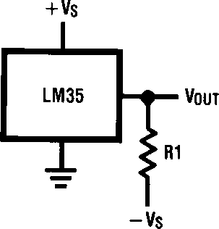

December 1994

LM35/LM35A/LM35C/LM35CA/LM35D

Precision Centigrade Temperature Sensors

General Description

The LM35 series are precision integrated-circuit tempera-

ture sensors, whose output voltage is linearly proportional to the Celsius (Centigrade) temperature. The LM35 thus has an advantage over linear temperature sensors calibrated in ° Kelvin, as the user is not required to subtract a large con- stant voltage from its output to obtain convenient Centi- grade scaling. The LM35 does not require any external cali-

bration or trimming to provide typical accuracies of g¹/4°C at room temperature and g³/4°C over a full b55 to a150°C temperature range. Low cost is assured by trimming and

calibration at the wafer level. The LM35’s low output imped- ance, linear output, and precise inherent calibration make interfacing to readout or control circuitry especially easy. It can be used with single power supplies, or with plus and minus supplies. As it draws only 60 mA from its supply, it has very low self-heating, less than 0.1°C in still air. The LM35 is

rated to operate over a b55° to a150°C temperature

range, while the LM35C is rated for a b40° to a110°C range (b10° with improved accuracy). The LM35 series is

available packaged in hermetic TO-46 transistor packages,

while the LM35C, LM35CA, and LM35D are also available in the plastic TO-92 transistor package. The LM35D is also available in an 8-lead surface mount small outline package and a plastic TO-202 package.

Features

Y Calibrated directly in ° Celsius (Centigrade)

Y Linear a 10.0 mV/°C scale factor

Y 0.5°C accuracy guaranteeable (at a25°C)

Y Rated for full b55° to a150°C range

Y Suitable for remote applications

Y Low cost due to wafer-level trimming

Y Operates from 4 to 30 volts

Y Less than 60 mA current drain

Y Low self-heating, 0.08°C in still air

Y Nonlinearity only g¹/4°C typical

Y Low impedance output, 0.1 X for 1 mA load

Connection Diagrams

TO-46

Metal Can Package*

TO-92

Plastic Package

SO-8

Small Outline Molded Package

TL/H/5516 – 2

TL/H/5516 – 1

*Case is connected to negative pin (GND)

TL/H/5516 – 21

Order Number LM35H, LM35AH,

LM35CH, LM35CAH or LM35DH

See NS Package Number H03H

Order Number LM35CZ,

LM35CAZ or LM35DZ

See NS Package Number Z03A

Top View

N.C. e No Connection

Order Number LM35DM See NS Package Number M08A

TO-202

Plastic Package

Typical Applications

TL/H/5516 – 3

FIGURE 1. Basic Centigrade Temperature

Sensor (a2°C to a150°C)

TL/H/5516 – 4

Choose R1 e bVS/50 mA

TL/H/5516 – 24

Order Number LM35DP See NS Package Number P03A

TRI-STATEÉ is a registered trademark of National Semiconductor Corporation.

VOUTea1,500 mV at a150°C

ea250 mV at a25°C eb550 mV at b55°C

FIGURE 2. Full-Range Centigrade

Temperature Sensor

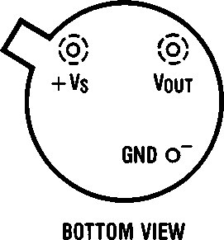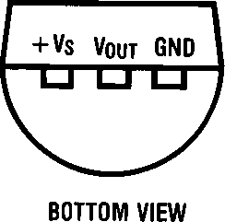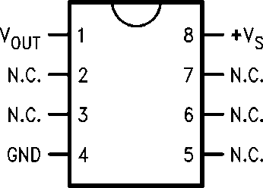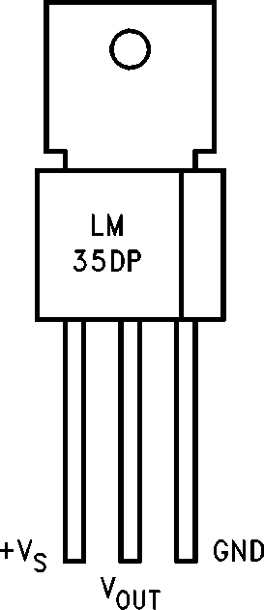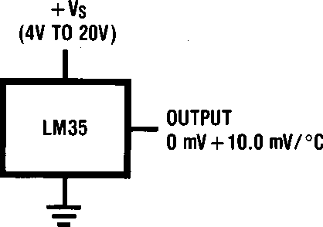C1995 National Semiconductor Corporation

LM35/LM35A/LM35C/LM35CA/LM35D

Precision Centigrade Temperature Sensors

TL/H/5516

RRD-B30M75/Printed in U. S. A.

Absolute Maximum Ratings (Note 10)

If Military/Aerospace specified devices are required, please contact the National Semiconductor Sales Office/Distributors for availability and specifications.

Supply Voltage a35V to b0.2V

SO Package (Note 12):

Vapor Phase (60 seconds) 215°C

Infrared (15 seconds) 220°C

ESD Susceptibility (Note 11) 2500V

Output Voltage a6V to b1.0V

Output Current 10 mA

Specified Operating Temperature Range: T (Note 2)

MIN

to T

MAX

Storage Temp., TO-46 Package, b60°C to a180°C

TO-92 Package, b60°C to a150°C

SO-8 Package, b65°C to a150°C TO-202 Package, b65°C to a150°C

LM35, LM35A b55°C to a150°C

LM35C, LM35CA b40°C to a110°C LM35D 0°C to a100°C

Lead Temp.:

TO-46 Package, (Soldering, 10 seconds) 300°C TO-92 Package, (Soldering, 10 seconds) 260°C TO-202 Package, (Soldering, 10 seconds) a230°C

Electrical Characteristics (Note 1) (Note 6)

|  |  |  |  |  |  |  |  |  |
| --- | --- | --- | --- | --- | --- | --- | --- | --- |
| Parameter | Conditions | LM35A | | | LM35CA | | | Units (Max.) |
| Typical | Tested Limit (Note 4) | Design Limit (Note 5) | Typical | Tested Limit (Note 4) | Design Limit (Note 5) |
| Accuracy | TAea25°C | g0.2 | g0.5 |  | g0.2 | g0.5 |  | °C |
| (Note 7) | TAeb10°C | g0.3 |  | g0.3 |  | g1.0 | °C |
|  | TAeTMAX | g0.4 | g1.0 | g0.4 | g1.0 |  | °C |
|  | TAeTMIN | g0.4 | g1.0 | g0.4 |  | g1.5 | °C |
| Nonlinearity (Note 8) | TMINsTAsTMAX | g0.18 |  | g0.35 | g0.15 |  | g0.3 | °C |
| Sensor Gain (Average Slope) | TMINsTAsTMAX | a10.0 | a9.9, a10.1 |  | a10.0 |  | a9.9, a10.1 | mV/°C |
| Load Regulation (Note 3) 0sILs1 mA | TAea25°C TMINsTAsTMAX | g0.4 g0.5 | g1.0 | g3.0 | g0.4 g0.5 | g1.0 | g3.0 | mV/mA mV/mA |
| Line Regulation (Note 3) | TAea25°C 4VsVSs30V | g0.01 g0.02 | g0.05 | g0.1 | g0.01 g0.02 | g0.05 | g0.1 | mV/V mV/V |
| Quiescent Current | VSea5V, a25°C | 56 | 67 |  | 56 | 67 |  | mA |
| (Note 9) | VSea5V | 105 |  | 131 | 91 |  | 114 | mA |
|  | VSea30V, a25°C | 56.2 | 68 |  | 56.2 | 68 |  | mA |
|  | VSea30V | 105.5 |  | 133 | 91.5 |  | 116 | mA |
| Change of Quiescent Current | 4VsVSs30V, a25°C  4VsVSs30V | 0.2  0.5 | 1.0 | 2.0 | 0.2  0.5 | 1.0 | 2.0 | mA mA |
| (Note 3) |  |  |  |  |  |  |  |  |
| Temperature Coefficient of Quiescent Current |  | a0.39 |  | a0.5 | a0.39 |  | a0.5 | mA/°C |
| Minimum Temperature for Rated Accuracy | In circuit of  *Figure 1* , ILe0 | a1.5 |  | a2.0 | a1.5 |  | a2.0 | °C |
| Long Term Stability | TJeTMAX, for 1000 hours | g0.08 |  |  | g0.08 |  |  | °C |

Note 1: Unless otherwise noted, these specifications apply: b55°CsTJsa150°C for the LM35 and LM35A; b40°sTJsa110°C for the LM35C and LM35CA; and 0°sTJsa100°C for the LM35D. VSea5Vdc and ILOADe50 mA, in the circuit of *Figure 2.* These specifications also apply from a2°C to TMAX in the circuit of *Figure 1* . Specifications in boldface apply over the full rated temperature range.

Note 2: Thermal resistance of the TO-46 package is 400°C/W, junction to ambient, and 24°C/W junction to case. Thermal resistance of the TO-92 package is 180°C/W junction to ambient. Thermal resistance of the small outline molded package is 220°C/W junction to ambient. Thermal resistance of the TO-202 package is 85°C/W junction to ambient. For additional thermal resistance information see table in the Applications section.

Electrical Characteristics (Note 1) (Note 6) (Continued)

|  |  |  |  |  |  |  |  |  |
| --- | --- | --- | --- | --- | --- | --- | --- | --- |
| Parameter | Conditions | LM35 | | | LM35C, LM35D | | | Units (Max.) |
| Typical | Tested Limit (Note 4) | Design Limit (Note 5) | Typical | Tested Limit (Note 4) | Design Limit (Note 5) |
| Accuracy, | TAea25°C | g0.4 | g1.0 |  | g0.4 | g1.0 |  | °C |
| LM35, LM35C  (Note 7) | TAeb10°C  TAeTMAX TAeTMIN | g0.5  g0.8 g0.8 | g1.5 | g1.5 | g0.5  g0.8 g0.8 |  | g1.5  g1.5 g2.0 | °C  °C  °C |
| Accuracy, LM35D  (Note 7) | TAea25°C  TAeTMAX TAeTMIN |  |  |  | g0.6 g0.9 g0.9 | g1.5 | g2.0 g2.0 | °C  °C  °C |
| Nonlinearity (Note 8) | TMINsTAsTMAX | g0.3 |  | g0.5 | g0.2 |  | g0.5 | °C |
| Sensor Gain (Average Slope) | TMINsTAsTMAX | a10.0 | a9.8, a10.2 |  | a10.0 |  | a9.8, a10.2 | mV/°C |
| Load Regulation (Note 3) 0sILs1 mA | TAea25°C TMINsTAsTMAX | g0.4 g0.5 | g2.0 | g5.0 | g0.4 g0.5 | g2.0 | g5.0 | mV/mA mV/mA |
| Line Regulation (Note 3) | TAea25°C 4VsVSs30V | g0.01 g0.02 | g0.1 | g0.2 | g0.01 g0.02 | g0.1 | g0.2 | mV/V mV/V |
| Quiescent Current | VSea5V, a25°C | 56 | 80 |  | 56 | 80 |  | mA |
| (Note 9) | VSea5V | 105 |  | 158 | 91 |  | 138 | mA |
|  | VSea30V, a25°C | 56.2 | 82 |  | 56.2 | 82 |  | mA |
|  | VSea30V | 105.5 |  | 161 | 91.5 |  | 141 | mA |
| Change of Quiescent Current | 4VsVSs30V, a25°C  4VsVSs30V | 0.2  0.5 | 2.0 | 3.0 | 0.2  0.5 | 2.0 | 3.0 | mA mA |
| (Note 3) |  |  |  |  |  |  |  |  |
| Temperature Coefficient of Quiescent Current |  | a0.39 |  | a0.7 | a0.39 |  | a0.7 | mA/°C |
| Minimum Temperature for Rated Accuracy | In circuit of  *Figure 1* , ILe0 | a1.5 |  | a2.0 | a1.5 |  | a2.0 | °C |
| Long Term Stability | TJeTMAX, for 1000 hours | g0.08 |  |  | g0.08 |  |  | °C |

Note 3: Regulation is measured at constant junction temperature, using pulse testing with a low duty cycle. Changes in output due to heating effects can be computed by multiplying the internal dissipation by the thermal resistance.

Note 4: Tested Limits are guaranteed and 100% tested in production.

Note 5: Design Limits are guaranteed (but not 100% production tested) over the indicated temperature and supply voltage ranges. These limits are not used to calculate outgoing quality levels.

Note 6: Specifications in boldface apply over the full rated temperature range.

Note 7: Accuracy is defined as the error between the output voltage and 10mv/°C times the device’s case temperature, at specified conditions of voltage, current, and temperature (expressed in °C).

Note 8: Nonlinearity is defined as the deviation of the output-voltage-versus-temperature curve from the best-fit straight line, over the device’s rated temperature range.

Note 9: Quiescent current is defined in the circuit of *Figure 1* .

Note 10: Absolute Maximum Ratings indicate limits beyond which damage to the device may occur. DC and AC electrical specifications do not apply when operating the device beyond its rated operating conditions. See Note 1.

Note 11: Human body model, 100 pF discharged through a 1.5 kX resistor.

Note 12: See AN-450 ‘‘Surface Mounting Methods and Their Effect on Product Reliability’’ or the section titled ‘‘Surface Mount’’ found in a current National Semiconductor Linear Data Book for other methods of soldering surface mount devices.

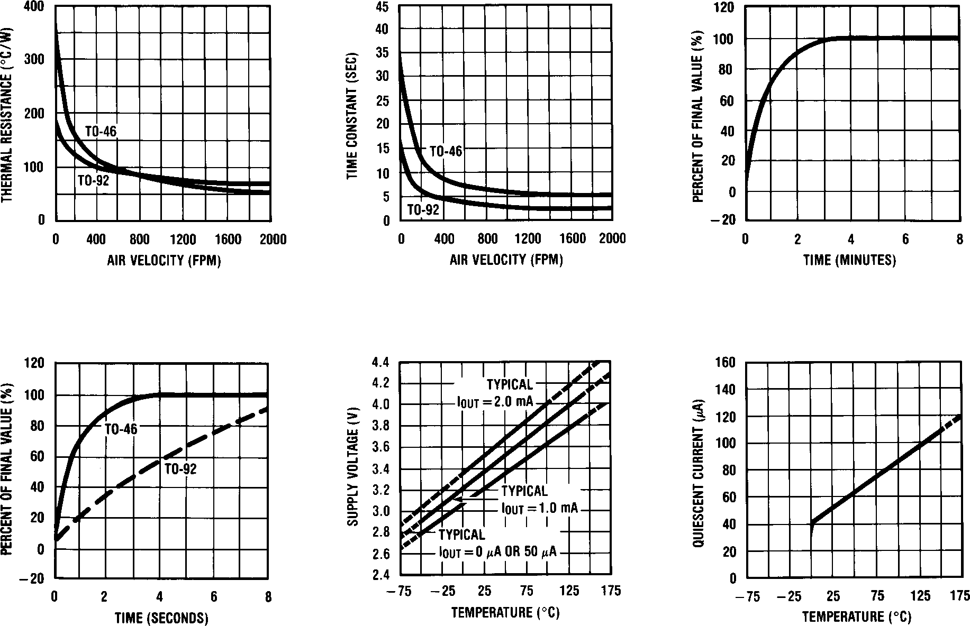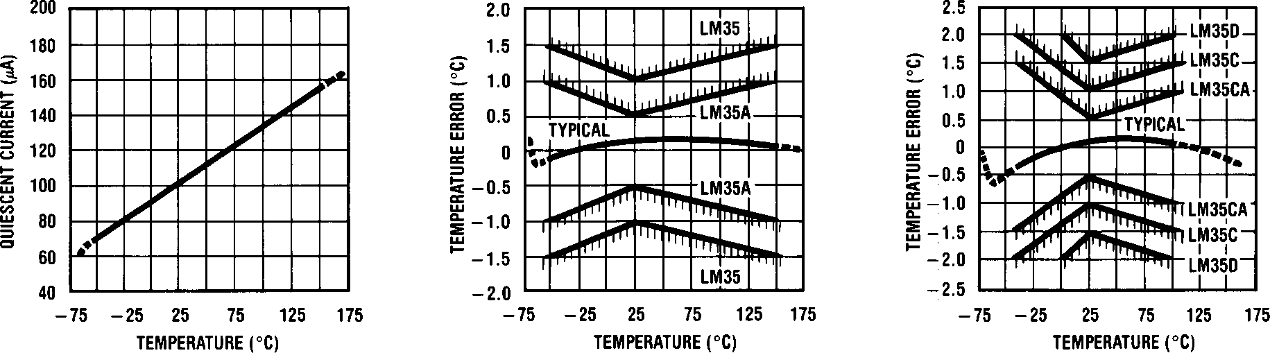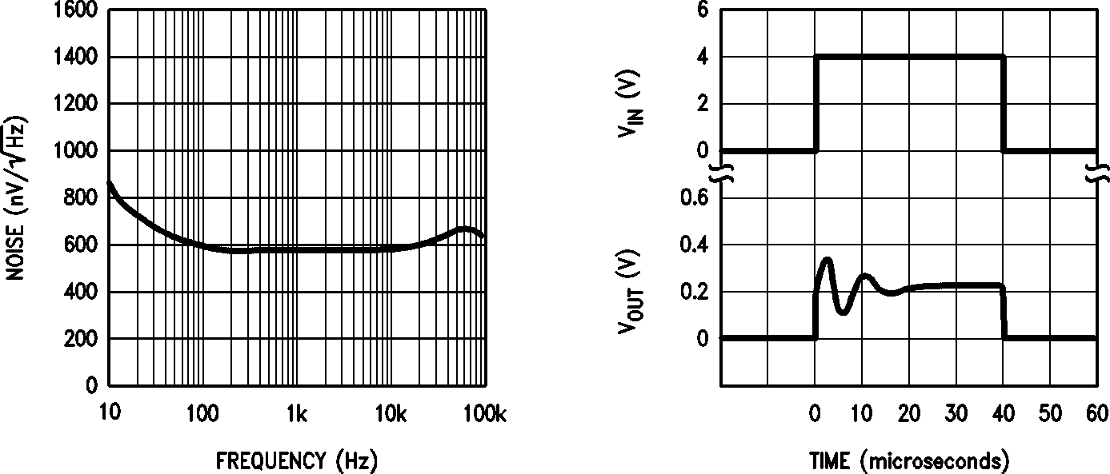

Typical Performance Characteristics

Thermal Resistance

Junction to Air Thermal Time Constant

Thermal Response

in Still Air

Thermal Response in

Stirred Oil Bath

Minimum Supply

Voltage vs. Temperature

Quiescent Current

vs. Temperature

(In Circuit of *Figure 1* .)

TL/H/5516 – 17

Quiescent Current

vs. Temperature

(In Circuit of *Figure 2* .)

Accuracy vs. Temperature

(Guaranteed)

Accuracy vs. Temperature

(Guaranteed)

TL/H/5516 – 18

Noise Voltage

Start-Up Response

TL/H/5516 – 22

###### Applications

The LM35 can be applied easily in the same way as other integrated-circuit temperature sensors. It can be glued or cemented to a surface and its temperature will be within about 0.01°C of the surface temperature.

This presumes that the ambient air temperature is almost the same as the surface temperature; if the air temperature were much higher or lower than the surface temperature, the actual temperature of the LM35 die would be at an inter- mediate temperature between the surface temperature and the air temperature. This is expecially true for the TO-92 plastic package, where the copper leads are the principal thermal path to carry heat into the device, so its tempera- ture might be closer to the air temperature than to the sur- face temperature.

To minimize this problem, be sure that the wiring to the LM35, as it leaves the device, is held at the same tempera- ture as the surface of interest. The easiest way to do this is to cover up these wires with a bead of epoxy which will insure that the leads and wires are all at the same tempera- ture as the surface, and that the LM35 die’s temperature will not be affected by the air temperature.

The TO-46 metal package can also be soldered to a metal surface or pipe without damage. Of course, in that case the Vb terminal of the circuit will be grounded to that metal. Alternatively, the LM35 can be mounted inside a sealed-end metal tube, and can then be dipped into a bath or screwed into a threaded hole in a tank. As with any IC, the LM35 and accompanying wiring and circuits must be kept insulated and dry, to avoid leakage and corrosion. This is especially true if the circuit may operate at cold temperatures where condensation can occur. Printed-circuit coatings and var- nishes such as Humiseal and epoxy paints or dips are often used to insure that moisture cannot corrode the LM35 or its connections.

These devices are sometimes soldered to a small light- weight heat fin, to decrease the thermal time constant and speed up the response in slowly-moving air. On the other hand, a small thermal mass may be added to the sensor, to give the steadiest reading despite small deviations in the air temperature.

Temperature Rise of LM35 Due To Self-heating (Thermal Resistance)

TO-46, TO-46, TO-92, TO-92, SO-8 SO-8 TO-202 TO-202 ***

no heat sink small heat fin* no heat sink small heat fin** no heat sink small heat fin** no heat sink small heat fin

Still air 400°C/W 100°C/W 180°C/W 140°C/W 220°C/W 110°C/W 85°C/W 60°C/W

|  |  |  |  |  |  |
| --- | --- | --- | --- | --- | --- |
| Moving air | 100°C/W | 40°C/W | 90°C/W | 70°C/W 105°C/W 90°C/W 25°C/W 40°C/W | |
| Still oil | 100°C/W | 40°C/W | 90°C/W | 70°C/W | |
| Stirred oil  (Clamped to metal, | 50°C/W | 30°C/W | 45°C/W | 40°C/W | |
| Infinite heat sink) | (24°C/W) | (55°C/W) | | | (23°C/W) |

* Wakefield type 201, or 1" disc of 0.020" sheet brass, soldered to case, or similar.

** TO-92 and SO-8 packages glued and leads soldered to 1" square of ¹/1。" printed circuit board with 2 oz. foil or similar.

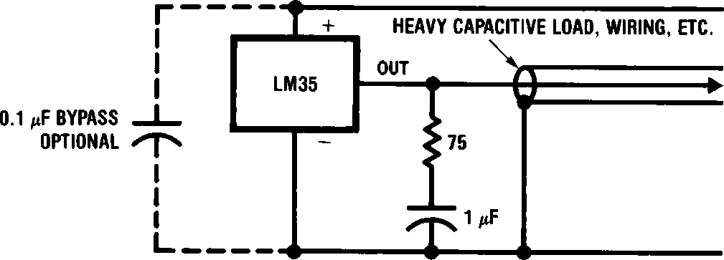Typical Applications (Continued)

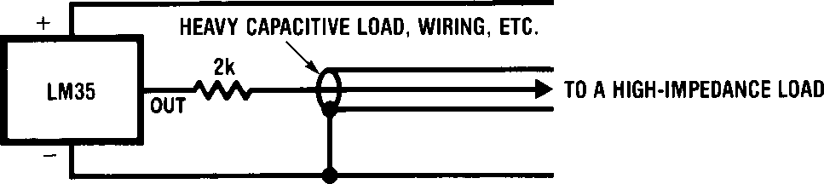

TL/H/5516 – 19

FIGURE 3. LM35 with Decoupling from Capacitive Load

FIGURE 4. LM35 with R-C Damper

TL/H/5516 – 20

CAPACITIVE LOADS

Like most micropower circuits, the LM35 has a limited ability to drive heavy capacitive loads. The LM35 by itself is able to drive 50 pf without special precautions. If heavier loads are anticipated, it is easy to isolate or decouple the load with a resistor; see *Figure 3* . Or you can improve the tolerance of capacitance with a series R-C damper from output to ground; see *Figure 4* .

When the LM35 is applied with a 200X load resistor as shown in *Figure 5, 6,* or *8,* it is relatively immune to wiring

capacitance because the capacitance forms a bypass from ground to input, not on the output. However, as with any linear circuit connected to wires in a hostile environment, its performance can be affected adversely by intense electro- magnetic sources such as relays, radio transmitters, motors with arcing brushes, SCR transients, etc, as its wiring can act as a receiving antenna and its internal junctions can act as rectifiers. For best results in such cases, a bypass capac- itor from VIN to ground and a series R-C damper such as

75X in series with 0.2 or 1 mF from output to ground are

often useful. These are shown in *Figures 13, 14,* and *16.*

TL/H/5516 – 6

FIGURE 6. Two-Wire Remote Temperature Sensor (Output Referred to Ground)

TL/H/5516 – 5

FIGURE 5. Two-Wire Remote Temperature Sensor (Grounded Sensor)

TL/H/5516 – 7

FIGURE 7. Temperature Sensor, Single Supply, b55° to

a150°C

TL/H/5516 – 8

FIGURE 8. Two-Wire Remote Temperature Sensor (Output Referred to Ground)

TL/H/5516 – 9

FIGURE 9. 4-To-20 mA Current Source (0°C to a100°C)

TL/H/5516 – 10

FIGURE 10. Fahrenheit Thermometer

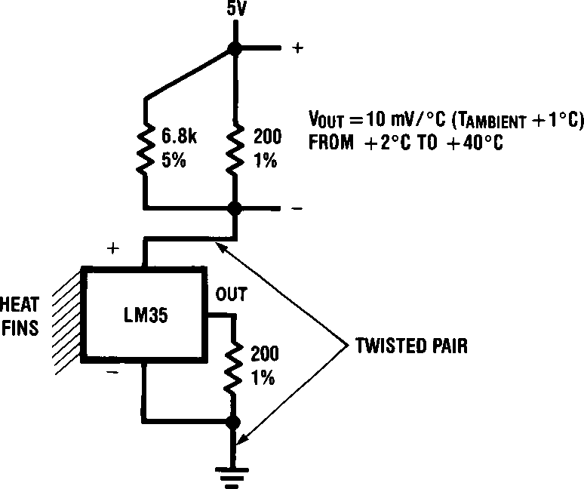 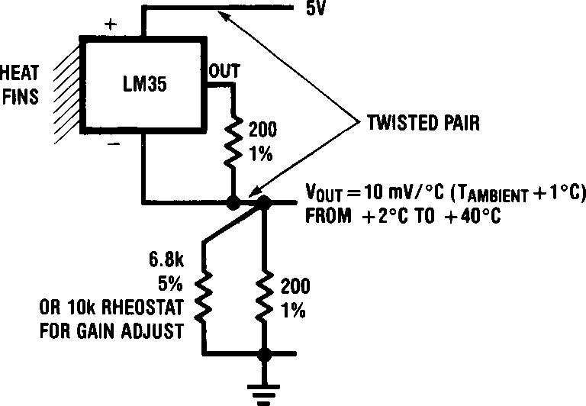

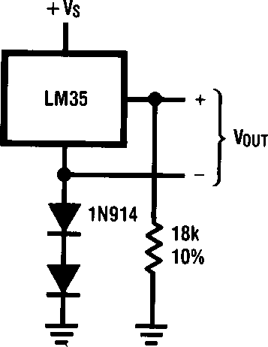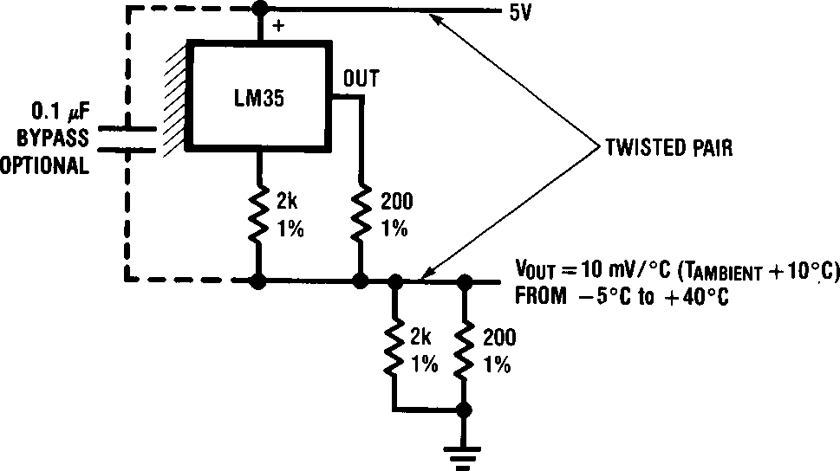

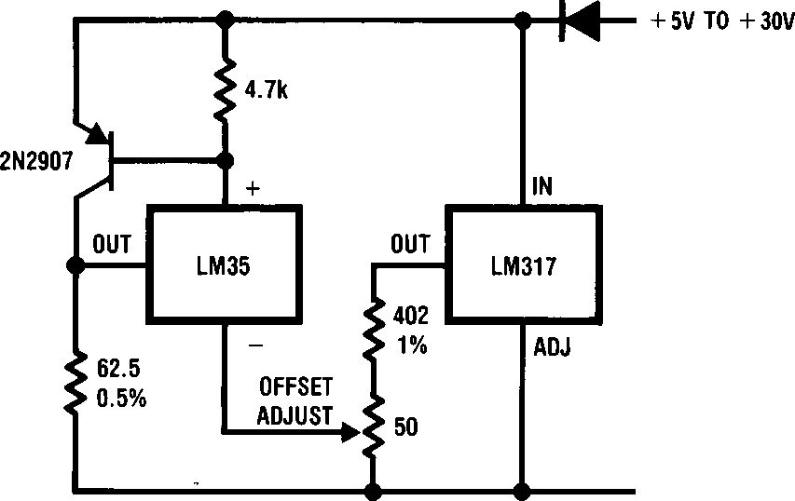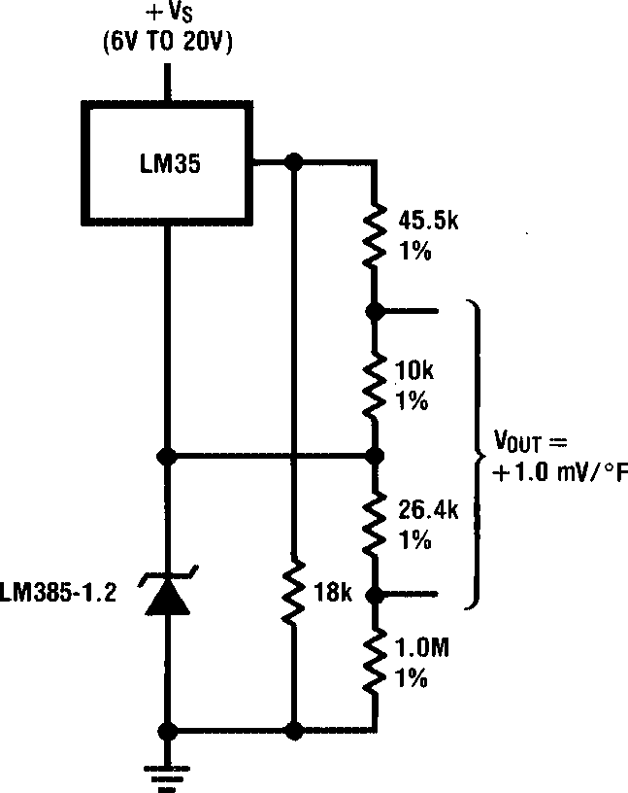

TL/H/5516 – 11

FIGURE 11. Centigrade Thermometer (Analog Meter)

TL/H/5516 – 12

FIGURE 12. Expanded Scale Thermometer (50° to 80° Fahrenheit, for Example Shown)

TL/H/5516 – 13

FIGURE 13. Temperature To Digital Converter (Serial Output) (a128°C Full Scale)

TL/H/5516 – 14

FIGURE 14. Temperature To Digital Converter (Parallel TRI-STATEÉ Outputs for Standard Data Bus to mP Interface) (128°C Full Scale)

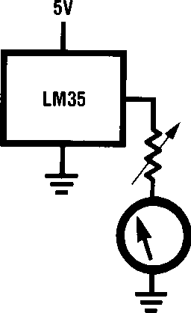 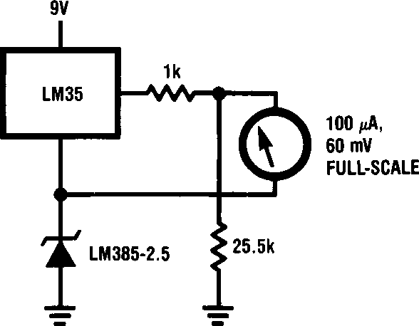

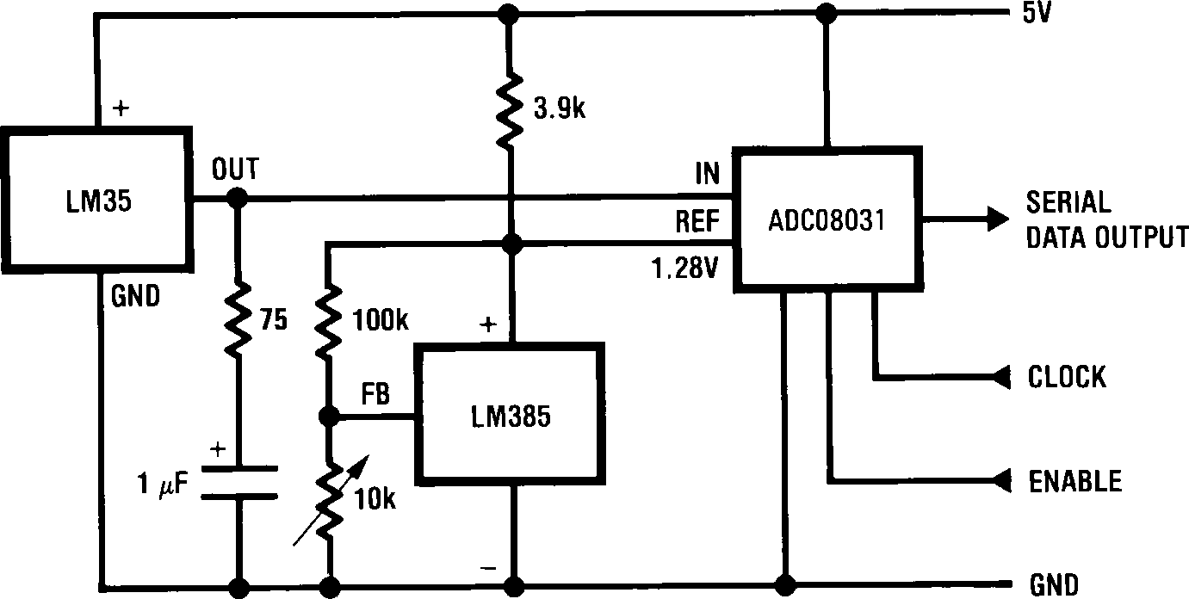

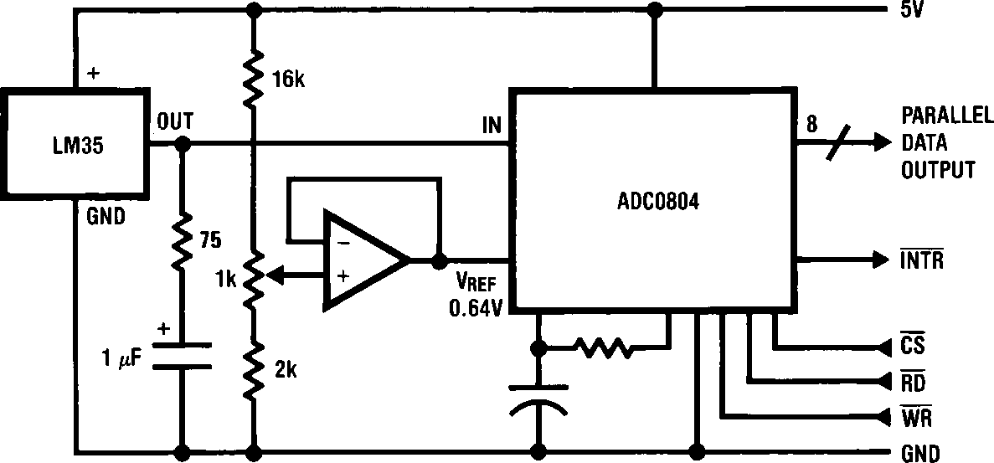

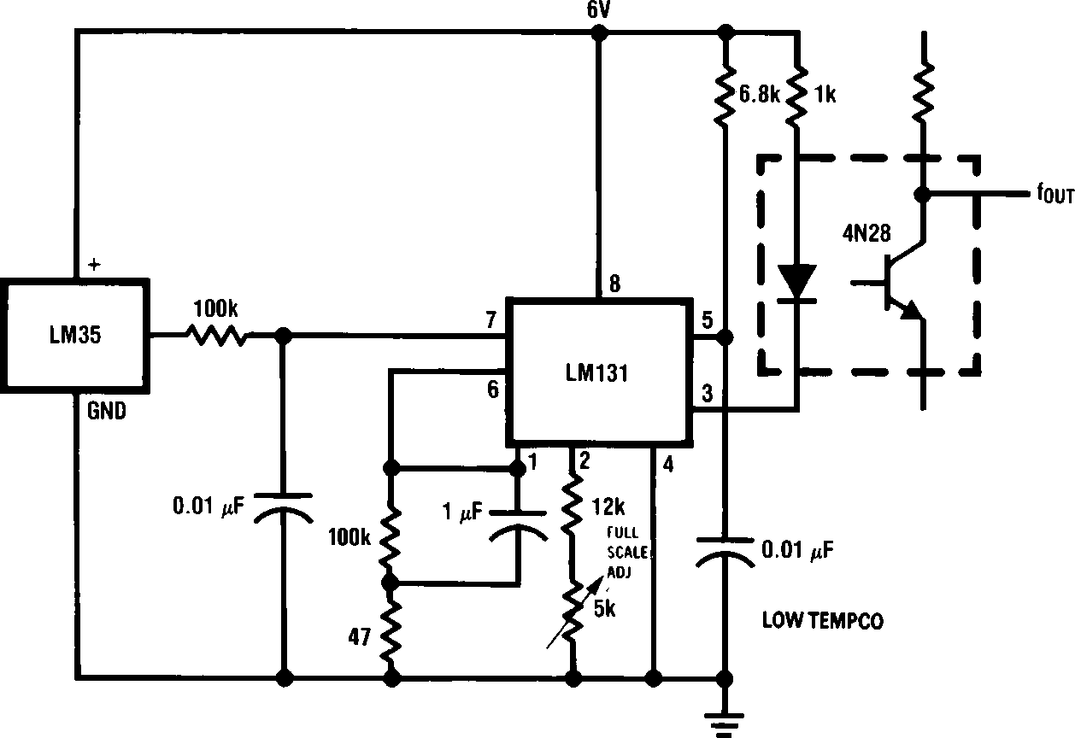

TL/H/5516 – 16

*e1% or 2% film resistor

-Trim RB for VBe3.075V

-Trim RG for VGe1.955V

-Trim RA for VAe0.075V a 100mV/°G c Tambient

-Example, VAe2.275V at 22°G

FIGURE 15. Bar-Graph Temperature Display (Dot Mode)

TL/H/5516 – 15

FIGURE 16. LM35 With Voltage-To-Frequency Converter And Isolated Output (2°C to a150°C; 20 Hz to 1500 Hz)

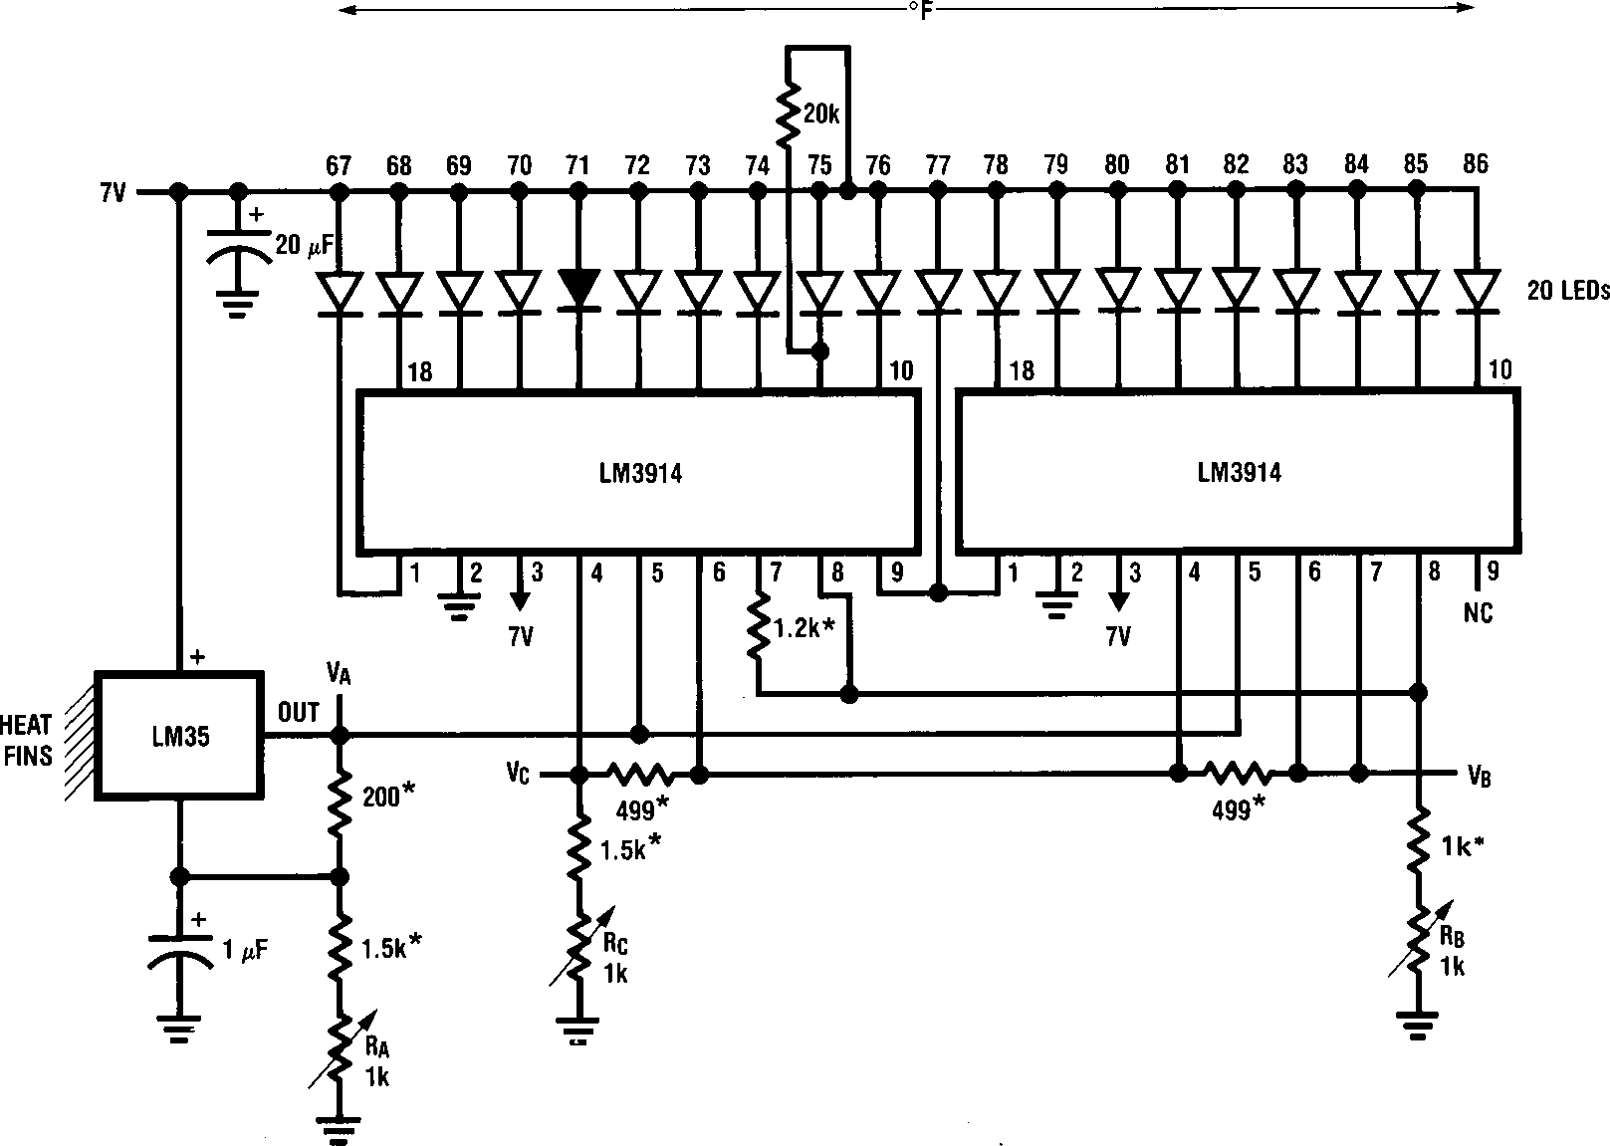

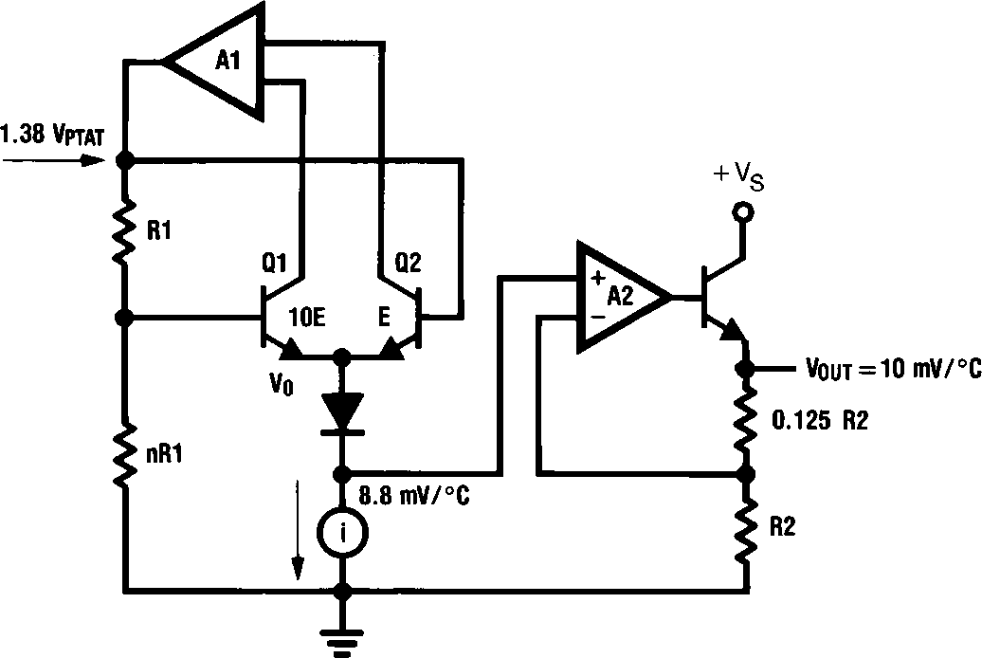

TL/H/5516 – 23

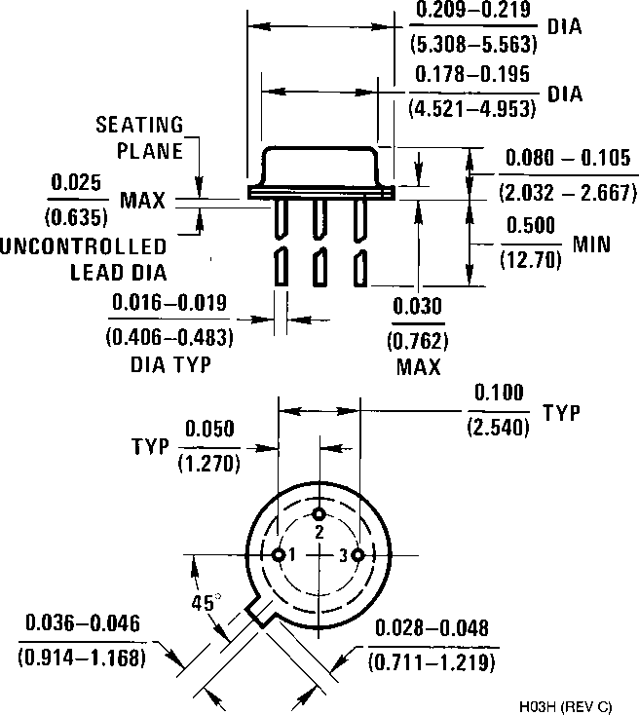

TO-46 Metal Can Package (H) Order Number LM35H, LM35AH, LM35CH,

LM35CAH, or LM35DH

NS Package Number H03H

SO-8 Molded Small Outline Package (M) Order Number LM35DM

NS Package Number M08A

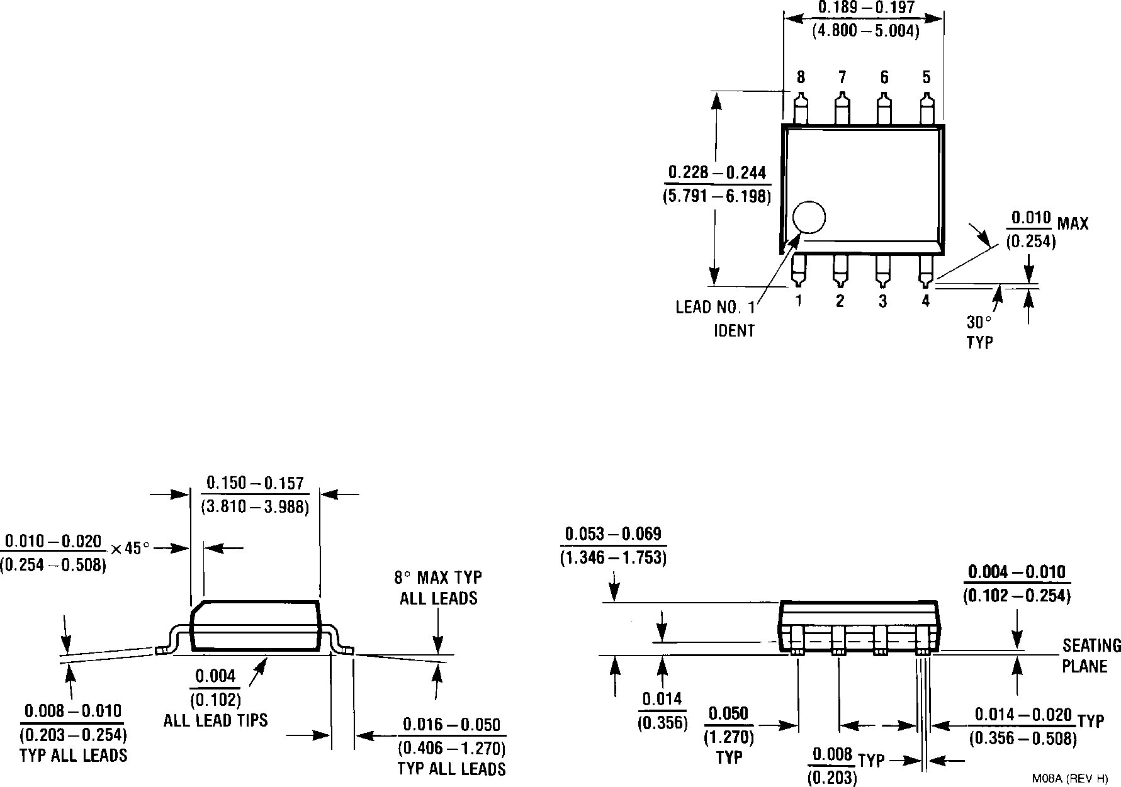

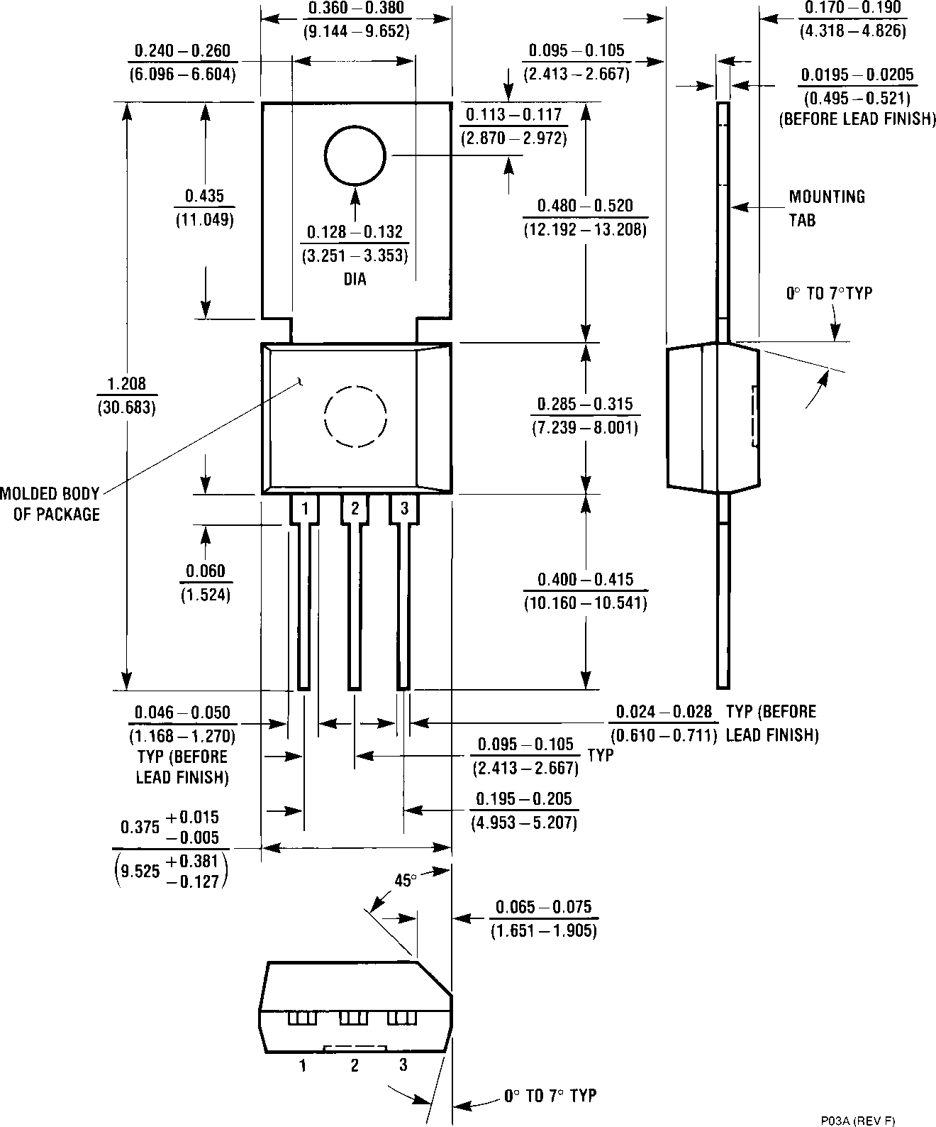

Power Package TO-202 (P) Order Number LM35DP NS Package Number P03A

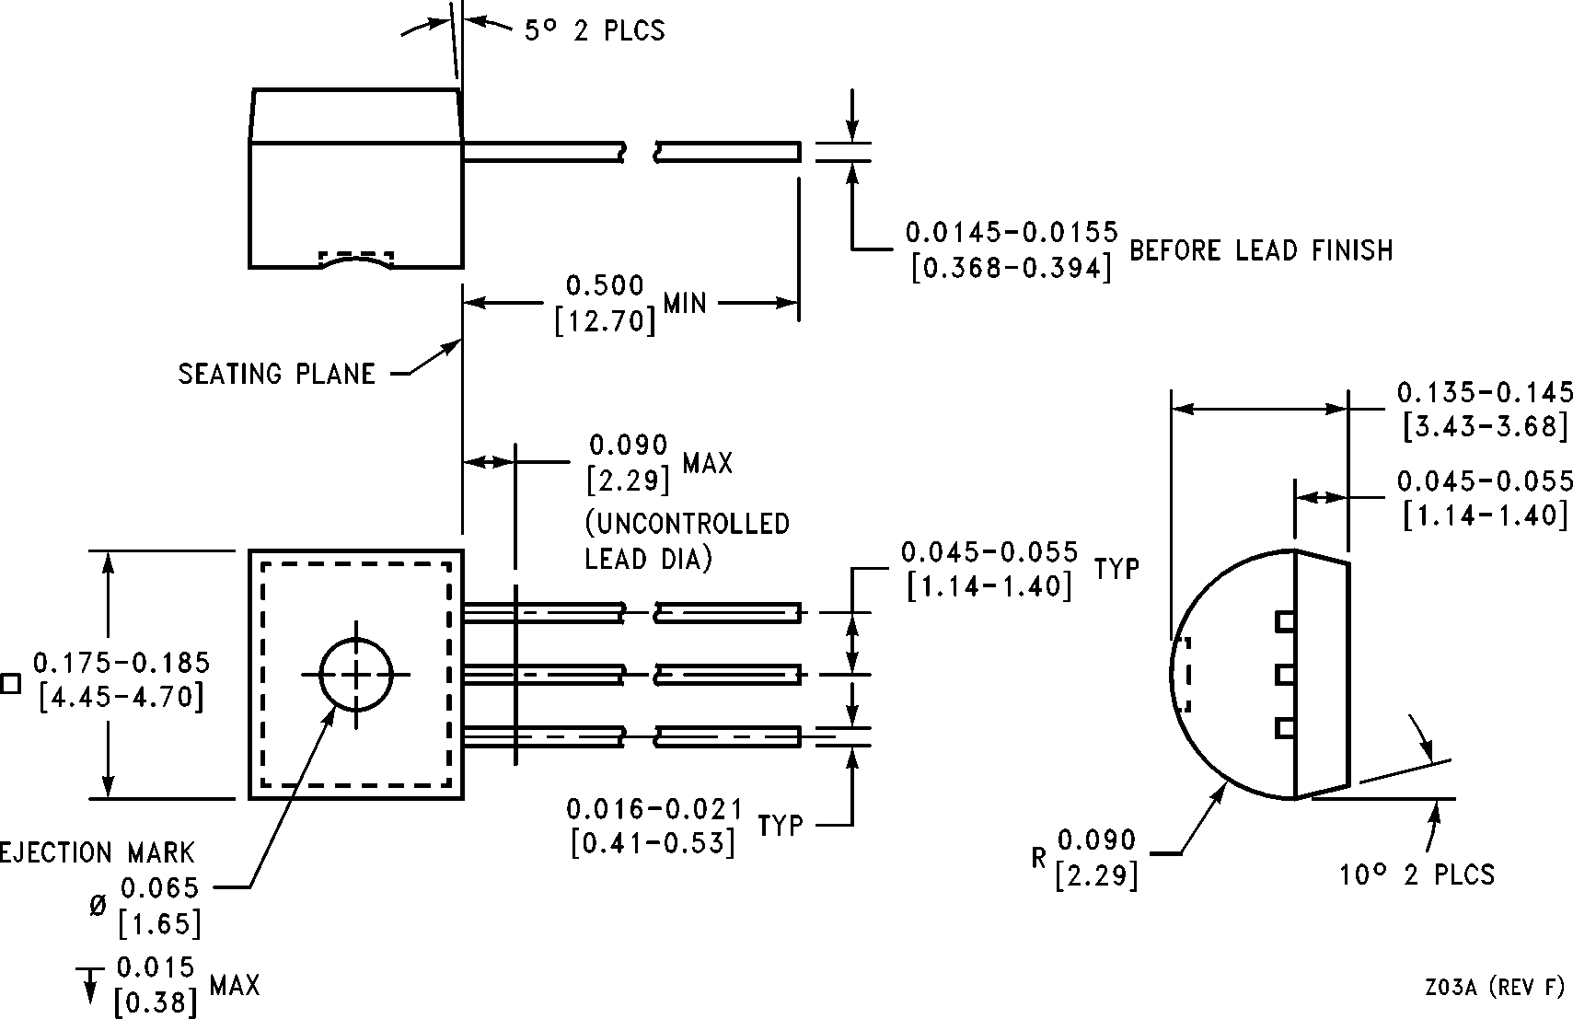

LM35/LM35A/LM35C/LM35CA/LM35D

Precision Centigrade Temperature Sensors



TO-92 Plastic Package (Z)

Order Number LM35CZ, LM35CAZ or LM35DZ NS Package Number Z03A

LIFE SUPPORT POLICY

NATIONAL’S PRODUGTS ARE NOT AUTHORIZED FOR USE AS GRITIGAL GOMPONENTS IN LIFE SUPPORT DEVIGES OR SYSTEMS WITHOUT THE EXPRESS WRITTEN APPROVAL OF THE PRESIDENT OF NATIONAL SEMIGONDUGTOR GORPORATION. As used herein:

1. Life support devices or systems are devices or 2. A critical component is any component of a life systems which, (a) are intended for surgical implant support device or system whose failure to perform can into the body, or (b) support or sustain life, and whose be reasonably expected to cause the failure of the life failure to perform, when properly used in accordance support device or system, or to affect its safety or with instructions for use provided in the labeling, can effectiveness.

be reasonably expected to result in a significant injury to the user.

National Semiconductor National Semiconductor National Semiconductor National Semiconductor

Corporation GmbH Japan Ltd.

2900 Semiconductor Drive Livry-Gargan-Str. 10 Sumitomo Ghemical

P.O. Box 58090 D-82256 F4urstenfeldbruck Engineering Genter

Santa Glara, GA 95052-8090 Germany Bldg. 7F

Hong Kong Ltd.

13th Floor, Straight Block, Ocean Gentre, 5 Ganton Rd. Tsimshatsui, Kowloon

Tel: 1(800) 272-9959

TWX: (910) 339-9240

Tel: (81-41) 35-0

Telex: 527649

Fax: (81-41) 35-1

1-7-1, Nakase, Mihama-Ku Hong Kong

Ghiba-Gity,

Giba Prefecture 261

Tel: (043) 299-2300

Fax: (043) 299-2500

Tel: (852) 2737-1600

Fax: (852) 2736-9960

National Semiconductores

Do Brazil Ltda.

Rue Deputado Lacorda Franco 120-3A

Sao Paulo-SP Brazil 05418-000

Tel: (55-11) 212-5066

Telex: 391-1131931 NSBR BR Fax: (55-11) 212-1181

National Semiconductor

(Australia) Pty, Ltd. Building 16 Business Park Drive

Monash Business Park Nottinghill, Melbourne Victoria 3168 Australia

Tel: (3) 558-9999

Fax: (3) 558-9998

National does not assume any responsibility for use of any circuitry described, no circuit patent licenses are implied and National reserves the right at any time without notice to change said circuitry and specifications.

This datasheet has been download from: [www.datasheetcatalog.com](http://www.datasheetcatalog.com/)

Datasheets for electronics components.

National Semiconductor was acquired by Texas Instruments.

<http://www.ti.com/corp/docs/investor_relations/pr_09_23_2011_national_semiconductor.html>

This file is the datasheet for the following electronic components:

LM35D - <http://www.ti.com/product/lm35d?HQS=TI-null-null-dscatalog-df-pf-null-wwe> LM35CA - <http://www.ti.com/product/lm35ca?HQS=TI-null-null-dscatalog-df-pf-null-wwe> LM35C - <http://www.ti.com/product/lm35c?HQS=TI-null-null-dscatalog-df-pf-null-wwe> LM35 - <http://www.ti.com/product/lm35?HQS=TI-null-null-dscatalog-df-pf-null-wwe> LM35A - <http://www.ti.com/product/lm35a?HQS=TI-null-null-dscatalog-df-pf-null-wwe>